A Weekly Newsletter of Nu‘uanu Congregational Church
NCC News
March 12, 2023

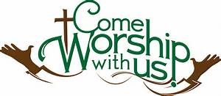

Witness at the Cross—Lenten book study
Starting: March 1st, 10am on the lanai; 6:30pm via Zoom.
From Pastor Jeannie
If you would like a book, it’s $18.84. There will be 3 copies in the church office tomorrow.

One Great Hour of Sharing
Our gifts to One Great Hour of Sharing (OGHS) will be received on March 19 during worship. OGHS is an annual offering in which we participate every year in March. The gifts you give to OGHS are combined with gifts from other UCC churches to make a greater impact in the areas of justice advocacy, sustainable development, refugee and asylum issues, migration, natural disasters, and assisting those most in need and vulnerable.
Throughout the country and the year, OGHS gifts help families and communities in desperate need of assistance. Strengthened by the power of God’s Spirit and your collective generosity, the United Church of Christ continues to work with partners to care for others, and not give up as together we build a just world for all.
OGHS offering envelopes were in the March issue of The Caller. Please mail them into the church office or bring them to Service on Sunday, March 19th.

Recycling
by Wayne Kobayashi
Starting April, the scouts of Troop 201 will be doing the recycling that Hui Malama was doing. This is a service project for the troop. Proceeds will continue to go towards the church. Hui Malama had been doing the recycling over the past 20 years, but as its members age, it was time to get younger people involved. Please continue to bring all HI-5 recyclables to church.

Hui Malama Work Day Change
by Wayne Kobayashi
The Hui Malama group will be changing its work day from the first Wednesday of each month to the last Friday of each month. The group gathers at 9 am for a short devotion, then do different tasks, like weeding, yard work, light maintenance and repair, etc. This ends before noon. Anyone interested in helping out are welcomed. You may contact any of the group members (Wayne Kobayashi, Micki Sasaki, Joyce Uyehara, Ruth Gushiken, Lani Hirohata, Claire Nakatsuka, Sybil Seto or Russell Ishida).

GEARING UP FOR GREEN DAY IX at NCC –
August 5, 2023 - 9:00 a.m. - 1:00 p.m.
The Missions Committee just got word that its GREEN DAY IX is “set to go”! It will take place on August 5, 2023, from 9:00 a.m. – 1:00 p.m. All proceeds will go to Ulu Wai’s Missions Ministry, which supports God's love and care for the hungry and needy, for the earth, for our community, and for the next generation. Start saving your gently used, give away kitchen and household items for Green Day IX. Please.... NO CLOTHING OR SHOES.

Missions Committee

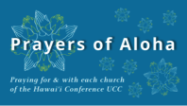
Week of March 12:
Church of the Pacific (Kaua'i)
Waihee Protestant Church (Maui)
Week of March 19:
Chuukese Cong'l Church of Christ (O'ahu)
Waianae Samoan Church (O'ahu)
Koolau Hui'ia Protestant Church (Kaua'i)
Week of March 26:
Community Church of Honolulu (O'ahu)
Waialua UCC (O'ahu)

Survivors of Natural Disasters, especially:
Turkey (Earthquake)
Syria (Earthquake)
South Sudan (Famine)

*You may donate through our church to our national relief efforts by writing a check to NCC with the specific relief effort written in the memo line.

2023 Altar Flower Donations
The chart for the 2023 Altar Flower Donations is ready to fill up! Please fill out the date that you want, either in person on Sunday, by email at nuuanucongregational@gmail.com, or by calling the office at (808) 595-3935.
Please have Altar Flowers delivered on Fridays, between 8 am and 4 pm or Sunday mornings at 8:30 am. There will not be anyone working on Saturday’s until further notice.

Can You Bring A Can - For The Food Pantry?
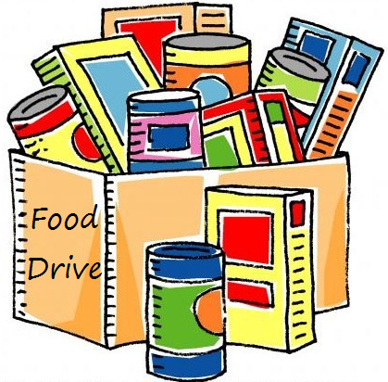
A guest speaker, Ann Leake, from Kaumakapili Church will tell us about their food pantry ministry on March 12. This is one of the organizations that Nuuanu supports through the Missions Committee. Food collected in February and March will be donated to this ministry.
Kitchen Towel Donations
From Sybil Seto
Thanks to generous donors, both upper and lower kitchens are fully stocked with towels. Mahalo for the donations!

Email Addresses
Pastor email: pastor.nuuanucongregational@gmail.com
Office email: nuuanucongregational@gmail.com
Bookkeeper email Bookkeeper@NuuanuCC.onmicrosoft.com

