Weekly Newsletter of Nu‘uanu Congregational Church
NCC News
January 7, 2024

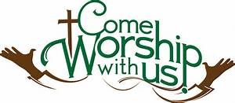

Documenting Your Wishes
Save the dates! The Diaconate is sponsoring, in partnership with Kokua Mau, two sessions that can help you consider, and communicate with your loved ones, about your wishes for end of life care. No one really likes to think about this, and it can be difficult to talk about. But there is a lot that can be done to make it easier. The sessions will be on February 11th & 25th. Because it is so important that your loved ones understand your wishes we strongly encourage having your adult children participate in person, or on Zoom.

Don Ikeda’s Chutney & Jams
There are jellies that were mixed in with the Chutney’s well! There are 2 jars of Surnam ($3.00 each).
If you want to get more of Don’s Chutney, we have quite a few in the office, ranging from $3.00 to $12.00. Please call Mairi at (808) 595-3935 or email her at nuuanucongregational@gmail.com.

2024 Altar Flower Donations
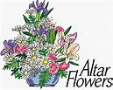
2024 Altar flowers Sign-up sheet is up. If there any dates you want to sign up for ahead of time, please email the office at nuuanucongregational@gmail.com
Please have Altar Flowers delivered on Fridays, between 8 am and 4 pm or Sunday mornings at 8:30 am. There will not be anyone working on Saturday’s until further notice.

Can You Bring A Can - For The Hawai‘i Foodbank?
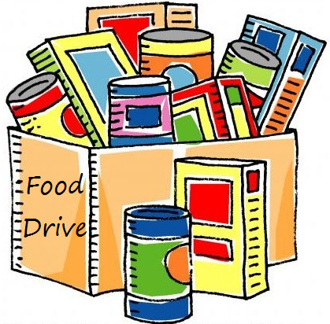
The last Sunday of each month is Missions Sunday. Please bring a canned good or other non-perishable food on December 31, 2023. Boxes will be available to collect them. All gifts will be taken to the Hawai‘i Foodbank

