A Weekly Newsletter of Nu‘uanu Congregational Church
NCC News
April 28, 2024

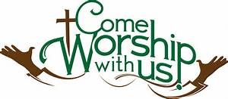
NCC’s Ulu Wai Ministry’s GREEN DAY X Fair
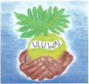
A big mahalo for all the wonderful donations and your attendance of Green Day X. We could not have done it without YOU! Mission Committee

Albert Matsumoto’s Celebration of Life
Albert Matsumoto’s celebration of life will be on Saturday, May 11, 2024 and 11 a.m., with lunch to follow.
We will have parking here at Nu‘uanu Congregational Church, as well as St. Stephen’s Catholic Church at 2747 Pali Highway, Honolulu, HI 96817.

Strengthen the Church Offering
From the UCC Conference Website
On May 19, 2024 we will receive your gifts for Strengthen the Church Offering.
The Strengthen the Church special offering supports the work of the Hawai'i Conference and the national United Church of. Strengthen the Church funds leadership development, youth and young adult ministries, and new and renewing congregations.
The envelope will be included with the May Caller.
If donating by check, please make it out to NCC, with “Strengthen the Church” on the memo line.

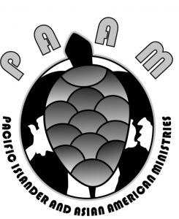
Pacific Islander and Asian American Ministries (PAAM) Convocation, June 18-22, Church of the Crossroads. PAAM will be celebrating it’s 50th anniversary in June and we are all invited to take part in the. PAAM is dedicated to nurturing connections, understanding, and advocacy within and beyond our communities. The convocation theme, which is deeply ingrained in Hawaiian wisdom, is Ola I Ka Wai, which means, “Water is Life.” We will discuss fresh water and its critical importance to sustaining life across all forms, from the mountains to the sea. Discussions and shared insight around the notion that Ola I Ka Wai will guide us as we share our wisdom, and as such, will have the power to shape our future. Special guests will be the Rev. Karen Georgia Thompson, Executive Minister of the UCC, and the Rev. James Bhagwan, General Secretary of the Pacific Conference of Churches, Oceania region’s peak ecumenical organization with 35 member denominations and 11 national Councils of churches from 19 Pacific Island Countries and territories. There will be field trips to several different cultural sites, and workshops. Among the workshops being offered are:

- Hymn Writing - Kahu Ken Makuakane, Kawaiahao Church
- Climate Change and Faith Communities – Rev. James Bhagwan
- Understanding the AHEC General Synod Resolutions - Ron Fujiyoshi AHEC and CAIM Residential Schools
- Militarization in the Pacific – Derek Duncan (Global Ministries) and Terumi Kataoka
- Bluezone Churches - Olive Douglass—regions and churches where longevity is enjoyed by a high percentage of the community.
- Ukulele Making Workshop
- What We Learned about the Maui Disaster and Preparation for the Next Disaster – Danny Tengan.

Registration is only online:
https://paamucc.org/2024-convocation-registration/
NCC’s William & Jean Wood Scholarship
As we are nearing the end of the college Spring Semester, we have the updated Instructions and Application for the Fall 2024 and Spring 2025 up on the website so you can start to prepare early.
The application deadline is June 14, 2024. Please notice the dates In the section “Due Dates and Methods of Delivery” on the second page.
To get the instructions and application, go to nuuanu.org, click on the word “Resources” under Nu‘uanu Congregational Church, then Nu‘uanu Scholarships.

2024 Altar Flower Donations
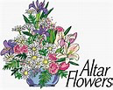
2024 Altar Sign-up sheet is up. If there are any dates you want to sign up for ahead of time, please email the office at nuuanucongregational@gmail.com.
Please have Altar Flowers delivered on Fridays, between 9 am and 5 pm or Sunday mornings at 8:30 am. No one will be working on Saturday’s until further notice.
All dates in April May and June are filled.

Can You Bring a Can for the Food Pantry?
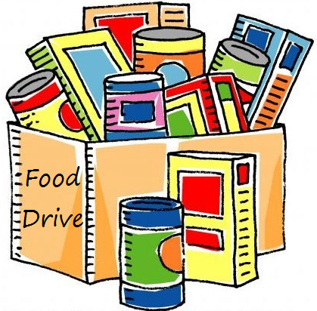
The last Sunday of each month is Missions Sunday. Please bring a canned good or other non-perishable food on April 28th. Boxes will be available to collect them. All gifts will be taken to the Hawai‘i Foodbank.
The Hawai’i Foodbank will not accept homemade or what looks like homemade items without the ingredients listed. If they don’t have the ingredients listed, the items will be discarded.
There’s a Donations Guideline in the office if you need a copy!
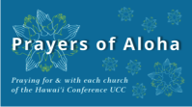
Week of April 28:
Honolulu Marshallese Ministry (O'ahu)
United Church of Christ - Judd Street (O'ahu)

Our current email addresses:
Pastor: pastor.nuuanucongregational@gmail.com
Office: nuuanucongregational@gmail.com
Bookkeeper: Bookkeeper@NuuanuCC.onmicrosoft.com

