A Weekly Newsletter of Nu‘uanu Congregational Church
NCC News
April 21, 2024

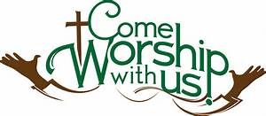
NCC’s Ulu Wai Ministry’s GREEN DAY X Fair
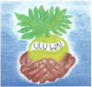
A big mahalo for all the wonderful donations and your attendance of Green Day X. We could not have done it without YOU! Mission Committee

Pastor Jeannie will be on PBS Hawaiʻi in a new live episode of KĀKOU: Hawaiʻi’s Town Hall this Thursday evening, April 25, 2024 from 7:30-9:00PM. She will one of a ten-person panel conversation on the topic: “De-stressing In A Stressful World.”

Pacific Islander and Asian American Ministries (PAAM) - United Church of Christ USA 50th Anniversary Convocation, June 18-22 at Church of the Crossroads. PAAM is dedicated to nurturing connections, understanding, and advocacy within and beyond our Asian and Pacific Islander communities. The conference theme, “Ola I Ka Wai,” means “Water is Life.” Featured speakers include the Rev. Dr. Karen Georgia A. Thompson, General Minister and President of the United Church of Christ. Registration deadline: May 1, https://paamucc.org/2024-convocation-registration/

NCC’s William & Jean Wood Scholarship
As we are nearing the end of the college Spring Semester, we have the updated Instructions and Application for the Fall 2024 and Spring 2025 up on the website so you can start to prepare early.
The application deadline is June 14, 2024. Please notice the dates In the section “Due Dates and Methods of Delivery” on the second page.
To get the instructions and application, go to nuuanu.org, click on the word “Resources” under Nu‘uanu Congregational Church, then Nu‘uanu Scholarships.

Join the Great Genki Ball Throw!
On Saturday, June 22 in the morning, we invite all the congregations to gather at the Ala Wai Canal in Waikiki for the big Genki Ball Throw!!!! This will take place on the final day of the national PAAM (Pacific Islander and Asian American Ministries) Convocation 2024, which runs from June 18 – 22.
For more information and to reserve a spot, contact Malia Galindo at associate@churchofthecrossroads.org.

2024 Altar Flower Donations
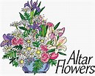
2024 Altar Sign-up sheet is up. If there are any dates you want to sign up for ahead of time, please email the office at nuuanucongregational@gmail.com.
Please have Altar Flowers delivered on Fridays, between 9 am and 5 pm or Sunday mornings at 8:30 am. No one will be working on Saturday’s until further notice.
All dates in April May and June are filled.

Can You Bring a Can for the Food Pantry?
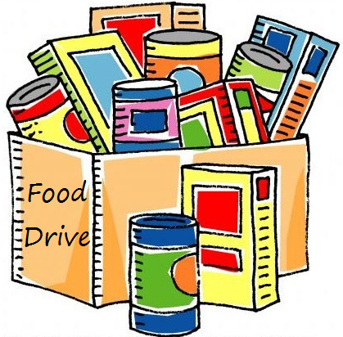
The last Sunday of each month is Missions Sunday. Please bring a canned good or other non-perishable food on April 28th. Boxes will be available to collect them. All gifts will be taken to the Hawai‘i Foodbank.
The Hawai’i Foodbank will not accept homemade or what looks like homemade items without the ingredients listed. If they don’t have the ingredients listed, the items will be discarded.
There’s a Donations Guideline in the office if you need a copy!

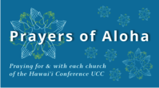
Week of April 21:
Kanaana Hou - Siloama UCC (Moloka'i)
United Community Church (Hawai'i Island)
Koloa Union Church (Kaua'i)
Week of April 28:
Honolulu Marshallese Ministry (O'ahu)
United Church of Christ - Judd Street (O'ahu)

Our current email addresses:
Pastor: pastor.nuuanucongregational@gmail.com
Office: nuuanucongregational@gmail.com
Bookkeeper: Bookkeeper@NuuanuCC.onmicrosoft.com

