A Weekly Newsletter of Nu‘uanu Congregational Church
NCC News
April 14, 2024

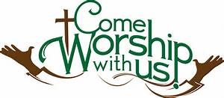

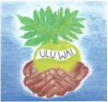
NCC’s Ulu Wai Ministry’s GREEN DAY X Fair
Remember to attend GREEN DAY X, this coming Saturday, April 20, 2024
from 9:00 a.m. – 1:00 p.m.

From April 14 – April 19, 2024 bring your donations for Green Day and leave them in the gym or other designated areas:
- Your new to gently used Rummage Sale items: kitchen and household items (such as utensils, dishware, pots ‘n pans, linen), books, toys, small tools, craft supplies, small working appliances, small workable tech/electronic devices, collectibles, art works, jewelry, etc. ...NO CLOTHING OR SHOES.
- 1 - 5 clean gallon size containers needed for water garden plants
- Potted plants, air plants, Water garden plants and place them outside in the back of Kosasa Hall near the palm trees
- Recyclable (HI 5) cans and bottles – Bring them washed, sorted, and bagged on April 20, 2024.
- E - waste pickup 9-11.

(continued)
Also available on April 20th:
- Waterless car wash tickets for that great car wash in the lower parking lot.
- Recycle tech items for pick up between 9-11 in the upper parking lot.
- Vermicasting: Worm and Worm castings for sale.
- Food: spam sushi, juju juice, fresh lemonade.

Mark your monthly calendar right now and write: “Attend GREEN DAY X APRIL 20, 2024, 9:00 a.m. - 1:00 p.m.”. See you there!

NCC’s William & Jean Wood Scholarship
As we are nearing the end of the college Spring Semester, we have the updated Instructions and Application for the Fall 2024 and Spring 2025 up on the website so you can start to prepare early.
The application deadline is June 14, 2024. Please notice the dates in the section “Due Dates and Methods of Delivery” on the second page.
To get the instructions and application, go to nuuanu.org, click on the word “Resources” under Nu‘uanu Congregational Church, then Nu‘uanu Scholarships.

Join the Great Genki Ball Throw!
All church mission committees, Sunday School children, and youth are invited to participate in the great Genki Ball Throw! Genki Ball is the unique dirt ball made out of rice grains, soil, and a special E-bacteria that eats up pollution and sludge in polluted waters. On Saturday, April 6 at 3 p.m., a special one-hour workshop on "How to Make Genki Balls" will be held at Church of the Crossroads (1212 University Avenue, Honolulu) for those interested in learning how to make the balls. Then invite your churches to participate in making them!
On Saturday, June 22 in the morning, we invite all the congregations to gather at the Ala Wai Canal in Waikiki for the big throw!!!! This will take place on the final day of the national PAAM (Pacific Islander and Asian American Ministries) Convocation 2024, which runs from
June 18 – 22.
Join us at the Genki Ball Workshop! For more information and to reserve a spot, contact Malia Galindo at associate@churchofthecrossroads.org.

2024 Altar Flower Donations
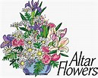
2024 Altar Sign-up sheet is up. If there are any dates you want to sign up for ahead of time, please email the office at nuuanucongregational@gmail.com.
Please have Altar Flowers delivered on Fridays, between 9 am and 5 pm or Sunday mornings at 8:30 am. No one will be working on Saturday’s until further notice.
All dates in April May and June are filled.

Can You Bring a Can for the Food Pantry?
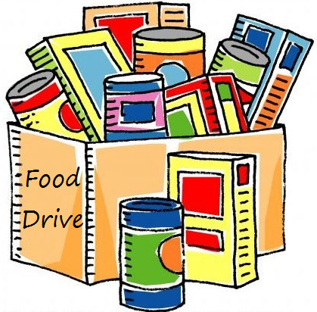
The last Sunday of each month is Missions Sunday. Please bring a canned good or other non-perishable food on April 28th. Boxes will be available to collect them. All gifts will be taken to the Hawai‘i Foodbank.
The Hawai’i Foodbank will not accept homemade or what looks like homemade items without the ingredients listed. If they don’t have the ingredients listed, the items will be discarded.
There’s a Donations Guideline in the office if you need a copy!

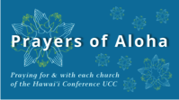
Week of April 14:
Huialoha Congregational Church (Maui)
Koolau Hui'ia Protestant Church (Kaua'i)
Week of April 21:
Kanaana Hou - Siloama UCC (Moloka'i)
United Community Church (Hawai'i Island)
Koloa Union Church (Kaua'i)
Week of April 28:
Honolulu Marshallese Ministry (O'ahu)
United Church of Christ - Judd Street (O'ahu)

Our current email addresses:
Pastor: pastor.nuuanucongregational@gmail.com
Office: nuuanucongregational@gmail.com
Bookkeeper: Bookkeeper@NuuanuCC.onmicrosoft.com

