A Weekly Newsletter of Nu‘uanu Congregational Church
NCC News
March 31, 2024

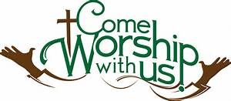
Easter Sunday, March 31, 2024
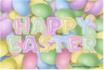
After today’s worship service, the Sunday School Children along with family and friends will be able to participate in the annual Easter Egg Hunt on the lawn around the sanctuary. Hope you brought your Easter basket to gather your eggs.
NCC’s Ulu Wai Ministry’s GREEN DAY X Fair
The Missions Committee’s GREEN DAY X will take place on April 20 2024, from 9:00 a.m. – 1:00 p.m. All proceeds will go to Ulu Wai’s Missions Ministry which supports God's love and care for the hungry and needy, for the earth, for our community, and for the next generation.

Start collecting rummage sale items:
- new to gently used Rummage Sale items: kitchen and household items (such as utensils, dishware, pots ‘n pans, linen), books, toys, small tools, craft supplies, small working appliances, small workable tech/electronic devices, collectibles, art works, jewelry, etc. but NO CLOTHING OR SHOES.
- 1 - 5 clean gallon size containers for water gardens
- recyclable (HI 5) cans and bottles
- plants
- Volunteers needed.
NCC’s William & Jean Wood Scholarship
As we are nearing the end of the college Spring Semester, we have the updated Instructions and Application for the Fall 2024 and Spring 2025 up on the website so you can start to prepare early.
The application deadline is June 14, 2024. Please notice the dates In the section “Due Dates and Methods of Delivery” on the second page.
To get the instructions and application, go to nuuanu.org, click on the word “Resources” under Nu‘uanu Congregational Church, then Nu‘uanu Scholarships.

Join the Great Genki Ball Throw!
All church mission committees, Sunday School children, and youth are invited to participate in the great Genki Ball Throw! Genki Ball is the unique dirt ball made out of rice grains, soil, and a special E-bacteria that eats up pollution and sludge in polluted waters. On Saturday, April 6 at 3 p.m., a special one-hour workshop on "How to Make Genki Balls" will be held at Church of the Crossroads (1212 University Avenue, Honolulu) for those interested in learning how to make the balls. Then invite your churches to participate in making them!
On Saturday, June 22 in the morning, we invite all the congregations to gather at the Ala Wai Canal in Waikiki for the big throw!!!! This will take place on the final day of the national PAAM (Pacific Islander and Asian American Ministries) Convocation 2024, which runs from
June 18 – 22.
Join us at the Genki Ball Workshop! For more information and to reserve a spot, contact Malia Galindo at associate@churchofthecrossroads.org.

2024 Altar Flower Donations
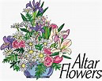
2024 Altar Sign-up sheet is up. If there are any dates you want to sign up for ahead of time, please email the office at nuuanucongregational@gmail.com.
Please have Altar Flowers delivered on Fridays, between 9 am and 5 pm or Sunday mornings at 8:30 am. No one will be working on Saturday’s until further notice.
The following are dates in April and May that need donations if you are willing and able:

- April 7
- April 28
- May 5
- May 12

Can You Bring a Can for the Food Pantry?
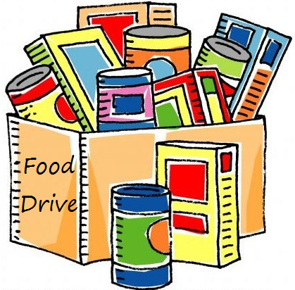
The last Sunday of each month is Missions Sunday. Please bring a canned good or other non-perishable food on March 31st. Boxes will be available to collect them. All gifts will be taken to the Hawai‘i Foodbank.
The Hawai’i Foodbank will not accept homemade or what looks like homemade items without the ingredients listed. If they don’t have the ingredients listed, the items will be discarded.
There’s a Donations Guideline in the office if you need a copy!

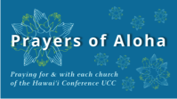
Week of March 31: Easter Sunday
Waiola Church (Maui)

Our current email addresses:
Pastor: pastor.nuuanucongregational@gmail.com
Office: nuuanucongregational@gmail.com
Bookkeeper: Bookkeeper@NuuanuCC.onmicrosoft.com

