A Weekly Newsletter of Nu‘uanu Congregational Church
NCC News
March 17, 2024

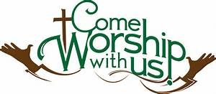
The Services of Lent 2024
Maundy Thursday – March 28, 2024
5:30 P.M. at Community Church
—jook and Communion

Good Friday – March 29, 2024
6:00 P.M. at Kaumakapili
There will be rides from NCC to Kaumakapili for Good Friday. We plan to leave NCC at 5:15pm.

Easter Sunday, March 31, 2024
After Easter Sunday worship, the Sunday School Children along with family and friends will be able to participate in the annual Easter Egg Hunt on the lawn around the sanctuary. Please bring your Easter basket to gather your eggs.
NCC’s Ulu Wai Ministry’s GREEN DAY X Fair
The Green Day Fair will be held on April 20, 2024, from 9:00 a.m. – 1:00 p.m. All proceeds will go to Ulu Wai’s Missions Ministry which takes care of God's creation through our overflowing love and care for the hungry and needy, for the earth, for our community, and for the next generation. Start putting aside items to sell at its Rummage Sale.
Don Ikeda’s Chutney
If you want to get more of Don’s Chutney, we have quite a few in the office, ranging from $8.00 to $12.00. Please call Mairi at (808) 595-3935 or email her at nuuanucongregational@gmail.com.

2024 Altar Flower Donations
2024 Altar Sign-up sheet is up. If there are any dates you want to sign up for ahead of time, please email the office at nuuanucongregational@gmail.com.
Please have Altar Flowers delivered on Fridays, between 9 am and 5 pm or Sunday mornings at 8:30 am. No one will be working on Saturday’s until further notice.
The following are dates in April and May that need donations if you are willing and able:

- April 7
- April 21
- April 28
- May 5
- May 12

Can You Bring a Can for the Food Pantry?
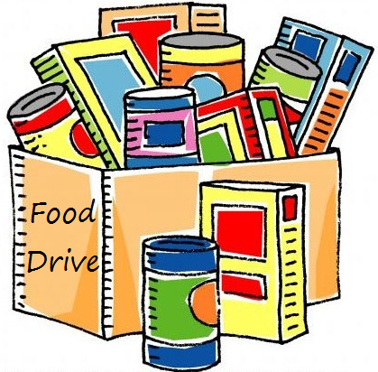
The last Sunday of each month is Missions Sunday. Please bring a canned good or other non-perishable food on March 31st. Boxes will be available to collect them. All gifts will be taken to the Hawai‘i Foodbank.
The Hawai’i Foodbank will not accept homemade or what looks like homemade items without the ingredients listed. If they don’t have the ingredients listed, the items will be discarded.
There’s a Donations Guideline in the office if you need a copy!

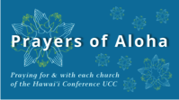
Week of March 17:
Samoan CC Church Honolulu (O'ahu)
Waianae Samoan Church (O'ahu)
Week of March 24:
Imiola Congregational Church (Hawai'i Island)
Waialua UCC (O'ahu)
Hanapepe UCC (Kaua'i)
Week of March 31: Easter Sunday
Waiola Church (Maui)

Our current email addresses:
Pastor: pastor.nuuanucongregational@gmail.com
Office: nuuanucongregational@gmail.com
Bookkeeper: Bookkeeper@NuuanuCC.onmicrosoft.com

