A Weekly Newsletter of Nu‘uanu Congregational Church
NCC News
September 3, 2023

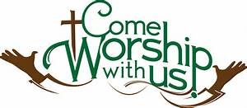

Capital Campaign Concludes in September
Here’s your September “to do” list as we close out this important giving opportunity.
- Find your Capital Campaign Pledge Letter.
- Fill out your Letter of Pledge Intent and return it to the church no later than Saturday, September 23.
- Join us in worship on Celebration Sunday, September 24, 2023, as we announce the grand total and thank our volunteers and donors.

Here’s a few more details you’ll need to know.
- If you have not yet received a Pledge Letter, pick yours up at church on either Sunday, September 10 or Sunday, September 17. On these Commitment Sundays, you will fill out your pledge information at church, put it in the privacy envelope, and place it in the box provided.
- If you need more time, take it home with you to mail back when you know what your contribution will be.
- Some of you have made Lead Gifts. If the church has received your Pledge Intent all you need to do is help us celebrate in worship on September 24.
- Any who are unable to make a pledge or choose not to do so, will follow the same instructions. Simply sign your letter of intent and cross out the contribution information. Place the letter in the envelope provided and return it to the church.
- Deadline for receiving all pledges is Saturday, September 23 so that your generosity can be part of our whole congregation’s final tally and celebration.

Celebration Sunday Luncheon
After service on September 24th, there will be a Capital Campaign celebration to celebrate the completion of the campaign. There will be a sign up list for bentos starting on Sunday, September 10th after we figure out where we will be ordering the bentos! You may also call Mairi at (808) 595-3935 if you aren’t in service.
We will need your orders by Sunday, September 17th. Please join us!

Give Aloha
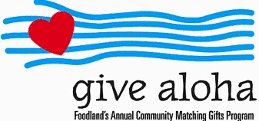
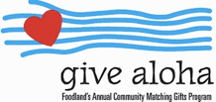
We will be participating in this year’s Give Aloha program again. Give Aloha will be running from September 1, 2023 through September 30, 2023 at all participating Foodland, Foodland Farms, and Sack-N-Saves.
Nu‘uanu Congregational Church’s organization number is 78424. There is a limit of up to $249.00 per Maika‘i Card number. Please make sure that you send us your receipt, either in the mail with your donation, or email a picture of it to nuuanucongregational@gmail.com. The receipt must have your name, amount, store number, and time of your transaction so that we can credit the donation to the right person/family!
Faithful Churches, Have Faith, Give Blood
Community Church of Honolulu will be hosting a blood drive tomorrow from 8:30A.M. to 2:00P.M. on their church grounds. UCC Judd Street and the Seventh Day Adventists churches will also be participating. After you have made your donation you are invited to stay and have a free waffle hot dog and other foods the churches will be bringing. There will also be music. So, come and have a picnic with Community Church of Honolulu and give blood.

Paul Osumi’s “Today’s Thoughts”
Norman Osumi, author to “Today’s Thought-Rev Osumi: the Man and His Message” had a book signing at Green Day IX. Mr. Osumi donated his time and books to support Green Day! Thank you Norman Osumi! In addition, he has donated 50 books and available for purchase. The books can be purchased during the week from Mairi in the church office. The funds raised from the book sale will be used to support local missions, such as Transition House, Family Promise, Food Bank to name a few. They make great gifts!

Donations Now Being Accepted

for Wildfires Disaster Relief
From UCC Coconut Wireless (8/9/23)
Churches and individuals may now make donations to the Hawai'i Disaster Relief Fund specifically for those people and areas devastated by the ongoing wildfires. Please note "Hawai‘i Wildfires Relief Fund" on the memo line of checks, or may donate to the Disaster relief at nuuanu.org. (scroll down about half way down the home page to where you see “Link for Donations/pledges”.
*You may donate through our church to our national relief efforts by writing a check to NCC with the specific relief effort written in the memo line.
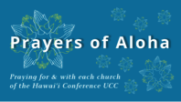
Week of September 3:
Honolulu Cosmopolitan UCC (O‘ahu)
Nu'uanu Congregational Church (O‘ahu)
*Please note – the whole HCUCC will be praying for us!
Week of September 10:
Honolulu Marshallese Ministry (O‘ahu)
Nu‘u Lotu (O‘ahu)
Kapa‘a First Hawaiian Church (Kaua‘i)
Week of September 17:
Ho‘olehua Congregational Church (Moloka‘i)
Nahiku Hawaiian Church (Maui)
Week of September 24:
Huialoha Congregational Church (Maui)
Mokuaikaua Church (Hawai‘i)
Kanana Fou Church (O‘ahu)

2023 Altar Flower Donations
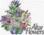
The 2023 Altar Flower Donations chart is filling up! Please put your name next to the date that you want either in person on Sunday, by emailing nuuanucongregational@gmail.com, or by calling the office at (808) 595-3935.
Please have Altar Flowers delivered on Fridays, between 8 am and 4 pm or Sunday mornings at 8:30 am. There will not be anyone working on Saturday’s until further notice.

Can You Bring a Can for the Food Pantry?
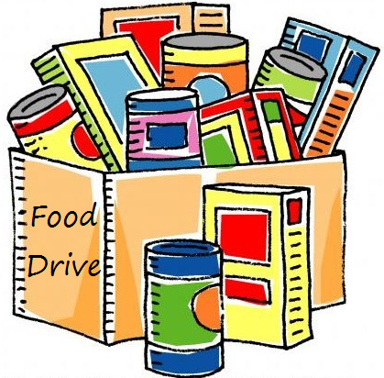
The last Sunday of each month is Missions Sunday. Please bring a canned good or other non-perishable food on September 24th. Boxes will be available to collect them. All gifts will be taken to the Hawai‘i Foodbank.

Our current email addresses:
- pastor.nuuanucongregational@gmail.com
- nuuanucongregational@gmail.com
- Bookkeeper@NuuanuCC.onmicrosoft.com

