A Weekly Newsletter of Nu‘uanu Congregational Church
NCC News
September 24, 2023

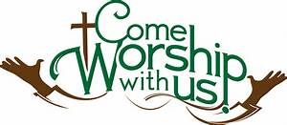

Office Volunteers
Mairi will be taking 2 days of vacation on October 2nd and 3rd, 2023. I am looking for volunteers just to answer phone calls while in the office. There’s no need for computer work to be done! Please let Mairi know if you are able to volunteer.

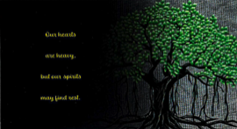
Hawaii Conference UCC – Maui Fire Relief
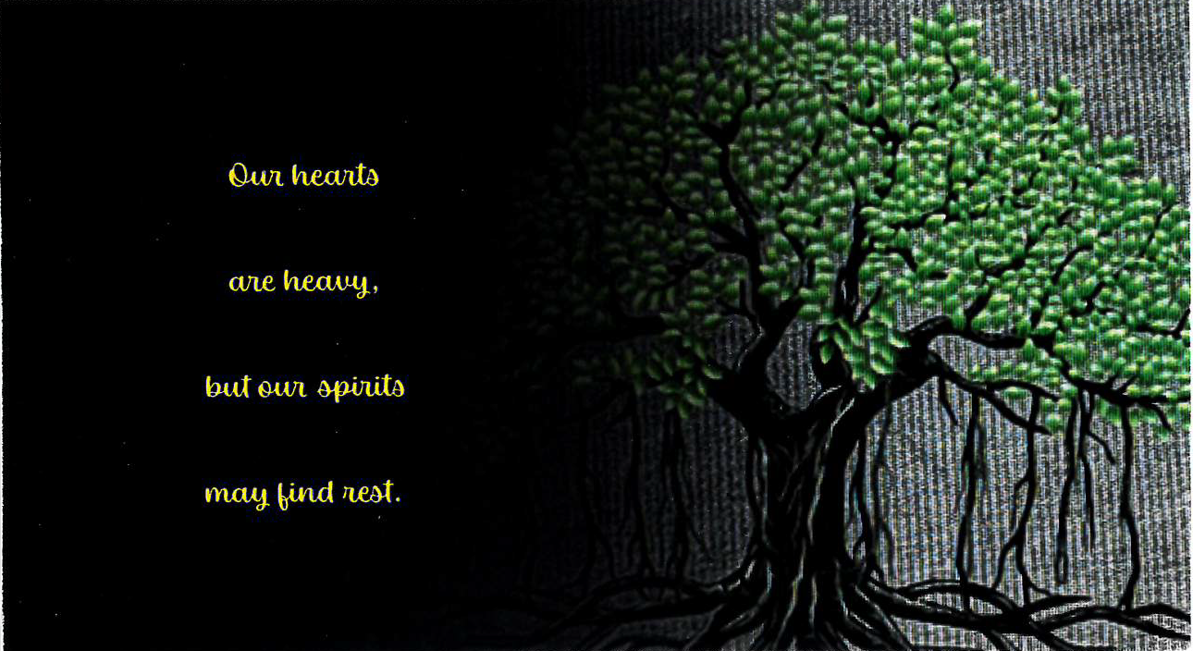
We received a letter of thanks from Conference Minister, the Rev. Dr. David Popham. He wanted to express his personal thanks for the $4,315 donation we sent in for Maui. Rev. Popham also reports that the funds received were used for: delivery of poi, temporary housing, portions of down payments as individuals replace vehicles lost to the fire, and gift cards distributed through crisis centers for families to purchase items of immediate need. Thank you for your generosity. It is making a real difference in the lives of many.

Changes with Family Promise Meals
By Judy Keith
Family Promise has changed the way they are providing dinners. Instead of having meals delivered to the families to eat on their own here, they have switched to Ohana Meals. These are congregant meals, served at the Family Promise offices at Kukui Center at 245 North Kukui Street. Sign up to provide a meal is being done online at their website: www.familypromisehawaii.org Scroll down to the section titled 'Ohana Nights to sign up to provide a meal or contact elliot@familypromisehawaii.org for more information. Please consider providing a meal with this new system.
Nu‘uanu Congregational Church has supported Family Promise since 2007. We continue to provide support by housing up to three families in Kibo Kan. We will continue with holiday gift cards through our White Christmas Drive.

World Communion/Blessings of the Animals
Neighbors in Need (NIN) is a special mission offering of the United Church of Christ that funds ministries of justice and compassion through a variety of peace and justice initiatives, advocacy efforts, and direct service projects through grants. The money we give to NIN will continue our church’s work in communities throughout the country.
Because we will celebrate NIN on World Communion Sunday we are inviting everyone to bring a loaf of bread—any kind—to church on that day, October 1. Please make sure it is unopened and in its original wrapper. After worship we will donate all of the bread to a non-profit organization that will help feed our sisters and brothers in the community.
Blessing of the Animals will also take place on October 1 after worship, on the streamside of the Sanctuary. So, bring Fluffy, Fido, or a photo, and bread, on Sunday, October 1, 2023.

Beautiful and Terrible Things
Join us for the book launch of “Beautiful and Terrible Things.” Dialogue with the author, Rev. Amy Butler, and book signing, October 3, 2023, 6-8 pm, Community Church of Honolulu, 2345 Nu’uanu Ave. www.cchonolulu.org.

Give Aloha
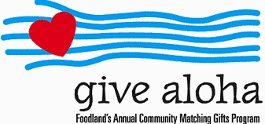
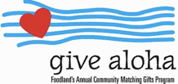
We will be participating in this year’s Give Aloha program again. Give Aloha will be running from September 1, 2023 through September 30, 2023 at all participating Foodland, Foodland Farms, and Sack-N-Saves.
Nu‘uanu Congregational Church’s organization number is 78424. There is a limit of up to $249.00 per Maika‘i Card number. Please make sure that you send us your receipt, either in the mail with your donation, or email a picture of it to nuuanucongregational@gmail.com. The receipt must have your name, amount, store number, and time of your transaction so that we can credit the donation to the right person/family!

Paul Osumi’s “Today’s Thoughts”
Norman Osumi, author to “Today’s Thought-Rev Osumi: the Man and His Message” had a book signing at Green Day IX. Mr. Osumi donated his time and books to support Green Day! Thank you Norman Osumi! In addition, he has donated 50 books which can be purchased during the week from Mairi in the church office. The funds raised from the book sale will be used to support local missions, such as Transition House, Family Promise, Food Bank to name a few. The book is $10.00. They make great gifts!

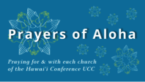
Week of September 24:
Huialoha Congregational Church (Maui)
Mokuaikaua Church (Hawai‘i)
Kanana Fou Church (O‘ahu)

2023 Altar Flower Donations
The 2023 Altar Flower Donations chart is filling up! Please put your name next to the date that you want either in person on Sunday, by emailing nuuanucongregational@gmail.com, or by calling the office at (808) 595-3935.
Please have Altar Flowers delivered on Fridays, between 8 am and 4 pm or Sunday mornings at 8:30 am. There will not be anyone working on Saturday’s until further notice.

The following dates are available:
October 15
October 22
October 29
November 12
November 26
December 3
December 31

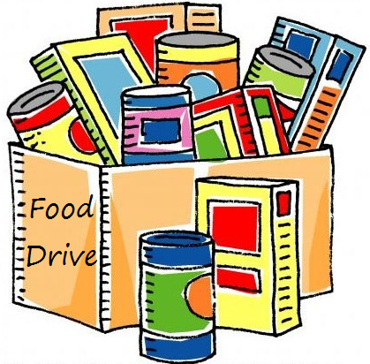
Can You Bring a Can for the Food Pantry?
The last Sunday of each month is Missions Sunday. Please bring a canned good or other non-perishable food on September 24th. Boxes will be available to collect them. All gifts will be taken to the Hawai‘i Foodbank.

Our current email addresses:
- pastor.nuuanucongregational@gmail.com
- nuuanucongregational@gmail.com
- Bookkeeper@NuuanuCC.onmicrosoft.com

