A Weekly Newsletter of Nu‘uanu Congregational Church
NCC News
August 6, 2023

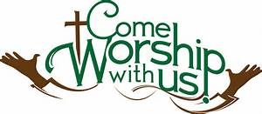
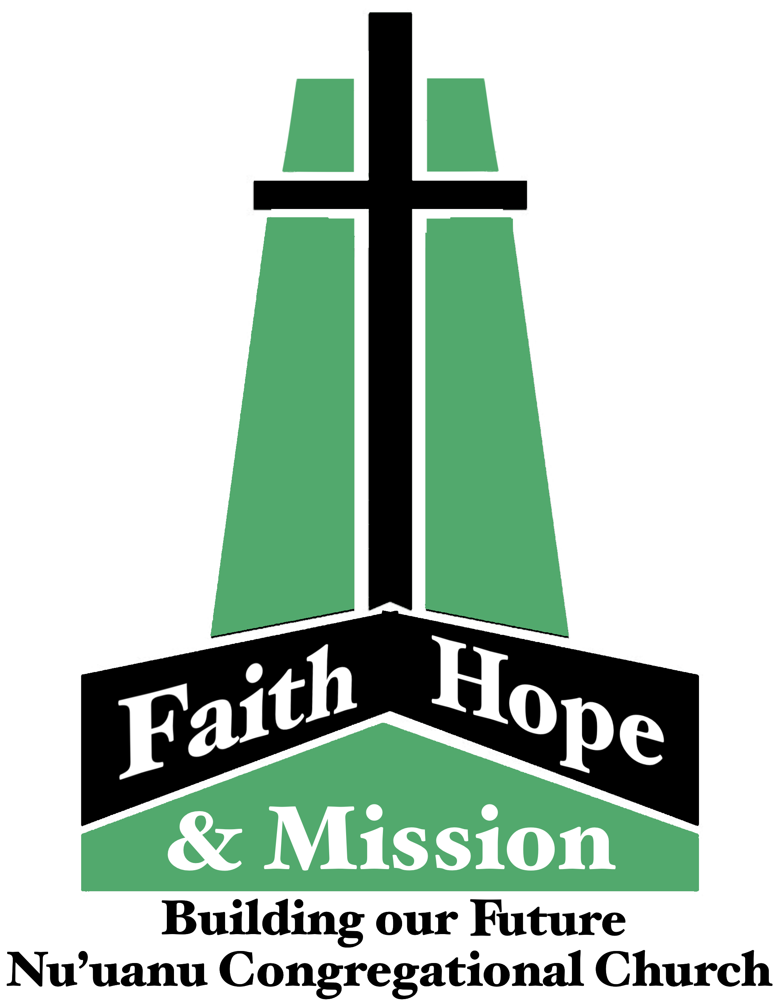
Capital Campaign Townhall Meetings
Last opportunity to attend a Capital Campaign meeting is August 13. Please sign up today.

School Supply Drive
Thanks to the amazing support from the congregation, our Sunday School kids were able to fill over fifty backpacks with a variety of school supplies. Members of the Missions Committee have delivered them to the following elementary schools: Kaahumanu. Kauluwela, Lincoln, & Palolo in time for the start of school on Tuesday. Backpacks were also provided to the two elementary school children currently residing in Kibo Kan. Your generosity is always so incredible & very much appreciated.

Community Church Hosts Women's Retreat

From UCC Conference Coconut Wireless 8/2/23
Community Church of Honolulu announces their 2023 Women's Retreat, "Beauty Out of Brokenness," on Saturday, September 30, from 8:00 a.m. to 2:00 p.m., at the O'ahu Country Club (150 Country Club Road, Honolulu). Register on the Community Church website cchonolulu.org (scroll down about half-way).

Spall Repair

Spall repair will begin on the Sanctuary, Monday, August 7, 2023. The repair will run through Thursday, August 31.

Golf to Support Mental Health Services

From UCC Conference Coconut Wireless 8/2/23
Attention golfers and mental health advocates! The Samaritan Counseling Center Hawai'i is holding its first annual Drive Fore Mental Health Golf Tournament on Friday, October 27, at Ewa Beach Golf Club on O'ahu. Sign up now to golf or donate to support this interfaith counseling center that ensures that mental health services are accessible to all, regardless of ability to pay. For more information and tickets, go to Samaritincounselingcenterhawaii.org. Proceeds will support the Client Assistance Fund, which subsidizes mental health counseling for people who are uninsured, underinsured, or have limited financial resources-no one is turned away for lack of funds.

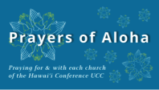
Week of August 6:
Henry O. / Hokuloa Chapel (Hawai'i Island)
Opihikao Cong'l Church (Hawai'i Island)
Week of August 13:
Hilo Coast UCC (Hawai'i Island)
Olowalu Lanakila Hawaiian Church (Maui)
Kauaha'ao Cong'l Church (Hawai'i Island)
Week of August 20:
Hilo Marshallese Ministry (Hawai'i Island)
Ola'a First Hawaiian Church (Hawai'i Island)
Week of August 27:
Hokuloa UCC (Hawai'i Island)
Ohana Niihau O Waimea Church (Kaua'i)
Kapa'a UCC (Kaua'i)

*You may donate through our church to our national relief efforts by writing a check to NCC with the specific relief effort written in the memo line.

2023 Altar Flower Donations
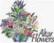
The 2023 Altar Flower Donations chart is filling up! Please put your name next to the date that you want either in person on Sunday, by emailing nuuanucongregational@gmail.com, or by calling the office at (808) 595-3935.
Please have Altar Flowers delivered on Fridays, between 8 am and 4 pm or Sunday mornings at 8:30 am. There will not be anyone working on Saturday’s until further notice.

Can You Bring a Can for the Food Pantry?
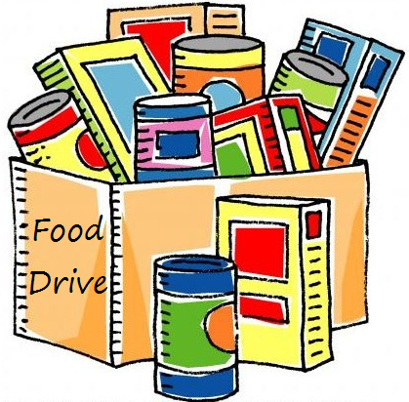
The last Sunday of each month is Missions Sunday. Please bring a canned good or other non-perishable food on August 27th. Boxes will be available to collect them. All gifts will be taken to the Hawai‘i Foodbank.

Our current email addresses:
- pastor.nuuanucongregational@gmail.com
- nuuanucongregational@gmail.com
- Bookkeeper@NuuanuCC.onmicrosoft.com

