A Weekly Newsletter of Nu‘uanu Congregational Church
NCC News
August 27, 2023

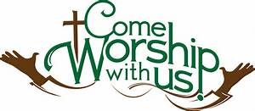

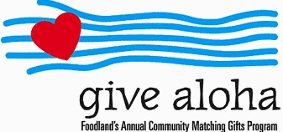
We will be participating in this years Give Aloha program again. Give Aloha will be running from September 1, 2023 through September 30, 2023 at all participating Foodland, Foodland Farms, and Sack-N-Saves.
Nu‘uanu Congregational Church’s organization number is 78424. There is a limit of up to $249.00 per Maika‘i Card number. Please make sure that you send us your receipt, either in the mail, with your donation, or email a picture of it to nuuanucongregational@gmail.com. The receipt must have your name, amount, store number, and time of your transaction so that we can credit the donation to the right person/family!

Paul Osumi’s “Today’s Thoughts”
Norman Osumi, author to “Today’s Thought-Rev Osumi: the Man and His Message” had a book signing at Green Day IX. Mr. Osumi donated his time and books to support Green Day! Thank you Norman Osumi! In addition, he has donated 50 books and available for purchase. The books can be purchased during the week from Mairi in the church office. The funds raised from the book sale will be used to support local missions, such as Transition House, Family Promise, Food Bank to name a few.

Donations Now Being Accepted

for Wildfires Disaster Relief
From UCC Coconut Wireless (8/9/23)
Churches and individuals may now make donations to the Hawai'i Disaster Relief Fund specifically for those people and areas devastated by the ongoing wildfires. Please note "Hawai‘i Wildfires Relief Fund" on the memo line of checks, or may donate to the Disaster relief at nuuanu.org. (scroll down about half way down the home page to where you see “Link for Donations/pledges”.

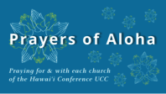
Week of August 27:
Hokuloa UCC (Hawai'i Island)
Ohana Niihau O Waimea Church (Kaua'i)
Kapa'a UCC (Kaua'i)

*You may donate through our church to our national relief efforts by writing a check to NCC with the specific relief effort written in the memo line.

2023 Altar Flower Donations
The 2023 Altar Flower Donations chart is filling up! Please put your name next to the date that you want either in person on Sunday, by emailing nuuanucongregational@gmail.com, or by calling the office at (808) 595-3935.
Please have Altar Flowers delivered on Fridays, between 8 am and 4 pm or Sunday mornings at 8:30 am. There will not be anyone working on Saturday’s until further notice.

Can You Bring a Can for the Food Pantry?
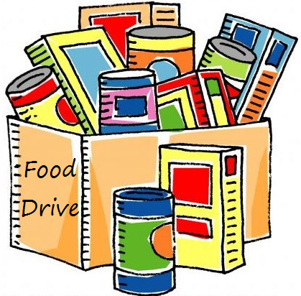
The last Sunday of each month is Missions Sunday. Please bring a canned good or other non-perishable food on August 27th. Boxes will be available to collect them. All gifts will be taken to the Hawai‘i Foodbank.

Our current email addresses:
- pastor.nuuanucongregational@gmail.com
- nuuanucongregational@gmail.com
- Bookkeeper@NuuanuCC.onmicrosoft.com

