A Weekly Newsletter of Nu‘uanu Congregational Church
NCC News
August 13, 2023

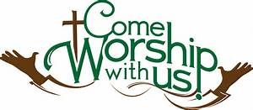

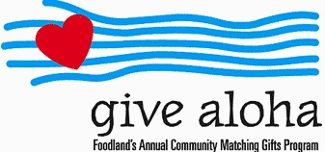
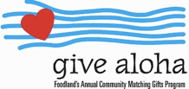
We will be participating in this years Give Aloha program again. Give Aloha will be running from September 1, 2022 through September 30, 2022 at all participating Foodland, Foodland Farms, and Sack-N-Saves.
Nu‘uanu Congregational Church’s organization number is 78424. There is a limit of up to $249.00 per Maika‘i Card number. Please make sure that you send us your receipt, either in the mail, with your donation, or email a picture of it to nuuanucongregational@gmail.com. The receipt must have your name, amount, store number, and time of your transaction so that we can credit the donation to the right person/family!
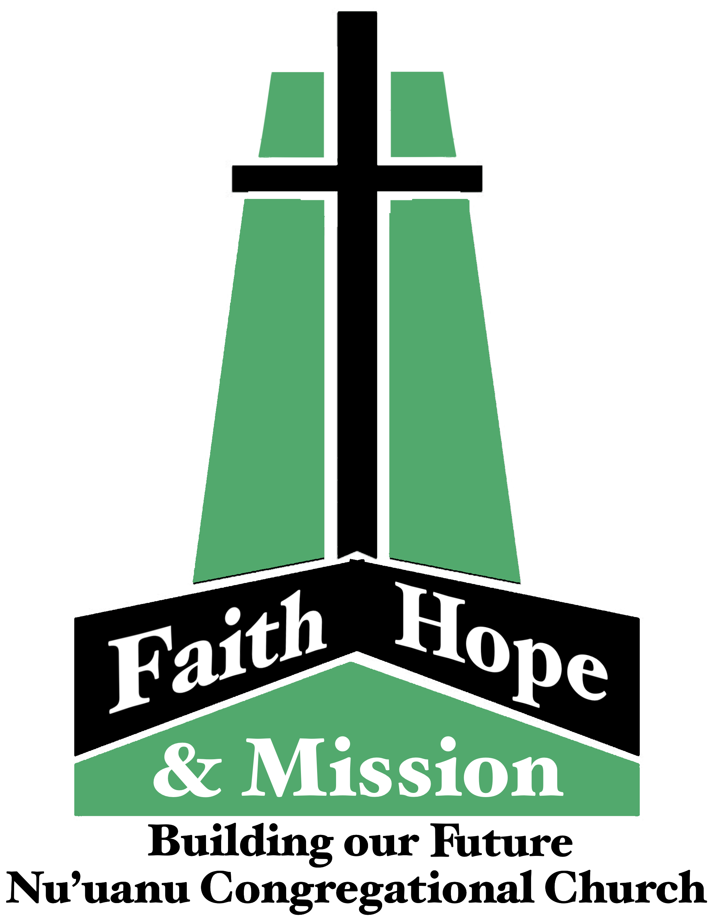
Capital Campaign Townhall Meetings
The 2nd and last Capital Campaign meeting is today, after church!

Don Ikeda’s Chutney, Lilikoi Jam, and Biscotti
We will be selling these after church for the next 2 weeks on Friendship Lanai.

Paul Osumi’s “Today’s Thoughts”
Norman Osumi, author to “Today’s Thought-Rev Osumi: the Man and His Message” had a book signing at Green Day IX. Mr. Osumi donated his time and books to support Green Day! Thank you Norman Osumi! In addition, he has donated 50 books and available for purchase. We will be selling these books for $10 on the friendship lanai, August 13 after worship. The books can also be purchased during the week from Mairi in the church office. The funds raised from the book sale will be used to support local missions, such as Transition House, Family Promise, Food Bank to name a few.

Green Day IX
Mahalo to Nuuanu Congregation Members, Family and Friends and to Troop 201. Green Day IX was a huge success due to the many hands who helped with the organizing, coordinating, setup, take down and many more duties and responsibilities. Thank you all for your support, time and muscles in making Green Day IX a day filled with fun and fellowship. Make your calendars for April 20, 2024, Green Day X! Mahalo Nui for your support to Green Day.

Maui Fires
From David Popham, UCC Conference Minister
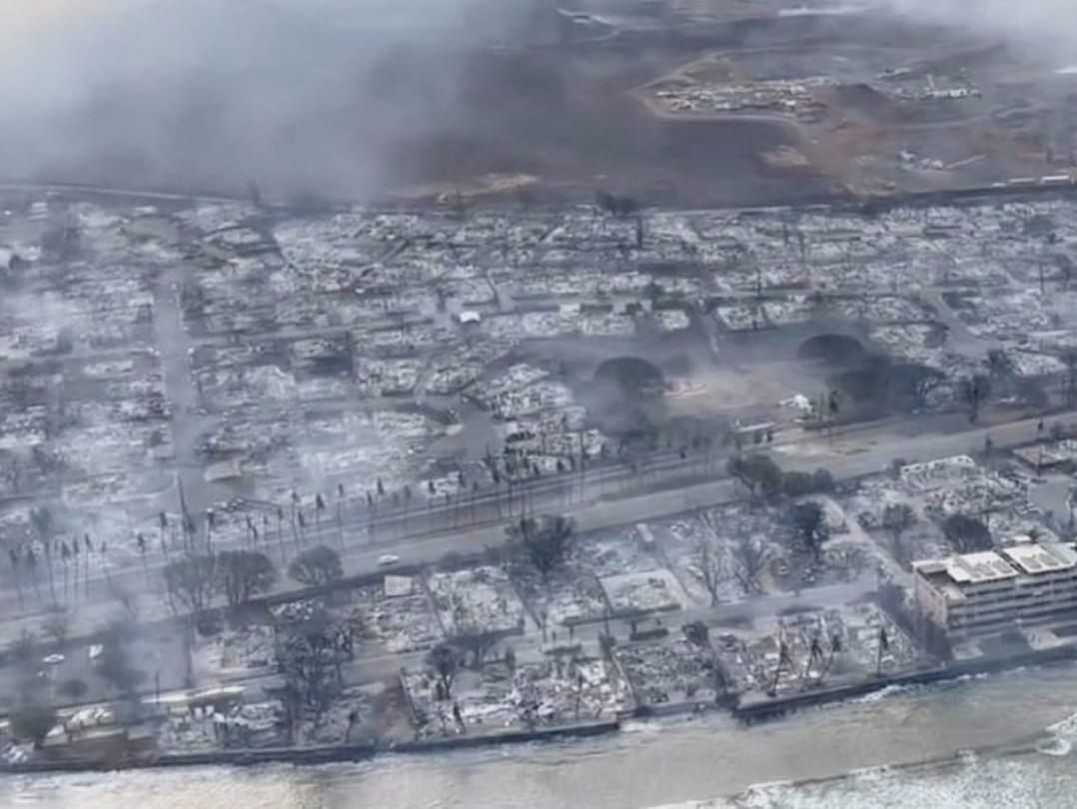
Adventures in Conference Ministry leads to solidarity in times of sorrow. Below is a picture of Lahaina following the fire. The death toll is now at 36. The 200 yr old congregation lost all buildings on its property. The Hawaii Conference Foundation lost an historic home for which it held the deed. Elsewhere on Maui two ministers evacuated, one was in a prepare-to-evacuate zone, one taking in a family of his church. Last night some of our Maui ministers gathered via Zoom. We talked through recovery response, how our souls were, and shared prayer. What a great privilege to work with these colleagues focused on helping the community even as they face their own uncertainties.

Donations Now Being Accepted

for Wildfires Disaster Relief
From UCC Coconut Wireless (8/9/23)
Churches and individuals may now make donations to the Hawai'i Disaster Relief Fund specifically for those people and areas devastated by the ongoing wildfires. Please note "Hawai‘i Wildfires Relief Fund" on the memo line of checks.

School Supply Drive
Thanks to the amazing support from the congregation, our Sunday School kids were able to fill over fifty backpacks with a variety of school supplies. Members of the Missions Committee have delivered them to the following elementary schools: Kaahumanu. Kauluwela, Lincoln, & Palolo in time for the start of school. Backpacks were also provided to the two elementary school children currently residing in Kibo Kan. Your generosity is always so incredible & very much appreciated.

Community Church Hosts Women's Retreat

From UCC Conference Coconut Wireless 8/2/23
Community Church of Honolulu announces their 2023 Women's Retreat, "Beauty Out of Brokenness," on Saturday, September 30, from 8:00 a.m. to 2:00 p.m., at the O'ahu Country Club (150 Country Club Road, Honolulu). Register on the Community Church website cchonolulu.org (scroll down about half-way).

Golf to Support Mental Health Services

From UCC Conference Coconut Wireless 8/2/23
Attention golfers and mental health advocates! The Samaritan Counseling Center Hawai'i is holding its first annual Drive Fore Mental Health Golf Tournament on Friday, October 27, at Ewa Beach Golf Club on O'ahu. Sign up now to golf or donate to support this interfaith counseling center that ensures that mental health services are accessible to all, regardless of ability to pay. For more information and tickets, go to Samaritincounselingcenterhawaii.org. Proceeds will support the Client Assistance Fund, which subsidizes mental health counseling for people who are uninsured, underinsured, or have limited financial resources-no one is turned away for lack of funds.

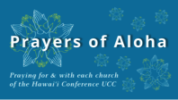
Week of August 13:
Hilo Coast UCC (Hawai'i Island)
Olowalu Lanakila Hawaiian Church (Maui)
Kauaha'ao Cong'l Church (Hawai'i Island)
Week of August 20:
Hilo Marshallese Ministry (Hawai'i Island)
Ola'a First Hawaiian Church (Hawai'i Island)
Week of August 27:
Hokuloa UCC (Hawai'i Island)
Ohana Niihau O Waimea Church (Kaua'i)
Kapa'a UCC (Kaua'i)

*You may donate through our church to our national relief efforts by writing a check to NCC with the specific relief effort written in the memo line.

2023 Altar Flower Donations
The 2023 Altar Flower Donations chart is filling up! Please put your name next to the date that you want either in person on Sunday, by emailing nuuanucongregational@gmail.com, or by calling the office at (808) 595-3935.
Please have Altar Flowers delivered on Fridays, between 8 am and 4 pm or Sunday mornings at 8:30 am. There will not be anyone working on Saturday’s until further notice.

Can You Bring a Can for the Food Pantry?
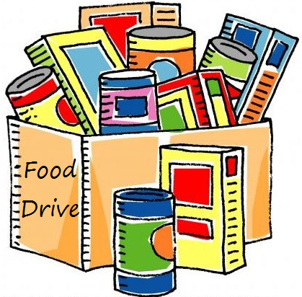
The last Sunday of each month is Missions Sunday. Please bring a canned good or other non-perishable food on August 27th. Boxes will be available to collect them. All gifts will be taken to the Hawai‘i Foodbank.

Our current email addresses:
- pastor.nuuanucongregational@gmail.com
- nuuanucongregational@gmail.com
- Bookkeeper@NuuanuCC.onmicrosoft.com

