A Weekly Newsletter of Nu‘uanu Congregational Church
NCC News
July 16, 2023

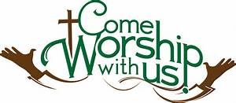
Capital Campaign Townhall Meetings
If you have not signed-up to attend a Capital Campaign meeting, Please do so today!
- July 23
- August 13

Christmas in July
From the Hawaii Conference website
The Christmas Fund for the Veterans of the Cross and the Emergency Fund is a Special Mission Offering that congregations have been supporting for over 100 years. The offering is administered through the United Church Board for Ministerial Assistance, the charitable arm of the Pension Boards. Funds provide direct financial support to those who serve the church and are facing financial difficulties. Active and retired clergy, lay employees, and their surviving spouses may be eligible for the Supplementation of Small Annuities, Supplementation of Health Premiums, Emergency Grants, and/or Christmas “Thank You” Gift Checks.
This offering will take place on Sunday, July 30, 2023. Please write “Christmas in July” in the memo line.

Family Promise
We currently have three families living in our Sunday School rooms. Five parents and four children ranging in age from one to ten years of age have a safe place to call home while they are preparing, with the help of Family Promise staff, to move to more permanent housing.
Sign ups for Family Promise meals are going well. The third quarter is completed. Thanks to the following for providing meals over the past three months: Velma Akinaka, Josie Ing, Cherie Nakamura, Mary Ann & Joy Saito, Sybil Seto, Lori Takeyama-Goshi, Jane Uyechi, Joyce Uyehara, Paula Yamamoto, & Ann Yoneshige.

School Supply Drive
Wow, but time gets away from us! The Missions Committee is again sponsoring a school supply drive during the month of July. We will collect donations through July 30th to be delivered to selected public schools in time for the start of the new school year on August 8th. Both Long's and Fisher keep lists of school supplies requested by local schools. Backpacks are especially desired.

GEARING UP FOR GREEN DAY IX at NCC
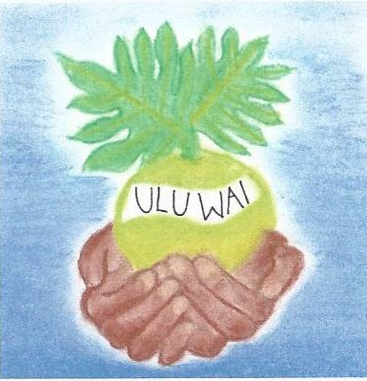
The Missions Committee’s GREEN DAY IX is a “go”! This event will take place on August 5, 2023, from 9:00 a.m. – 1:00 p.m. All proceeds will go to Ulu Wai’s Missions Ministry, which takes care of God's creation through our overflowing love and care for the hungry and needy, for the earth, for our community, and for the next generation.
There will be eco friendly waterless car washes ($10/carwash, no vacuuming). Drop off your of HI-5 containers (makai driveway) and then come into the gym to start rummaging for some super buys such as collectibles (Pennibear, coke memorabilia etc.) or gently used small appliances, dishes, a portable A/C, or that grill that you always wanted. There will be many tech items to check out such as laptops, monitors, printers, keyboards, VCR/DVD players, MP3 players, cell phones, digital /video cameras, batteries (only auto, boat, lead acid), laser disk player etc. Water and soil plants, vermiculture items (red wrigglers, “poi dog” worms, worm castings) will be available to take care of the Earth. After all that shopping please your palette with some homemade jams, mango chutney and biscotti.
Be “cool” and join us in Nu’uanu. There will be something for everyone so come and find a treasure while doing your part in recycling items to sustain our community and our environment at Green Day IX.

We invite you faithful, resourceful members and friends to collect rummage sale items for Green Day. An In Kind Donation form is available so you can list your generous donations for tax purposes. See Velma for the forms. Bring your donations to church on the designated dates below:
- On two Sundays, July 23rd and July 30th, bring 1-5 gallon size containers and leave them under the benches near the breezeway next to the office.
- On July 23rd and July 30th – Aug. 4th, place your donated items in a box/bag labeled “Green Day IX” in the mauka-Waikiki corner of Kosasa Hall closest to Mr. Lee’s cottage.
  - Acceptable Rummage Sale items: new to gently used kitchen and household items such as utensils, pots ‘n pans, books, toys, small tools, craft supplies, small working appliances, small workable tech and electronic devices, personal use items etc. but NO CLOTHING OR SHOES.
  - Clean gently used shopping bags and boxes for our customers to take home their goodies.
  - Buy your waterless car wash ticket ($10) from Becky or Wayne Kobayashi.
  - Alert your family and friends to save August 5th for a trip to NCC’s Green Day IX!!

- On Friday, August 4th:
  - Place potted plants, air plants, Water garden plants and grasses outside in the back of Kosasa Hall to the left of the Palm trees and in the shade.
  - Bring any last minute donations to Kosasa Hall
  - Put your clean, dry HI-5 containers in out of the way area near the recycled storage cage.
  - Get out your personal calendar and write: “GREEN DAY IX, August 5, 2023, 9-1”. See you there!

Can You Bring a Can for the Food Pantry?
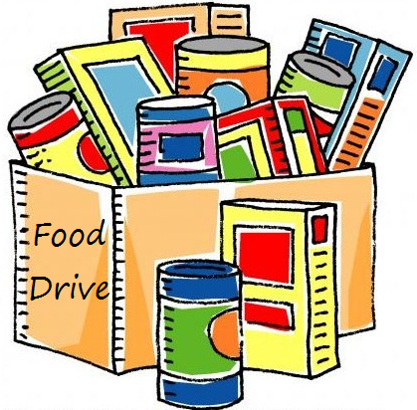
The last Sunday of each month is Missions Sunday. Please bring a canned good or other non-perishable food on July 30th. Boxes will be available to collect them. All gifts will be taken to the Hawai‘i Foodbank.

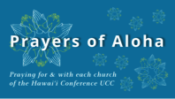
Week of July 16:
Hau'oli Kamana'o Church (Hawai'i Island)
Pearl City Community Church (O'ahu)
Kaulanapueo Cong'l Church (Maui)
Week of July 23:
Hawai'i Kai UCC (O'ahu)
Palapala Ho'omau Cong'l Church (Maui)
Week of July 30:
Central Christian Church (Hawai'i Island)
Paia Hawaiian Protestant Church (Maui)
Kaua'i Marshallese Ministry (Kaua'i)

*You may donate through our church to our national relief efforts by writing a check to NCC with the specific relief effort written in the memo line.

2023 Altar Flower Donations
The 2023 Altar Flower Donations chart is filling up! Please put your name next to the date that you want either in person on Sunday, by emailing nuuanucongregational@gmail.com, or by calling the office at (808) 595-3935.
Please have Altar Flowers delivered on Fridays, between 8 am and 4 pm or Sunday mornings at 8:30 am. There will not be anyone working on Saturday’s until further notice.

Our current email addresses:
- pastor.nuuanucongregational@gmail.com
- nuuanucongregational@gmail.com
- Bookkeeper@NuuanuCC.onmicrosoft.com

