A Weekly Newsletter of Nu‘uanu Congregational Church
NCC News
June 25, 2023

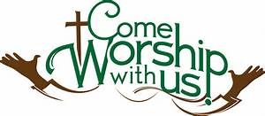

Another Scam Alert!

from 6/7/23 Coconut Wireless
Once again scammers are seeking to confuse our church members with false information appearing to come from the Conference Minister via email. Another similar scam email is circulating using Andrew Bunn's name—please be aware and akamai!
Always keep in mind that if Rev. Popham or any staff person should ever be in a position of needing emergency help, policies are in place within the conference office that guide such requests. Those polices prohibit all staff members from approaching our members for personal monetary assistance.

Conversation & Tea with Pastor Jeannie
Tea Time will be suspended for June 29. Please come back on July 6!

Can You Bring a Can for the Food Pantry?
The last Sunday of each month is Missions Sunday. Please bring a canned good or other non-perishable food on June 25th. Boxes will be available to collect them. All gifts will be taken to the Hawai‘i Foodbank.

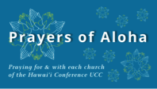
Week of June 25:
Hanapepe Hawaiian Cong'l Church (Kaua'i)
Puka'ana Cong'l Church (Hawai'i Island)

*You may donate through our church to our national relief efforts by writing a check to NCC with the specific relief effort written in the memo line.

2023 Altar Flower Donations
The 2023 Altar Flower Donations chart is filling up! Please put your name next to the date that you want either in person on Sunday, by emailing nuuanucongregational@gmail.com, or by calling the office at (808) 595-3935.
Please have Altar Flowers delivered on Fridays, between 8 am and 4 pm or Sunday mornings at 8:30 am. There will not be anyone working on Saturday’s until further notice.

Our current email addresses:
- pastor.nuuanucongregational@gmail.com
- nuuanucongregational@gmail.com
- Bookkeeper@NuuanuCC.onmicrosoft.com

