A Weekly Newsletter of Nu‘uanu Congregational Church
NCC News
July 2, 2023

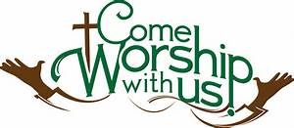
Family Promise
We currently have three families living in our Sunday School rooms. Five parents and four children ranging in age from one to ten years of age have a safe place to call home while they are preparing, with the help of Family Promise staff, to move to more permanent housing.
Sign ups for Family Promise meals are going well. The third quarter is completed. Thanks to the following for providing meals over the past three months: Velma Akinaka, Josie Ing, Cherie Nakamura, Mary Ann & Joy Saito, Sybil Seto, Lori Takeyama-Goshi, Jane Uyechi, Joyce Uyehara, Paula Yamamoto, & Ann Yoneshige.

School Supply Drive
Wow, but time gets away from us! The Missions Committee is again sponsoring a school supply drive during the month of July. We will collect donations through July 30th to be delivered to selected public schools in time for the start of the new school year on August 8th. Both Long's and Fisher keep lists of school supplies requested by local schools. Backpacks are especially desired.

Conversation & Tea with Pastor Jeannie
Please come back on July 6!

Can You Bring a Can for the Food Pantry?
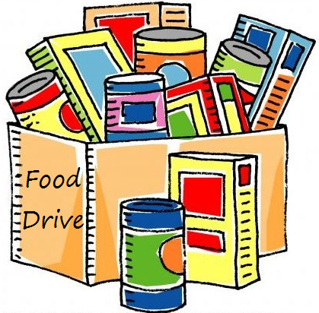
The last Sunday of each month is Missions Sunday. Please bring a canned good or other non-perishable food on July 30th. Boxes will be available to collect them. All gifts will be taken to the Hawai‘i Foodbank.

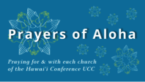
July 2023
Hanapepe UCC (Kaua‘i)
Pookela Church (Maui)
Kaumakapili Church (O‘ahu)
Hau‘ula Cong'l Church (O‘ahu)
Pohakupuka Cong'l Church (Hawai‘i Island)
Hauoli Kamana‘o Church (Hawai‘i Island)
Pearl City Community Church (O‘ahu)
Kaulanapueo Cong'l Church (Maui)
Hawai‘i Kai UCC (O‘ahu)
Palapala Hoomau Cong'l Church (Maui)
Central Christian Church (Hawai‘i Island)
Paia Hawaiian Protestant Church (Maui)
Kaua‘i Marshallese Ministry (Kaua‘i)

*You may donate through our church to our national relief efforts by writing a check to NCC with the specific relief effort written in the memo line.

2023 Altar Flower Donations
The 2023 Altar Flower Donations chart is filling up! Please put your name next to the date that you want either in person on Sunday, by emailing nuuanucongregational@gmail.com, or by calling the office at (808) 595-3935.
Please have Altar Flowers delivered on Fridays, between 8 am and 4 pm or Sunday mornings at 8:30 am. There will not be anyone working on Saturday’s until further notice.

Our current email addresses:
- pastor.nuuanucongregational@gmail.com
- nuuanucongregational@gmail.com
- Bookkeeper@NuuanuCC.onmicrosoft.com

