A Weekly Newsletter of Nu‘uanu Congregational Church
NCC News
April 16, 2023

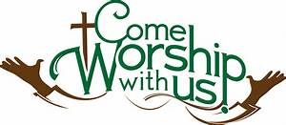
Make Today Count
By Mairi Manley
Make Today Count, which is a cancer support group, used to meet at Nu‘uanu Congregational Church. They were generous enough to donate to NCC ten wigs that anyone or knows anyone who is need of a wig may have.
Please take one after church or call the office to get them.

Family Promise Meals
Judy Keith is taking volunteers for Family Promise meals for the second quarter. Our commitment is for the 2nd & 4th Sundays of each month. We have a good number of people who have been doing this semi-regularly, but it is always good to enlarge the core. If you are interested in more information, contact Judy. Ph 808-783-4028, email judykeith808@gmail.com

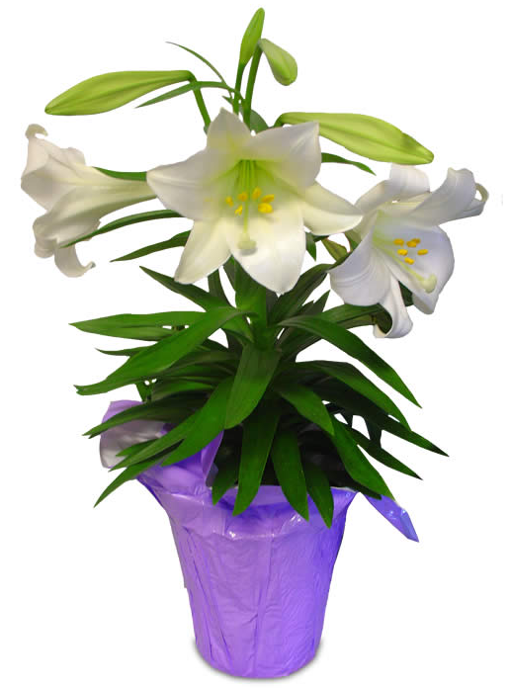
NCC Scholarship
We are taking applications for our annual scholarships. The scholarship application is on our website and deadline is May 31, 2023.
Your Application with the Personal Essay, (2) Scholarship Reference Forms, and a certified transcript from your current school must be postmarked by Saturday, May 27, 2023 or dropped off to the office by 4 p.m. on May 31, 2023.

GEARING UP FOR GREEN DAY IX at NCC –
August 5, 2023 - 9:00 a.m. - 1:00 p.m.
The Missions Committee just got word that its GREEN DAY IX is “set to go”! It will take place on August 5, 2023, from 9:00 a.m. – 1:00 p.m. All proceeds will go to Ulu Wai’s Missions Ministry, which supports God’s love and care for the hungry and needy, for the earth, for our community, and for the next generation. Start saving your gently used, give away kitchen and household items for Green Day IX. Please.... NO CLOTHING OR SHOES.

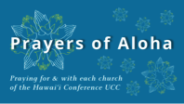
Week of April 16:
Cup of Freedom UCC (O'ahu)
Wahiawa UCC (O'ahu)
Week of April 23:
Epenesa Fou CC Samoan Church, HI (O'ahu)
United Community Church (Hawai'i Island)
Kokokahi UCC (O'ahu)
Week of April 30
Ewa Community Church (O'ahu)
United Church of Christ - Judd Street (O'ahu)

Survivors of Natural Disasters, especially:
Turkey (Earthquake)
Syria (Earthquake)
South Sudan (Famine)

*You may donate through our church to our national relief efforts by writing a check to NCC with the specific relief effort written in the memo line.
Can You Bring a Can for the Food Pantry?
The last Sunday of each month is Missions Sunday. Please bring a canned good or other non-perishable food on that day. Boxes will be available to collect them. All gifts will be taken to the Hawai‘i Foodbank.

2023 Altar Flower Donations
The 2023 Altar Flower Donations chart is filling up! Please put your name next to the date that you want either in person on Sunday, by emailing nuuanucongregational@gmail.com, or by calling the office at (808) 595-3935.
Please have Altar Flowers delivered on Fridays, between 8 am and 4 pm or Sunday mornings at 8:30 am. There will not be anyone working on Saturday’s until further notice.

From Lori Yamashiro
We’ve been informed that individuals from our sister churches were recently scammed through email and have consequently lost financial resources.
It has become common for scammers to pose as pastors in attempts to take advantage of unsuspecting, generous church members by contacting them through email or even text message, asking for a favor.

- Read: New phishing scam uses church pastors' names as bait

These email scams are not new but we want to remind you again so you can avoid being scammed.

A few signs that an email is likely a scam:
- Sender's email address is wrong (though correct name appears)
- Sender claims to be busy/in a meeting, tells you not to call them
- Sender asks for help purchasing a gift card
- Sender asks for personal information
- Sender makes request with little background or reason

If you receive any vague message, especially something out of the ordinary that appears to be from our pastor or church office, check the sender's email address. If it does NOT match our pastor’s email addresses, it is likely a scam, no matter how convincing it seems. Delete the message and don't respond!

If you are ever in doubt and questioning the legitimacy of a message or request that comes through email or text from someone claiming to be from the church, call the church office: 808-595-3935. Do not act on any strange email messages.

Our current email addresses:
- pastor.nuuanucongregational@gmail.com
- nuuanucongregational@gmail.com
- Bookkeeper@NuuanuCC.onmicrosoft.com

