A Weekly Newsletter of Nu‘uanu Congregational Church
NCC News
March 5, 2023

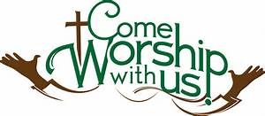

From Our Moderator
Dear Members and Friends of NCC,
Thank you to all those who participated in our Annual Meeting. We will be moving forward with the initiatives set forth in our Strategic Plan and also the Capital Campaign as approved by the NCC members last year. We would like to invite you to the upcoming events so we can have further discussion on the Capital Campaign, its purpose and process.
Town Hall Meeting is scheduled for after worship today, to discuss the Capital Campaign plan and the process we’ll be following. After this meeting, the congregation may sign up for small group meetings that will be held on Sunday, March 12, 2023, following worship for more discussion.
Our goal for this event is to provide our NCC Ohana opportunities to ask questions and understand why the need for the Capital Campaign so that we may move forward with confidence and faith.

Mahalo, Laurie Hamano, Moderator

Witness at the Cross—Lenten book study
Starting: March 1st, 10am on the lanai; 6:30pm via Zoom.
From Pastor Jeannie
If you would like to order the book, it’s $18.84. Please call the church office and let us know if we need to order more.

One Great Hour of Sharing
Our gifts to One Great Hour of Sharing (OGHS) will be received on March 19 during worship. OGHS is an annual offering in which we participate every year in March. The gifts you give to OGHS are combined with gifts from other UCC churches to make a greater impact in the areas of justice advocacy, sustainable development, refugee and asylum issues, migration, natural disasters, and assisting those most in need and vulnerable.
Throughout the country and the year, OGHS gifts help families and communities in desperate need of assistance. Strengthened by the power of God’s Spirit and your collective generosity, the United Church of Christ continues to work with partners to care for others, and not give up as together we build a just world for all.
OGHS offering envelopes were in the March issue of The Caller. Please mail them into the church office or bring them to Service on Sunday, March 19th.

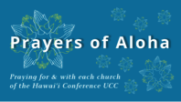
Week of March 5:
Church of the New Testament (O'ahu)
Waikoloa Marshallese Ministry (Hawai'i Island)
Kosrae Honolulu Cong'l Church (O'ahu)
Week of March 12:
Church of the Pacific (Kaua'i)
Waihee Protestant Church (Maui)
Week of March 19:
Chuukese Cong'l Church of Christ (O'ahu)
Waianae Samoan Church (O'ahu)
Koolau Hui'ia Protestant Church (Kaua'i)
Week of March 26:
Community Church of Honolulu (O'ahu)
Waialua UCC (O'ahu)

Survivors of Natural Disasters, especially:
Turkey (Earthquake)
Syria (Earthquake)
South Sudan (Famine)

*You may donate through our church to our national relief efforts by writing a check to NCC with the specific relief effort written in the memo line.

2023 Altar Flower Donations
The chart for the 2023 Altar Flower Donations is ready to fill up! Please fill out the date that you want, either in person on Sunday, by email at nuuanucongregational@gmail.com, or by calling the office at (808) 595-3935.
Please have Altar Flowers delivered on Fridays, between 8 am and 4 pm or Sunday mornings at 8:30 am. There will not be anyone working on Saturday’s until further notice.

Can You Bring A Can - For The Food Pantry?
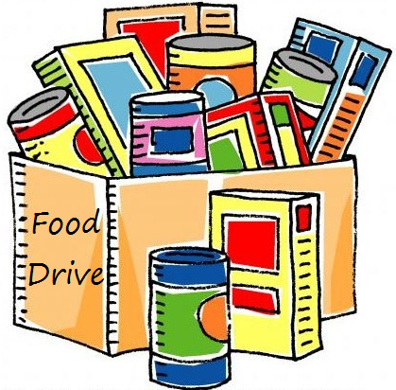
A guest speaker, Ann Leake, from Kaumakapili Church will tell us about their food pantry ministry on March 12. This is one of the organizations that Nuuanu supports through the Missions Committee. Food collected in February and March will be donated to this ministry.
Kitchen Towel Donations
From Sybil Seto
NCC has very few kitchen towels for wiping dishes in both upper and lower kitchens. If anyone has any, Please drop them off to the office or bring them to service with you.

Email Addresses
Pastor email: pastor.nuuanucongregational@gmail.com
Office email: nuuanucongregational@gmail.com
Bookkeeper email bookkeeper@NuuanuCC.onmicrosoft.com

