A Weekly Newsletter of Nu‘uanu Congregational Church
NCC News
March 19, 2023

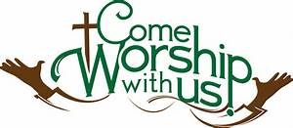

One Great Hour of Sharing
Our gifts to One Great Hour of Sharing (OGHS) will be received today, March 19 during worship. OGHS is an annual offering in which we participate every year in March. The gifts you give to OGHS are combined with gifts from other UCC churches to make a greater impact in the areas of justice advocacy, sustainable development, refugee and asylum issues, migration, natural disasters, and assisting those most in need and vulnerable.
Throughout the country and the year, OGHS gifts help families and communities in desperate need of assistance. Strengthened by the power of God’s Spirit and your collective generosity, the United Church of Christ continues to work with partners to care for others, and not give up as together we build a just world for all.

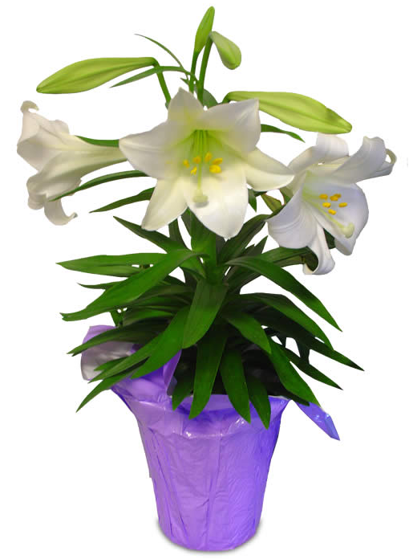
Easter Lily Sale
We will be having our Presale of Easter Lily Plants at $12.00 per plant. There is a limited supply and there is a sign up sheet available!
NCC Scholarship
We will be starting to take applications for our annual scholarships. The deadline is May 31, 2023.
Your Application with the Personal Essay, (2) Scholarship Reference Forms, and a certified transcript from your current school must be postmarked by Saturday, May 27, 2023 or dropped off to the office by 4 p.m. on May 31, 2023.

Recycling
by Wayne Kobayashi
Starting April, the scouts of Troop 201 will be doing the recycling that Hui Malama was doing. This is a service project for the troop. Proceeds will continue to go towards the church. Hui Malama had been doing the recycling over the past 20 years, but as its members age, it was time to get younger people involved. Please continue to bring all HI-5 recyclables to church.

Hui Malama Work Day Change
by Wayne Kobayashi
The Hui Malama group will be changing its work day from the first Wednesday of each month to the last Friday of each month. The group gathers at 9 am for a short devotion, then do different tasks, like weeding, yard work, light maintenance and repair, etc. This ends before noon. Anyone interested in helping out are welcomed. You may contact any of the group members (Wayne Kobayashi, Micki Sasaki, Joyce Uyehara, Ruth Gushiken, Lani Hirohata, Claire Nakatsuka, Sybil Seto or Russell Ishida).

GEARING UP FOR GREEN DAY IX at NCC –
August 5, 2023 - 9:00 a.m. - 1:00 p.m.
The Missions Committee just got word that its GREEN DAY IX is “set to go”! It will take place on August 5, 2023, from 9:00 a.m. – 1:00 p.m. All proceeds will go to Ulu Wai’s Missions Ministry, which supports God's love and care for the hungry and needy, for the earth, for our community, and for the next generation. Start saving your gently used, give away kitchen and household items for Green Day IX. Please.... NO CLOTHING OR SHOES.

Missions Committee

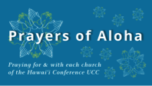
Week of March 19:
Chuukese Cong'l Church of Christ (O'ahu)
Waianae Samoan Church (O'ahu)
Koolau Hui'ia Protestant Church (Kaua'i)
Week of March 26:
Community Church of Honolulu (O'ahu)
Waialua UCC (O'ahu)

Survivors of Natural Disasters, especially:
Turkey (Earthquake)
Syria (Earthquake)
South Sudan (Famine)

*You may donate through our church to our national relief efforts by writing a check to NCC with the specific relief effort written in the memo line.

2023 Altar Flower Donations
The chart for the 2023 Altar Flower Donations is ready to fill up! Please fill out the date that you want, either in person on Sunday, by email at nuuanucongregational@gmail.com, or by calling the office at (808) 595-3935.
Please have Altar Flowers delivered on Fridays, between 8 am and 4 pm or Sunday mornings at 8:30 am. There will not be anyone working on Saturday’s until further notice.

Can You Bring A Can - For The Food Pantry?
Kaumakapili Church’s food pantry is one of the organizations that Nuuanu supports through the Missions Committee. Food collected in February and March will be donated to this ministry.

Kitchen Towel Donations
From Sybil Seto
Thanks to generous donors, both upper and lower kitchens are fully stocked with towels. Mahalo for the donations!

Email Addresses
Pastor email: pastor.nuuanucongregational@gmail.com
Office email: nuuanucongregational@gmail.com
Bookkeeper email Bookkeeper@NuuanuCC.onmicrosoft.com

