A Weekly Newsletter of Nu‘uanu Congregational Church
NCC News
February 5, 2023

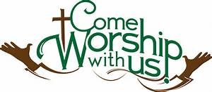
Palm Crosses
By Lori Takeyama-Goshi
Please bring your palm crosses from last year to church on Sunday, February 19th. We will be burning the crosses after service, and Becky Kanenaka will prepare the ashes for the Ash Wednesday Service on February 22nd. If you forget, or can’t find your old cross, we have extra crosses from last year.

Services for Ash Wednesday
February 22 – Noon at NCC
and 6:00 PM at United Church of Christ Judd Street

This year Ash Wednesday falls on February 22, and we will have two opportunities to worship and observe the day.
The first service will begin at 12-noon in our church Sanctuary. We will have a brief time of worship followed by the Imposition of Ashes.
The second service will be held at our sister church, United Church of Christ, located at 467 Judd Street. The service will be held in the Sanctuary. Worship begins at 6:00PM also followed by Imposition of Ashes.

2022 Year-End Donation Statements
Your donation statements have been mailed out. If you haven’t received one, please call Mairi at (808) 595-3935 or email her at nuuanucongregational@gmail.com.
YMCA Nu‘uanu Pali Preschool
The YMCA Pali Nu‘uanu preschool is now accepting applications. To get information about the preschool, please visit https://www.ymcahonolulu.org.

Family Promise Meals
The meals for the first quarter of 2023 have all been assigned. If you are interested in cooking, please contact Judy Keith. Big mahalos to everyone who has signed up for meals!

2023 Altar Flower Donations
The chart for the 2023 Altar Flower Donations is ready to fill up! Please fill out the date that you want, either in person on Sunday, by email at nuuanucongregational@gmail.com, or by calling the office at (808) 595-3935.
Please have Altar Flowers delivered on Fridays, between 8 am and 4 pm or Sunday mornings at 8:30 am. There will not be anyone working on Saturday’s until further notice.

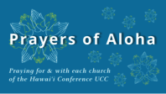
Week of February 5:
Helani Congregational Church (Hawai'i)
Waiola Church (Maui)
Lāna'i Union Church (Lāna'i)
Week of February 12:
Central Union Church (O'ahu)
Waiokeola Congregational Church (O'ahu)
Week of February 19:
Church of the Crossroads (O'ahu)
Waimea UCC (Kaua'i)
Lahuiokalani Ka'anapali Congregational Church (Maui)
Week of February 26:
Church of the Holy Cross (Hawai'i)
Wailuku Union Church (Maui)

Can you bring a can?
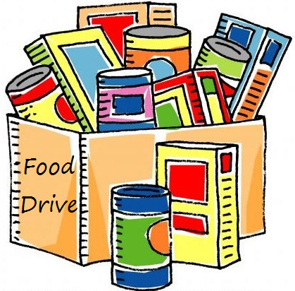
The last Sunday of each month is Missions Sunday. Please bring a canned good or other non-perishable food on that day. Boxes will be available to collect them. All gifts will be taken to the Hawai‘i Foodbank.

New Email Addresses
by Mairi Manley
Pastor email: pastor.nuuanucongregational@gmail.com
Office email: nuuanucongregational@gmail.com
Bookkeeper email bookkeeper@NuuanuCC.onmicrosoft.com

