**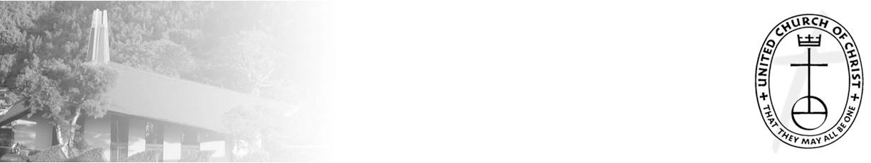***A Weekly Newsletter of Nu‘uanu Congregational Church*

***NCC News***

**February 12, 2023**

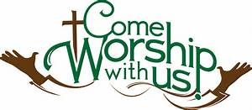

**Palm Crosses**

*By Lori Takeyama-Goshi*

Please bring your palm crosses from last year to church on Sunday, February 19th.  We will be burning the crosses after service, and Becky Kanenaka will prepare the ashes for the Ash Wednesday Service on February 22nd.  If you forget, or can’t find your old cross, we have extra crosses from last year.

**Nichigobu Support Group**

*By Arthur Goto*

The Nichigobu Support Group (NSG) will be having a meeting on Sunday February 19, 2023 in the former church library immediately following the worship service. Contact Arthur Goto tp. 808-526-2226 for further information.

**UCC Issues Special Appeal for Turkey, Syria**

*From 2/8/23 UCC Coconut Wireless*

A magnitude 7.8 earthquake has struck the area around the border of Turkey and Syria, killing thousands of people and injuring countless more. The United Church of Christ (UCC) has been in contact with partners in the affected region and is assessing the most critical needs and ways in which the UCC can respond.   
     *The UCC has issued an appeal to assist those affected by the devastation in the region and others. If you are willing to help, please write a check to Nu‘uanu Congregational Church and write Turkey & Syria Earthquake relief in the memo line!

**Services for Ash Wednesday**

February 22 – Noon at NCC

and 6:00 PM at United Church of Christ Judd Street

This year Ash Wednesday falls on February 22, and we will have two opportunities to worship and observe the day.

The first service will begin at 12-noon in our church Sanctuary. We will have a brief time of worship followed by the Imposition of Ashes.

The second service will be held at our sister church, United Church of Christ Judd Street. We look forward to joining together for our Ash Wednesday Service on February 22nd at United Church of Christ-Judd Street (467 N. Judd Street). Pupus will be offered as a time of fellowship beginning at 5 PM in our courtyard. The service will be from 5:30-6 PM. Masks are required in the sanctuary and the mauka side is reserved for those who desire to maintain social distance. If you are unable to attend, please know that you can join us online for this worship service by clicking on the following link: <https://www.youtube.com/channel/UC7pHg4hsqJ-KwamgwbL6RmA>

**2022 Year-End Donation Statements**

Your donation statements have been mailed out. If you haven’t received one, please call Mairi at (808) 595-3935 or email her at [nuuanucongregational@gmail.com](mailto:nuuanucongregational@gmail.com).

**2023 Altar Flower Donations**

 The chart for the 2023 Altar Flower Donations is ready to fill up! Please fill out the date that you want, either in person on Sunday, by email at [nuuanucongregational@gmail.com](mailto:nuuanucongregational@gmail.com), or by calling the office at (808) 595-3935.

*Please have Altar Flowers delivered on Fridays, between 8 am and 4 pm or Sunday mornings at 8:30 am. There will not be anyone working on Saturday’s until further notice.*

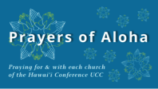

**Week of February 12**:  
Central Union Church (O'ahu)  
Waiokeola Congregational Church (O'ahu)

**Week of February 19**:  
Church of the Crossroads (O'ahu)  
Waimea UCC (Kaua'i)  
Lahuiokalani Ka'anapali Congregational Church (Maui)  
  
**Week of February 26**:  
Church of the Holy Cross (Hawai'i)  
Wailuku Union Church (Maui)

Survivors of Natural Disasters, especially:

Turkey (Earthquake)

Syria (Earthquake)

South Sudan (Famine)

*You may donate through our church to our national relief efforts by writing a check to NCC with the specific relief effort written in the memo line.

**Can you bring a can?**

The last Sunday of each month is Missions Sunday. Please bring a canned good or other non-perishable food on that day. Boxes will be available to collect them. All gifts will be taken to the Hawai‘i Foodbank.

**New Email Addresses**

*by Mairi Manley*

*Pastor email:* [pastor.nuuanucongregational@gmail.com](mailto:pastor.nuuanucongregational@gmail.com)

*Office email:* [nuuanucongregational@gmail.com](mailto:nuuanucongregational@gmail.com)

*Bookkeeper email* [bookkeeper@NuuanuCC.onmicrosoft.com](mailto:bookkeeper@NuuanuCC.onmicrosft.com)