A Weekly Newsletter of Nu‘uanu Congregational Church
NCC News
December 24, 2023

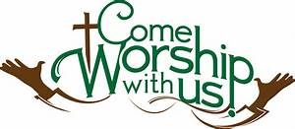
For Today’s Morning Service:
- Please note that there are new words for the Doxology today. The melody, however, is the same.
- Today, we are glad to reprise the video Christmas pageant we made a few years ago. My, how people have grown!

Kadomatsu for Sale
We have 10 large ($40.00) and 2 small ($30.00) Kadomatsu for sale in the office. Please see Mairi if you are interested in purchasing any or know someone who would like to!

Documenting Your Wishes
Save the dates! The Diaconate is sponsoring, in partnership with Kokua Mau, two sessions that can help you consider, and communicate with your loved ones, about your wishes for end of life care. No one really likes to think about this, and it can be difficult to talk about. But there is a lot that can be done to make it easier. The sessions will be on February 11th & 25th. Because it is so important that your loved ones understand your wishes we strongly encourage having your adult children participate in person, or on Zoom.
2023 Reimbursements
Your reimbursement for materials or services purchased for the church in 2023 must be in the office by Tuesday, December 26th.

Planning for December Services
As we patiently await the birth of the Christ Child, we will engage in a little merry making by observing the following Sundays:
- December 24 - Christmas Eve - Wear green, white and/or red
- Christmas Eve Service – 7 P.M.
Hope you will join us each Sunday, whether you dress up or not, for this special Advent season!

Don Ikeda’s Chutney & Jams
There are a handful of jars of Jellies that were mixed in with the Chutney’s well! There is only 1 jar of Lilikoi ($7.00) and 2 jars of Surnam ($3.00 each)
If you want to get more of Don’s Chutney, we have quite a few in the office, ranging from $3.00 to $12.00. Please call Mairi at (808) 595-3935 or email her at nuuanucongregational@gmail.com.

2024 Altar Flower Donations
2024 Altar Sign-up sheet is up. If there any dates you want to sign up for ahead of time. Please email the office nuuanucongregational@gmail.com
Please have Altar Flowers delivered on Fridays, between 8 am and 4 pm or Sunday mornings at 8:30 am. There will not be anyone working on Saturday’s until further notice.

Can You Bring a Can for the Food Pantry?
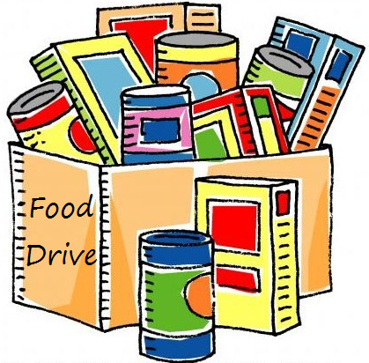
The last Sunday of each month is Missions Sunday. Please bring a canned good or other non-perishable food on December 31st. Boxes will be available to collect them. All gifts will be taken to the Hawai‘i Foodbank.

Our current email addresses:
- pastor.nuuanucongregational@gmail.com
- nuuanucongregational@gmail.com
- Bookkeeper@NuuanuCC.onmicrosoft.com

