A Weekly Newsletter of Nu‘uanu Congregational Church
NCC News
December 10, 2023

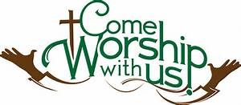
Before You Decorate for Christmas…
Seems like the whole culture jumps from Halloween to full-on Christmas! So, it takes intentionality to make room for other important items on the calendar.
One of those is our congregation’s annual stewardship drive. By now you should have received a 2024 pledge card in the mail to support NCC’s operating budget. You are asked to make a sacred space in this busy season to contemplate how you use your time, skills, and financial resources as a grateful response to God’s blessings in your life.
Return your pledge card to the offering plate or to the church office by December 10. Additional pledge cards are available. Should you need one, contact the church office.

Events for Advent:
The following events are going to be right after service on the following dates:
- December 10 - Christmas Card Writing

Planning for December Services
As we patiently await the birth of the Christ Child, we will engage in a little merry making by observing the following Sundays:
- December 10 - Christmas Sweater Day - Wear your Christmas sweater. If you choose to wear your "ugliest" Christmas sweater, please make sure no one at church gave you that sweater!
- December 17 - Christmas in Hawaii - Wear your bright colored aloha attire, fake flower lei, straw hat, whatever bright aloha attire you have!
- December 24 - Christmas Eve - Wear green, white and/or red
- Christmas Eve Service – 7 P.M.
Hope you will join us each Sunday, whether you dress up or not, for this special Advent season!

Don Ikeda’s Chutney & Jams
There are a handful of jars of Jellies that were mixed in with the Chutney’s well! There are only 5 jars of Lilikoi ($7.00 each) and 2 jars of Surnam ($3.00 each)
If you want to get more of Don’s Chutney, we have quite a few in the office, ranging from $3.00 to $12.00. Please call Mairi at (808) 595-3935 or email her at nuuanucongregational@gmail.com.

The Missions Committee wants you to know...
White Christmas
Advent is here and it is time to bring in gift cards to be distributed to Family Promise, River of Life Mission, & Transition House. Cards will be collected each Sunday through the seventeenth.

Kadomatsu Production Volunteers
If you have a couple of hours to spare on the 15th or 16th, the Scouts would really appreciate your help preparing kadomatsu. This would be a great way to say thanks to the troop for everything they do for us.
Please email Wendy Sekiya if you are able to help at wendy.sekiya@gmail.com.

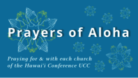

Week of December 10:
Kalaiakamanu Hou Congregational Church (Moloka‘i)
Lihu‘e Christian Church (Kaua‘i)

Week of December 17:

Kalanikāhua Hou Church (Maui)
Laupahoehoe Congregational Church (Hawai‘i Island)
2024 Altar Flower Donations
2024 Altar Sign-up sheet is up. If there any dates you want to sign up for ahead of time. Please email the office nuuanucongregational@gmail.com
Please have Altar Flowers delivered on Fridays, between 8 am and 4 pm or Sunday mornings at 8:30 am. There will not be anyone working on Saturday’s until further notice.

Can You Bring a Can for the Food Pantry?
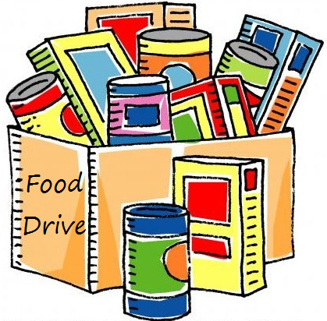
The last Sunday of each month is Missions Sunday. Please bring a canned good or other non-perishable food on December 31st. Boxes will be available to collect them. All gifts will be taken to the Hawai‘i Foodbank.

Our current email addresses:
- pastor.nuuanucongregational@gmail.com
- nuuanucongregational@gmail.com
- Bookkeeper@NuuanuCC.onmicrosoft.com

