A Weekly Newsletter of Nu‘uanu Congregational Church
NCC News
November 26, 2023

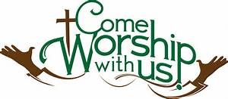

Things in the Mail
Please keep an eye out in the mail for the 2024 Annual Meeting Notice.

The Missions Committee wants you to know...
White Christmas
It's not too early to start picking up gift cards for White Christmas. Advent is right around the corner. We will be collecting gift cards to share with Family Promise, River of Life Mission, & Transition House. Think of places like Foodland, Long's or Ross for basics or maybe places like McDonald's or Jamba Juice for a treat.

Kadomatsu Production Volunteers
For years now, Troop 201 has graciously given kadomatsu to our shut-ins. They anticipate needing help with kadomatsu production this year and have asked if there are volunteers from NCC who might be able to assist the troop with their major fundraiser. Production will be on December 14, 15, 16, & 17. There are many roles to be filled. Washing, drying, & oiling are all pretty simple, while decorating and quality control require skills at which many in our congregation excel. It would be wonderful if we could show our appreciation to Troop 201 for the donations of kadomatsu, and everything else they do for us, by turning out to help them in December.
Let Judy Keith know if you are interested or would like more information.

From The Med Team:
Now is the time to make sure you are up to date on the necessary immunizations: seasonal flu, RSV, and yes, Covid. The Covid vaccine appears to be in short supply, so your appointments may get cancelled. Persevere & get that shot! And in the event that you get Covid anyway (it happens), don't feel like the vaccine did not work. The evidence is clear: the vaccination is successful in keeping you out of the hospital or dying. And your case of Covid is much less likely to be severe.

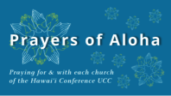

Week of November 26:
Kailua Christian Church (O‘ahu)
Liliuokalani Protestant Church (O‘ahu)
2023 Altar Flower Donations
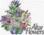
The 2023 Altar Flower Donations chart is filling up! Please put your name next to the date that you want either in person on Sunday, by emailing nuuanucongregational@gmail.com, or by calling the office at (808) 595-3935.
Please have Altar Flowers delivered on Fridays, between 8 am and 4 pm or Sunday mornings at 8:30 am. There will not be anyone working on Saturday’s until further notice.

The following date is available: December 3

Can You Bring a Can for the Food Pantry?
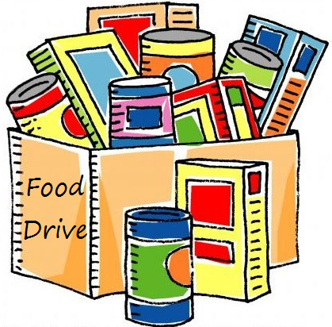
The last Sunday of each month is Missions Sunday. Please bring a canned good or other non-perishable food on November 19th. Boxes will be available to collect them. All gifts will be taken to the Hawai‘i Foodbank.

Our current email addresses:
- pastor.nuuanucongregational@gmail.com
- nuuanucongregational@gmail.com
- Bookkeeper@NuuanuCC.onmicrosoft.com

