A Weekly Newsletter of Nu‘uanu Congregational Church
NCC News
October 8, 2023

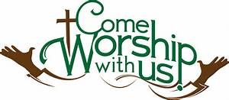

Pastor Jeannie will be out
Jeannie will be having knee replacement surgery on October 24th. More information to come.

Photographs for All Saints’ Day—
Please bring a photograph of a loved one for our annual observance of All Saints’ Day on Sunday, November 5. This is a special time to remember all our loved ones who have died, especially those who have died in the past year. What we acknowledge and celebrate is that through Christ death does not have the last word. Together, on All Saints Day we remember them with love, and thank God and them for their life and faithfulness.

UCC Judd Street Invitation
UCC Judd Street Church has a pickleball ministry. Their Pickleball Ministry Team would like to invite any of our church members for a pickleball tournament on Friday, October 13, from 4-8 p.m. at Judd Street Church.

Give Aloha
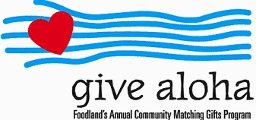
We participated in this year’s Give Aloha program again. Give Aloha ran from September 1, 2023 through September 30, 2023.
Please make sure that you send us your receipt, either in the mail with your donation, or email a picture of it to nuuanucongregational@gmail.com. The receipt must have your name, amount, store number, and time of your transaction so that we can credit the donation to the right person/family!

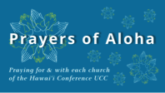
Week of October 8
Imiola Congregational Church (Hawai‘i Island)
Maui Marshallese Ministry (Maui)
Kana‘ana Hou - Siloama UCC (Moloka‘i)

Week of October 15
Ka Hana O Ke Akua Church (O‘ahu)
Maui Evangelical Church (Maui)

Week of October 22
Kaahumanu Church (Maui)
Mānoa Valley Church (O‘ahu)
Kaluaaha Congregational Church (Moloka‘i)

Week of October 29
Kahakuloa Hawaiian Congregational Church (Maui)
Malamalama Ole Alofa Tunoa CCC UCC (O‘ahu)

2023 Altar Flower Donations
The 2023 Altar Flower Donations chart is filling up! Please put your name next to the date that you want either in person on Sunday, by emailing nuuanucongregational@gmail.com, or by calling the office at (808) 595-3935.
Please have Altar Flowers delivered on Fridays, between 8 am and 4 pm or Sunday mornings at 8:30 am. There will not be anyone working on Saturday’s until further notice.
The following dates are available:
October 15
October 22
October 29
November 12
November 26
December 3
December 31

Can You Bring a Can for the Food Pantry?
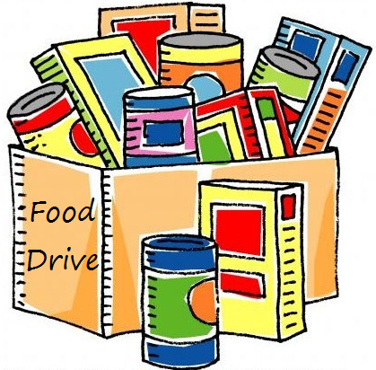
The last Sunday of each month is Missions Sunday. Please bring a canned good or other non-perishable food on October 29th. Boxes will be available to collect them. All gifts will be taken to the Hawai‘i Foodbank.

Our current email addresses:
- pastor.nuuanucongregational@gmail.com
- nuuanucongregational@gmail.com
- Bookkeeper@NuuanuCC.onmicrosoft.com

