A Weekly Newsletter of Nu‘uanu Congregational Church
NCC News
October 22, 2023

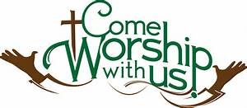
Photographs for All Saints’ Day—
Please bring a photograph of a loved one for our annual observance of All Saints’ Day on Sunday, November 5. This is a special time to remember all our loved ones who have died, especially those who have died in the past year. What we acknowledge and celebrate is that through Christ death does not have the last word. Together, on All Saints Day we remember them with love, and thank God and them for their life and faithfulness.
From The Med Team:
Now is the time to make sure you are up to date on the necessary immunizations: seasonal flu, RSV, and yes, Covid. The Covid vaccine appears to be in short supply, so your appointments may get cancelled. Persevere & get that shot! And in the event that you get Covid anyway (it happens), don't feel like the vaccine did not work. The evidence is clear: the vaccination is successful in keeping you out of the hospital or dying. And your case of Covid is much less likely to be severe.

The Missions Committee wants you to know...
- We will be putting the sukkah up on November 15th at nine am. Volunteers are needed to help with this. Let Judy Keith know if you can help.
- It's not too early to start picking up gift cards for White Christmas. Advent is right around the corner. We will be collecting gift cards to share with Family Promise, River of Life Mission, & Transition House. Think of places like Foodland, Long's or Ross for basics or maybe places like McDonald's or Jamba Juice for a treat.

Nu’uanu Valley Interfaith Thanksgiving Service—
2023 Strong Roots, Strong Life
This year, our annual Nu’uanu Valley Interfaith Thanksgiving Service (NVITS) will be held on November 21, 2023. The host will be our sister church, United Church of Christ at 467 Judd Street.
This year’s theme is Strong Roots, Strong Life. Our inspiration for the theme is the banyan tree that managed to survive the Maui wildfires that swept through west Maui. To honor the people and to help contribute to the recovery, the annual interfaith Thanksgiving service will be dedicated to the people of Maui.
Thus, the offering we receive during the service will be donated to Maui Strong which is a project of the Hawaii Community Foundation. Maui Strong is providing financial resources to support immediate needs. However, Maui Strong will also provide resources for the long-term recovery for the people and places affected by the wildfires.
During the service, the choir will sing “Lahaina Luna,” and we will join them. We will hope with them and the people of Maui that a time of renewal will begin. We will sing of our hope for the healing of the people and the land.
Please plan on attending, being part of the choir or the audience, or watching the livestream on UCC Judd Street’s YouTube channel. All the information you will need will be in the November Caller, and in the Sunday bulletin announcements leading up to November 21st.

Pastor Jeannie will be out
Jeannie will be having knee replacement surgery on October 24th. More information to come.

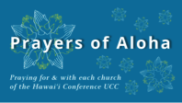
Week of October 22
Kaahumanu Church (Maui)
Mānoa Valley Church (O‘ahu)
Kaluaaha Congregational Church (Moloka‘i)

Week of October 29
Kahakuloa Hawaiian Congregational Church (Maui)
Malamalama Ole Alofa Tunoa CCC UCC (O‘ahu)

Give Aloha
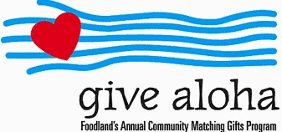
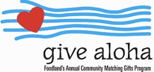
Please make sure that you send us your receipt, either in the mail with your donation, or email a picture of it to nuuanucongregational@gmail.com. The receipt must have your name, amount, store number, and time of your transaction so that we can credit the donation to the right person/family!

2023 Altar Flower Donations
The 2023 Altar Flower Donations chart is filling up! Please put your name next to the date that you want either in person on Sunday, by emailing nuuanucongregational@gmail.com, or by calling the office at (808) 595-3935.
Please have Altar Flowers delivered on Fridays, between 8 am and 4 pm or Sunday mornings at 8:30 am. There will not be anyone working on Saturday’s until further notice.
The following dates are available:
October 29 November 26 December 3, 31

Can You Bring a Can for the Food Pantry?
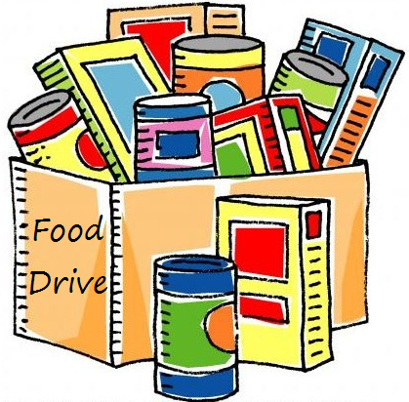
The last Sunday of each month is Missions Sunday. Please bring a canned good or other non-perishable food on October 29th. Boxes will be available to collect them. All gifts will be taken to the Hawai‘i Foodbank.

Our current email addresses:
- pastor.nuuanucongregational@gmail.com
- nuuanucongregational@gmail.com
- Bookkeeper@NuuanuCC.onmicrosoft.com

