A Weekly Newsletter of Nu‘uanu Congregational Church
NCC News
January 22, 2023

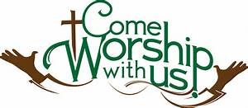
YMCA Nu‘uanu Pali Preschool
The YMCA Pali Nu‘uanu preschool is now accepting applications. To get information about the preschool, please visit https://www.ymcahonolulu.org.

Dollars and Sense Mtg, Annual Mtg
Please put these dates in your calendar!
- 2023 Annual Meeting - Sunday, January 29, 2023 at 10:30 am.
- 2022 Annual Reports are ready, please take one!
Please join us for these two meetings!

Family Promise Meals
The meals for the first quarter of 2023 have all been assigned, with the exception of March 12. If you are interested in cooking for that night, please contact Judy Keith. Big mahalos to everyone who has signed up for meals!

2023 Altar Flower Donations
The chart for the 2023 Altar Flower Donations is ready to fill up! Please fill out the date that you want, either in person on Sunday, by email at nuuanucongregational@gmail.com, or by calling the office at (808) 595-3935.
As of right now, February only needs the 19th.

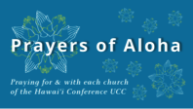
Week of January 22:
Bishop Memorial Church (O'ahu)
Waipahu UCC (O'ahu)
Kalemela Church (Hawai'i)
Week of January 29:
Bread of Life Church (O'ahu)
Wai'oli Hui'ia Church (Kaua'i)

Can you bring a can?
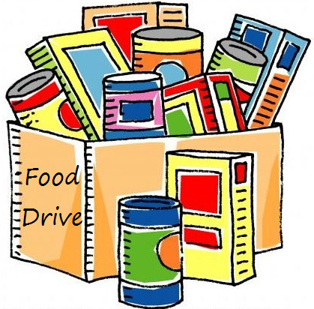
The last Sunday of each month is Missions Sunday. Please bring a canned good or other non-perishable food on that day. Boxes will be available to collect them. All gifts will be taken to the Hawai‘i Foodbank.

New Email Addresses
by Mairi Manley
Pastor email:
pastor.nuuanucongregational@gmail.com

Office email:
nuuanucongregational@gmail.com

Bookkeeper email bookkeeper@NuuanuCC.onmicrosoft.com

