A Weekly Newsletter of Nu‘uanu Congregational Church
NCC News
March 27, 2022

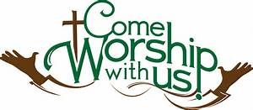
Emergency Contact Form
By Lori Yamashiro
Included in Sunday's worship bulletin will be an emergency contact form that we are asking our worship attendees to complete. The information provided will only be used in case of an emergency while you are on the church campus. The form asks for at least one emergency contact, there is space to add a second if you'd like to have more than one person contacted. Completion of the form is optional but would be helpful in the case of an emergency. If you have any questions, please contact Lori Yamashiro.

Pipe Replacement on Saturday, March 26, 2022
Colburn Plumbing will be replacing a water line from our valve on the property to the Board of Water Supply junction box on the sidewalk, near the Sanctuary. There will be no water going to the Kibo Kan Building!

Green Day in April
Green Day on April 23, 2022 will be postponed to August 13, 2022!

Prayers of Aloha
From UCC Coconut Wireless 3/16/22
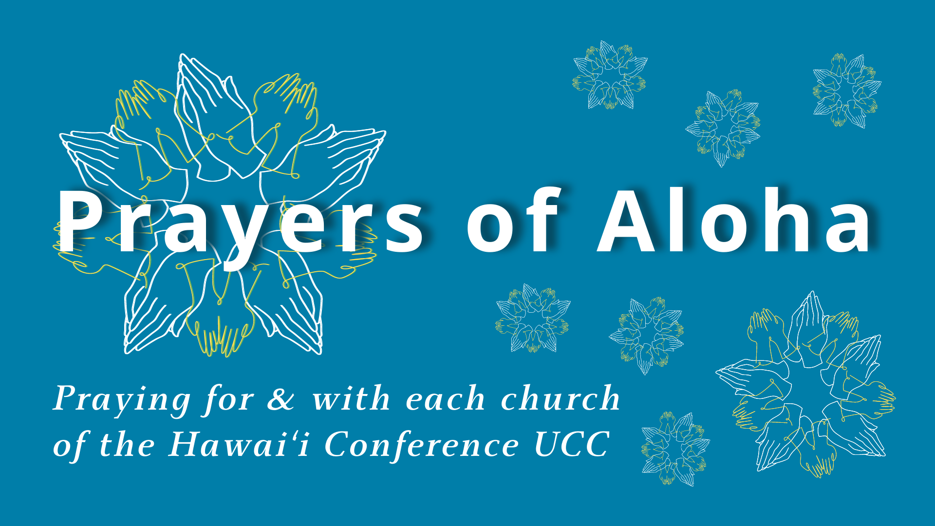
Join us in praying for and with our churches in the Hawai'i Conference. We encourage you to pray for any or all of the churches listed for each week, in whatever way you are moved. Week of March 20 will be Chuukese Congregational Church, Waianae Samoan Church, and Ko‘olau Hui‘ia Protestant Church (Kauai).

Maundy Thursday at The Community Church of Honolulu April 14, 2022, 5 to 6 p.m.
Our church is invited to Jook Soup & Holy Communion at our sister church, Community Church of Honolulu, 2345 Nuuanu Avenue. Masks are recommended, tables will be socially distanced and soup will be provided. Also, we would like to give them a head count. So, please put your name on the sign-up sheet, or call the church office during the week.

Good Friday Tenebrae Service, April 15, 6 p.m. at Nu'uanu Congregational Church
2651 Pali Hwy.
The Community Church of Honolulu & United Church of Christ Judd Street will join us in our sanctuary for Good Friday Tenebrae Service. Tenebrae means "darkness" or "shadows" and as Scripture is read candles will be extinguished symbolizing Christ's death on the cross. Masks and social distancing are recommended.

Townhall Meeting
Dear Members and Friends of NCC,
There is so much happening that we can't tell you about all of it in a note in the Caller. So we scheduled our next Town Hall meeting on April 24, 2022 right after church service. So please be there so you can hear what is happening and be a part of the exciting happenings at NCC!!

Ukraine Emergency Appeal
The United Church of Christ is appealing for support for refugees and for elderly and other vulnerable people who are displaced within Ukraine and unable to leave. As a member of the ACT Alliance, UCC support is being targeted to people most in need through humanitarian relief partners with a history of working in the region. Aid also is being extended through Hungarian Reformed Church Aid, the relief agency of the Reformed Church in Hungary. The UCC’s long-term relationship with the Reformed Church in Hungary is held through the Europe and the Middle East Office of Global Ministries.
Gifts made to UCC Ukraine Relief Fund will provide shelter, food, and other care to war refugees and internally displaced people. It also will help refugees and asylum seekers from African, Middle Eastern and other countries who had sought refuge in Ukraine and now are twice displaced, as well as other citizens of more than 125 countries living in Ukraine.
You may put your gifts into the offering plate this morning, or send it into the church office. Checks should me made out to Nu‘uanu Congregational Church with “UCC Ukraine Relief” in the memo!

Sanctuary Repairs Starting on April 19, 2022
The Sanctuary Repairs will finally start! The building permit was issued in early February 2022. Makainai Construction will be from April 19, 2022 through the end of May 2022, pending any unforeseen conditions and inclement weather. The scope of work is replacing the termite eaten fascia, T&G decking, and painting. For safety reasons, the Sanctuary will not be accessible during the repair work. Therefore, we will worship in the gym.
Thank you for your patience and understanding.

