A Weekly Newsletter of Nu‘uanu Congregational Church
NCC News
February 20, 2022

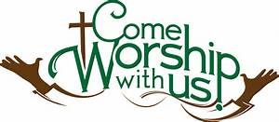
From the Moderators Desk

News from the YMCA and NCC Council:
NCC planned to start the YMCA KUPUNA program funded with a City Grant in early February. Several things happened. 1) The COVID-19 numbers grew exponentially and again 2) In-Person Worship services were postponed. The Ad-Hoc Medical Team were concerned about these numbers and about NCC members’ participation.
Therefore, by informing the YMCA program of our misgivings they found another site for February at Windward YMCA. We are sorry for this change but the Council felt that this would be the best for now. We will continue our discussions with the YMCA to begin the Kupuna Program in the Fall of this year.
However, this has not stopped the discussion and planning for the YMCA Spring Intersession to happen March 14 to 18, 2022. More on this as we receive the information from the YMCA advisors. We will proceed with this program if the YMCA reports that there are sufficient students to run the program.
Keep your eyes open for the latest happenings coming your way!!

Aloha, Laurie Hamano, NCC Moderator
Ash Wednesday
Pastor Jeannie will be having an Ash Wednesday service on Wednesday, March 2, 2022 in the lower parking lot at 6 pm.

Lent 2022 Devotional
by Rev. Jeannie Thompson
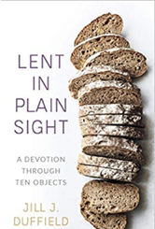
God is often at work through the
ordinary: ordinary people, ordinary objects,
ordinary grace. Through the ordinary, God communicates epiphanies, salvation, revelation,
and reconciliation. Very often, it is through the
mundane that we hear God’s quiet voice.
In this devotion for the season of Lent,
Jill J. Duffield draws readers’ attention to ten
ordinary objects that Jesus would have encountered on his
way to Jerusalem: dust, bread, the cross, coins, shoes, oil,
coats, towels, thorns, and stones. In each object, readers will
find meaning in the biblical account of Jesus’ final days. Each
week, readers encounter a new object to consider through
Scripture, prayer, and reflection. From Ash Wednesday to
Easter, Lent in Plain Sight reminds Christians to open
ourselves to the kingdom of God.
Please call the church office if you would like to order
a copy of the book—$12.50. Pastor Jeannie is working on a reading/discussion schedule—it will be published by
February 16.

