A Weekly Newsletter of Nu‘uanu Congregational Church
NCC News
November 27, 2022

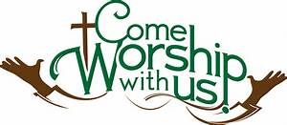

YMCA Winter Intersession
The YMCA will be having their Winter Day Camp at NCC. It will be held from December 19-23 and 27-30, 2022.
People may register their children in elementary & Middle school Students (K-8) at ymcahonolulu.org or call (808) 678-4296. They are offering 20% off youth programs, swim lessons, and more with a Y membership!

Planning for December services
As we patiently await the birth of the Christ Child, we will engage in a little merry making by observing the following Sundays:
- December 4 - School Pride Sunday - Wear your school colors and/or apparel - can be either high school or college.
- December 11 - Christmas Sweater Day - Wear your best/ugliest Christmas sweater. If you choose to wear your ugliest Christmas sweater, please make sure no one at church gave you that sweater!
- December 18 - Birthday Celebration - Wear bright colors - stay after service for cake, ice cream and soda floats. For those of us who are lactose intolerant, we'll just eat and run.
- December 25 - Christmas Day - Wear green, white and/or red
Hope you will join us each Sunday, whether you dress up or not, for this special Advent season!

Holidays with our Family Promise Guests
- For the Christmas season, we have small artificial trees for each room. We are purchasing small ornaments for the families to trim their trees.
- As in the past we will be collecting gift cards during Advent to be shared with several local charities. This year, we would like to give each of the families currently living on campus gift cards near the beginning of the month, so that the parents may shop for Christmas gifts for their own children. So if possible, please make your White Christmas donations early in the month.
- Please consider purchasing gift cards for White Christmas to be given to the families in early December so they are able to do Christmas shopping for their children. Suggested sites for cards include Longs, Ross, Target, and Walmart. Thank you for your generosity and continued support.

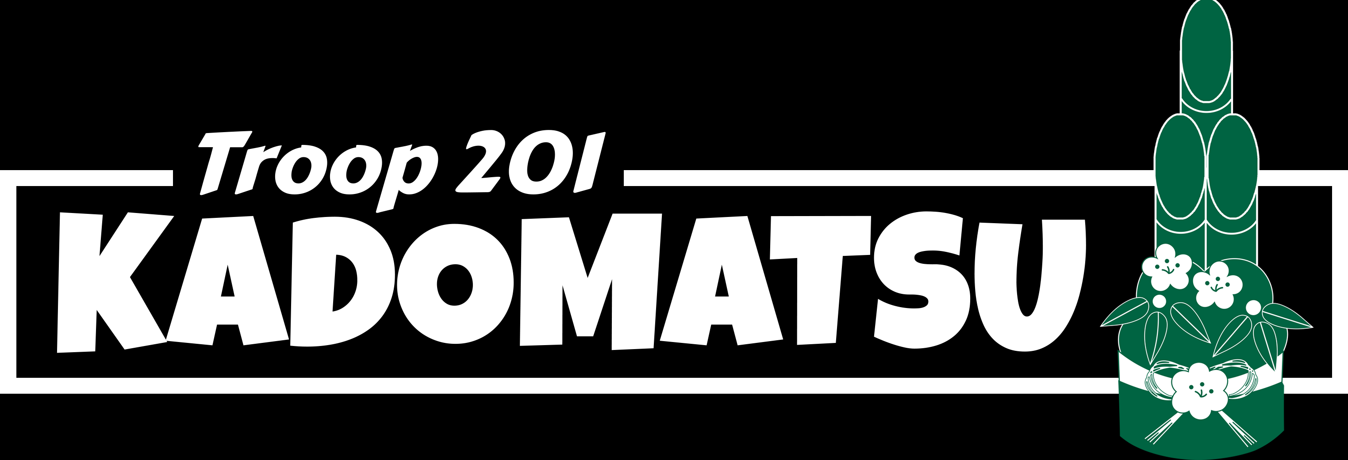
Troop 201 will be assembling their kadomatsu on Friday, December 16 through Sunday, December 17 in our gym. It is a huge undertaking and is the troop's sole fundraiser for the year. In the past quite a number of NCC members have helped the scouts assemble their kadomatsu. They have been so supportive of our programs over the years & this is a great way for us to demonstrate our appreciation. This year, the troop has designed a T-shirt for people to wear on the work day. While it is in no way mandatory for anyone to purchase a shirt, if you would like to obtain one, they will be available for $10. The clip art shows the design. Please let Judy Keith know if you would like to buy a shirt.

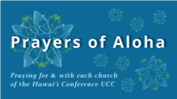
Week of November 27:
Kailua Christian Church (O'ahu)
Liliuokalani Protestant Church (O'ahu)

New Email Addresses
by Mairi Manley
On Friday, November 4 - the office changed phone and internet service. Our phone number will remain the same! We will be using different email addresses to the following:
Pastor email:
pastor.nuuanucongregational@gmail.com

Office email:
nuuanucongregational@gmail.com

Bookkeeper email bookkeeper@NuuanuCC.onmicrosoft.com

Contributions and Pledges 2022
Just a reminder....in order for contributions to be credited for the 2022 tax year, they must be either mailed to the church with a USPS postmark not later than December 31, 2022, or received by the church office before 12:00 p.m. Friday, December 30, 2022. Contributions received after that will be credited to 2023.
Also, please remember that this is Stewardship month. You should have received your pledge cards in the mail. Mahalo to all who brought in their pledges last Sunday. If you have not, please mail it in or you may drop it into the offering plate.

