A Weekly Newsletter of Nu‘uanu Congregational Church
NCC News
August 7, 2022
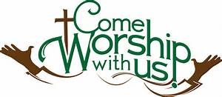

A Prayer to End Gun Violence: a meditation—Part 2
Last month we all read and prayed about gun violence because of the inordinate number of mass shootings in our country. We spent all o0f July with a prayer printed in the Caller.
After a month of prayer, it is important for each of us to ask ourselves: What did God show me as I prayed about the violence and death?
Today, and for the whole month, there will be an index card in the Sunday bulletin. Please jot down any thoughts that come to you about this tragedy in our midst. Here are some questions to help you focus:
What did God show me?
When you pray for the end of gun violence, whose face do you see?
Who particularly comes to mind? Why?
What do you wish God would say to your heart about this?

Each week, the questions will be new, or a little different. You do not need to sign the card unless you want to. Later this year, we will spend some time looking at the thoughts we have shared, and we will discern together if there is some way in which our church is being called to bring God’s healing into our community.
You may leave your index card comments in the collection plate.
Donation Statements
Mid-Year donation statements are ready for pick up. Please check them to make sure everything is correct. If there’s a change to be made, please contact Howard Mau at nccfinsec@hawaiiantel.net.

Memorial Service for Yoko Asada
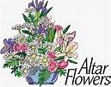
For those who RSVPed with Arthur Goto, the memorial service for Pastor Yoko Asada (former NCC associate pastor for Nichigobu and Ohana Ministry), here at NCC is today at 4:00 p.m.

School Supplies
By Judy Keith
We collected an amazing amount of school supplies! We were able to deliver supplies to the following elementary schools: Kaahumanu, Ka‘imiloa, Lincoln, Palolo, and Puuloa. The Missions Committee was truly amazed at your generosity. Thanks so much!

Family Promise Meals
By Judy Keith
We will be providing dinner on August 14th & 28th for the three Family Promise families staying on our campus. Two to three individuals or a group would be optimal for each meal. Sign up with Judy Keith. More information will be provided when you sign up. Thank you.

Gearing up for GREEN DAY
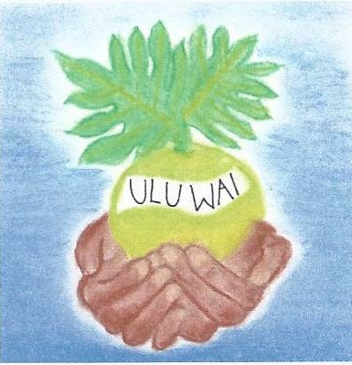
Ulu Wai Ministry is gearing up for its GREEN DAY VIII on Saturday, August 13, 2022, from 9:00 a.m. – 1:00 p.m. All proceeds will go to Ulu Wai’s Missions Ministry, which takes care of all of God's creations.
You still have time to buy a waterless car wash ticket today from your Mission Committee friends: Becky K., Joyce U., Micki S., Judy K., Sybil, Wayne K., Velma A. and the Scouts.
Just as a reminder, the famous Dr. Don Ikeda’s jellies, jams, and chutney will be on sale as well! He will also have his Washi Bead bracelet, necklaces, and earrings
There also will not have e-waste at this Green Day!
See all you customers on Saturday, August 13, 2022!

Free Safe Falling Presentations
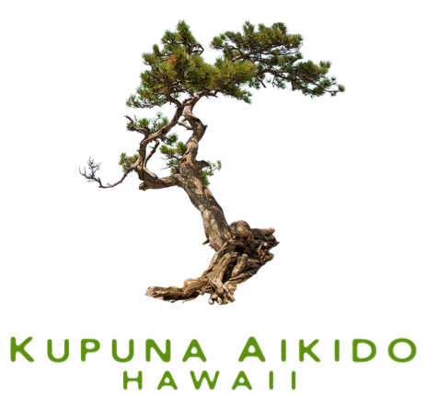
September is National Fall Prevention month. To support National Fall Prevention month, KuA is doing several free safe falling presentations at the libraries listed below. If you have never attended one of our presentations, please come.
We offer fall prevention tips and discuss the principles behind our safe falling techniques. If you know anyone who might benefit from this presentation, please pass on the information. The injury you prevent may be one of your loved ones.
For more information about these presentations, please contact the individual library. We are also working with libraries at other locations and will list them on our website once they are finalized.
- Aiea Library, August 13 10 am

Reminder: If you are interested in taking one of our safe falling classes, registration is now open. Please check out the classes on our website at https://www.kupunaaikido.org/.

Altar Flowers
Sign up on the Flower Chart on Sundays, or call Mairi at the church office, (808) 595-3935, or email her at nccadmin@hawaiiantel.net.

The following are available for the remainder of the year:
  - October 2, 2022
  - November 13, 2022
  - December 25, 2022
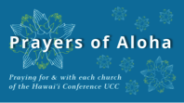
Week of August 7:
Henry 'Ōpūkaha'ia/Hokuloa Chapel (Hawai‘i Island)
Opihikao Congregational Church (Hawai‘i Island)
As Covid counts remain high, we ask you take precautions:
The following information is taken from an article
in the Washington Post by Dr. Lena Wen.
Three things to consider:
- Do you have optimal protection?
  - Make sure you are up to date with your vaccines. If you have not had all your boosters, do not put off getting the next one till fall, hoping for a variant specific booster.
  - It is time to upgrade your mask. You should have a well fitting N95 mask. Every time you put it on, pinch around your nose to get a close fit. If your glasses fog, the fit is not tight.
- Have you stocked up on tests? Home rapid tests are very good at detecting covid. Test kits are covered by insurance. You should have two kits available for each member of the family. Here are three reasons to test:
  - You develop a cough, runny nose, sore throat, or generalized aching. If you test negative, but still feel sick, you should re-test in two to three days.
  - Test as a method to end isolation. Start testing regularly on day five to see when it is safe to be around other people.
  - Just before you will be visiting others in an indoor setting. This will help lower community spread.
  - False positive results are rare with the home antigen tests. You should not need to get a PCR test to confirm that you have Covid.
- Do you have a plan for what to do if you test positive?
  - Call your physician and see if they want to put you on medication. Do this right away, as the medication needs to be started within five days of developing symptoms.
  - Think about your home situation. Do you have a place where you can isolate at home? You should wear a mask when you are around family members.

