A Weekly Newsletter of Nu‘uanu Congregational Church
NCC News
July 31, 2022
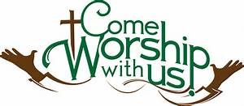
Special Congregational Meeting
There will be a Special Congregational Meeting on today, right after church service! This is so that the information about the Capital Campaign can be discussed and voted on. NCC members need to sign in prior to the meeting. You should have received a letter on this in the mail.

Blessing of the Backpacks & School Supplies Collection
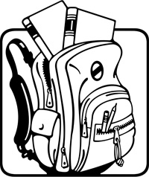
Our children will be returning to school during the first week of August. To "send them off" all children are invited to bring their backpacks to worship to receive a blessing, and a special NCC backpack tag. We are also giving backpacks and school supplies to the FP kids and youth who are staying here with us.
As most of us know: many teachers purchase school supplies out of their own funds for children whose families cannot afford them. So, if there are any leftover supplies, they will be donated to Kauluwela Elementary School.

Donation Statements
Mid-Year donation statements are ready for pick up. Please check them to make sure everything is correct. If there’s a change to be made, please contact Howard Mau at nccfinsec@hawaiiantel.net.
Memorial Service for Yoko Asada
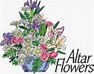
There will be a memorial service for Pastor Yoko Asada (former NCC associate pastor for Nichigobu and Ohana Ministry), here at NCC on Sunday, August 7, 2022 at 4:00 p.m.
While all are invited to attend, it would be appreciated, if you plan to attend, that you would let Arthur Goto know of that fact by 5:00 p.m. on Wednesday, August 3, 2022 for planning purposes. You may reach him to respond via Tp. 808-526-2226 (Ofc) or 808-261-2598 (Residence), or, in person to him, or by any other means convenient.
The service is at the request and sponsorship of the Nichigobu Support Group, Kazuko Love (Rev. Yoko’s cousin in Hawaii) and her family, Micki Sasaki a very close friend of Yoko Asada and of course an NCC member, and Ronald Fujiyoshi, M.Div. who will also be participating in the service. Arrangements for Rev. Takie Nishizawa, Pastor Yoko’s pastor, at her home church in Japan (now retired), to participate are also being made.

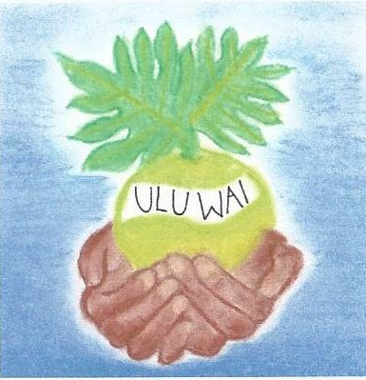
Gearing up for GREEN DAY
Next Sunday, August 7, 2022, is THE day to bring your donations for Green Day VIII.

- Place your Rummage Sale “gifts” inside Kosasa Hall on the mauka end:
  - new to gently used kitchen and household items such as utensils, pots ‘n pans, books, toys, small working appliances and electronic devices, personal use items etc.
  - Please… NO CLOTHING OR SHOES.
- Put water plants, water grasses, fish, red wiggler worms, worm casting, clean 1 - 5 gallon size containers on/under the old pew next to the Kosasa Hall breezeway.
- Put potted plants, tillandsia, and other living natural items outside in back of Kosasa Hall in the shade.

Volunteers are needed for 1 – 2 work shifts (Shift 1: 8:45-11:00, Shift 2: 10:45-1:30) as roaming or “sit-down” watchful eyes in different areas. Please lend a hand and sign up with Becky asap to come and help make it a success.

Free Safe Falling Presentations
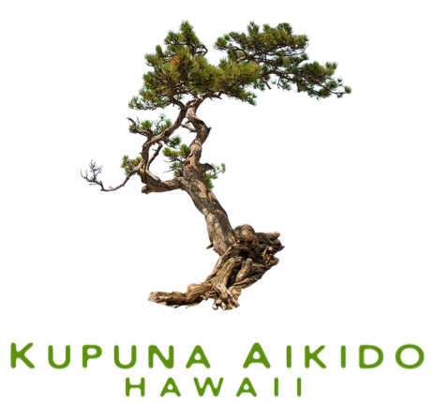
September is National Fall Prevention month. To support National Fall Prevention month, KuA is doing several free safe falling presentations at the libraries listed below. If you have never attended one of our presentations, please come.
We offer fall prevention tips and discuss the principles behind our safe falling techniques. If you know anyone who might benefit from this presentation, please pass on the information. The injury you prevent may be one of your loved ones.
For more information about these presentations, please contact the individual library. We are also working with libraries at other locations and will list them on our website once they are finalized.

- Kaneohe Library, August 2 10 am
- Pearl City Library August 3 10 am
- Wahiawa Library, August 5 11:30 am
- Kapolei Library, August 6 10 am
- Aiea Library, August 13 10 am

Reminder: If you are interested in taking one of our safe falling classes, registration is now open. Please check out the classes on our website at https://www.kupunaaikido.org/.

Hawai’i Foodbank Donations
In August, we will start accepting donations for the Hawaii Foodbank on the last Sunday of the month.

Altar Flowers
Sign up on the Flower Chart on Sundays, or call Mairi at the church office, (808) 595-3935, or email her at nccadmin@hawaiiantel.net.

The following are available for the remainder of the year:
  - October 2, 2022
  - November 13, 2022
  - December 11, 2022
  - December 25, 2022

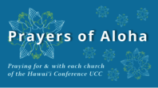
Week of July 31:
Central Christian Church (Hawai‘i Island)
Paia Hawaiian Protestant Church (Maui)
Kaua‘i Marshallese Ministry (Kaua‘i)
As Covid counts remain high, we ask you take precautions:
Three things to consider:
- Do you have optimal protection?
  - Make sure you are up to date with your vaccines. If you have not had all your boosters, do not put off getting the next one till fall, hoping for a variant specific booster.
  - It is time to upgrade your mask. You should have a well fitting N95 mask. Every time you put it on, pinch around your nose to get a close fit. If your glasses fog, the fit is not tight.
- Have you stocked up on tests? Home rapid tests are very good at detecting covid. Test kits are covered by insurance. You should have two kits available for each member of the family. Here are three reasons to test:
  - You develop a cough, runny nose, sore throat, or generalized aching. If you test negative, but still feel sick, you should re-test in two to three days.
  - Test as a method to end isolation. Start testing regularly on day five to see when it is safe to be around other people.
  - Just before you will be visiting others in an indoor setting. This will help lower community spread.
  - False positive results are rare with the home antigen tests. You should not need to get a PCR test to confirm that you have Covid.
- Do you have a plan for what to do if you test positive?
  - Call your physician and see if they want to put you on medication. Do this right away, as the medication needs to be started within five days of developing symptoms.
  - Think about your home situation. Do you have a place where you can isolate at home? You should wear a mask when you are around family members.

