A Weekly Newsletter of Nu‘uanu Congregational Church
NCC News
August 8, 2021

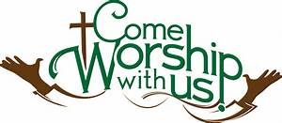

Learn to Play the Organ!
By Katherine Crosier
The American Guild of Organists-Hawaii Chapter is accepting scholarship applications from August 1 to August 31, 2021 for the scholarship period October 2021 through September 2022. Auditions will be held in September 2021. Visit agohawaii.org to download an application. For details, e-mail Elizabeth Wong at ew_ago_hawaiichapter@yahoo.com
Give Aloha will be Back
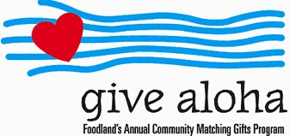
Correction: The cumulative total of up to $249.00 per person/per
organization is allowed. During the
month of September 2021, you may make donations through Give Aloha at Foodland, Sac N Save, or Foodland Farms.
Please drop off or mail your receipt, with your name at the top of the receipt, to the office as soon as you can. The absolute deadline to turn in your receipt is by
December 31, 2021 so that we may add it to your donation total for the year.

Community Garden
This has been moved to Aug. 14. On July 31, 2021, in the morning, Nate Cantrill from the Scouts Troop 201 will be constructing the community garden here at church. The garden will be where Hale Ohana was in the concrete area.

Second Quarter Donation Statements
The 2nd Quarter statements are printed and will be ready for pickup at worship service on August 1, 2021. Included in the packet is a letter from
Lori Yamashiro and Income Expenses up until June of 2021. Please ask for them either before or after service.
The statement will be mailed to you if it is not picked up by the end of worship service on August 8, 2021. Mahalo!

Hawai‘i Foodbank & Family Promise School Supply Drive
By Judy Keith
Thanks to all who supported the Foodbank and School supplies collections last week. Your generosity was overwhelming. We collected 209 pounds of food and checks totaling $1,525.00 for the Foodbank and so many school supplies that we were able to donate to both Family Promise and Puuhale Elementary School. The needs in our community are even greater than usual this year and it was wonderful to see the outpouring of donations to the two drives.
