A Weekly Newsletter of Nu‘uanu Congregational Church
NCC News
December 19, 2021

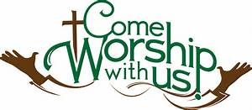
White Christmas
By Judy Keith
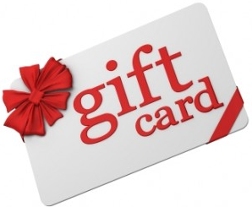
Advent is just around the corner. We will be doing our White Christmas gift card collection each Sunday during Advent. Last year we collected over $1,500.00 dollars for Family Promise, River of Life Mission, & the Transition House. It's been a rough year for everyone, Let's do what we can to brighten the holiday for others who are in need.
Please mail or drop off the cards to the NCC Office.

YMCA Update
Unfortunately, with low or no enrollment for the plans with the YMCA to use our facilities during Christmas break, the YMCA has cancelled their Winter Intersession here at NCC!
On the bright side, the YMCA is planning on having “Ages 60 and up, free lunches + activities starting
February 2, 2022, between 10 am and 1 pm. The YMCA contact information is (808) 678-4296 or cinamasu@ymcahonolulu.org,
You may also apply to volunteer at www.ymcahonolulu.org/volunteer.

Christmas Eve Service
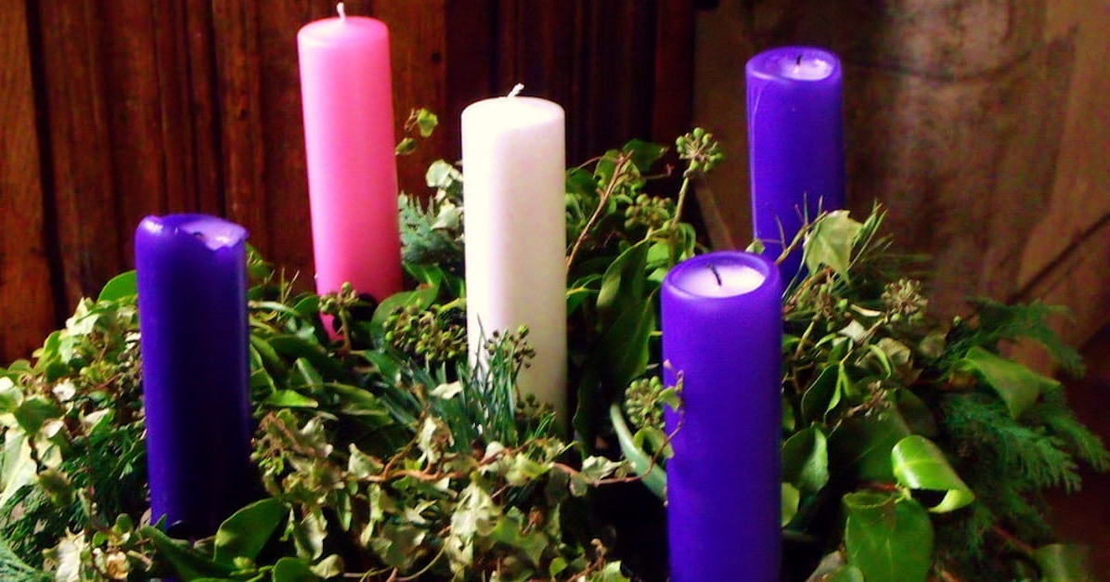
We are having a Christmas Eve Service here at Nu‘uanu Congregational Church. It will be on December 24, 2021 at 7:00 p.m., dependent on the rain. If it is not raining, the service will be in the parking lot like last year but it won’t only be shown on a screen! Please keep an eye out in your email sometime Thursday after 4 pm.

Give Aloha Reminder
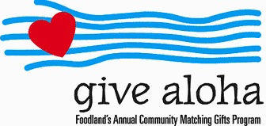
We’re in December! There are only a handful of receipts that haven’t been turned in yet! Please drop off or mail your receipt, with your name at the top of the receipt, to the office as soon as you can. We would like to make sure it’s part of 2021 Donations/Pledges!

