**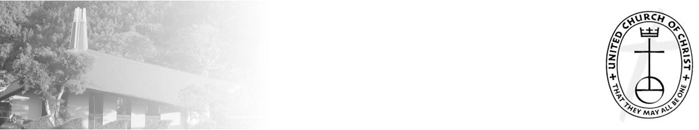**

***NCC News***

**November 7, 2021**



*A Weekly Newsletter of Nu‘uanu Congregational Church*

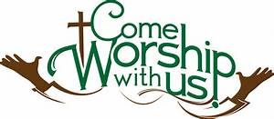

## ****Crossroads Opens Nominations for Peacemaker Award****

*From UCC Coconut Wireless*

Church of the Crossroads is now accepting nominations for the 2022 Hawai'i [Martin Luther King, Jr., Peacemaker Award](https://hcucc.us1.list-manage.com/track/click?u=d09d80abc8cc6a2ef04d9acf4&id=df3356b9dd&e=893b6006d9" \t "_blank). If you know of a deserving person or organization in the Hawai'i community whose life and work exemplify a lifelong concern and commitment to the ideals of peace and social justice, please submit your nomination, including any supporting documents. Please include a contact number or email for confirmation of receipt of the submission. Mail nominations to: Dr. Martin Luther King, Jr. Celebration Committee, Attention: Jim Howell, Church of the Crossroads, 1212 University Avenue, Honolulu, HI, 96826, or email [office@churchofthecrossroadshawaii.org](mailto:office@churchofthecrossroadshawaii.org). The deadline to submit nominations and supporting documents is **December 10**.

**Give Aloha Reminder**

*by Mairi Manley*

Please drop off or mail your receipt, with your name at the top of the receipt, to the office as soon as you can. We would like to make sure it’s part of 2021 Donations/Pledges!

**Third Quarter Pledge Statement Pick-up**

Third Quarter Pledge Statements will be ready for pick up on Sunday, November 14, 2021. We will have them ready to be picked up until Sunday, November 21, 2021, and then they will be mailed to you!

**Food Drive**

*By Mairi Manley*

**** Our monthly collection for the Hawaii Foodbank will be on November 7, 2021. Please bring your donations when we have our very 1st In-Person Service since August.

In the first year of the pandemic, the Hawaii Foodbank had to purchase more than 12.5 million dollars worth of emergency food. Their regular annual budget is $400,000. So the need is great. Last month we collected 164 pounds of food and $50.00 dollars.

Monetary donations are always welcome. We will no longer accept checks

made payable to Nu‘uanu Congregational Church for the Hawai‘i Foodbank.

**Please make checks payable to: Hawaii Foodbank.**

**In Search of Rev. Masaichi’s Wartime Banner**

*by Randy Obata*

We’ve received a picture of the banner from Albert Matsumoto! If anyone else has any photo’s, please call Mairi in the office!

We need your help locating an old cloth banner—or any information related to the banner—which was once stored for many years, dating back to the 1970s, at Nuuanu Congregational Church but appears to be missing. The banner was created by Rev. Masaichi Goto and displayed at NCC’s men’s dormitory during World War II when the church was located at Kukui Street and Nuuanu Avenue. The banner lists the names of dormitory residents who volunteered to serve our country when the war began. Also listed are names of the young men, highlighted with a blue star, who were killed in action. One person recalls the banner having a colored border along its edges and measuring approximately 3.5 ft. wide x 5 ft. long. We are also interested in finding the names of anyone who lived in the dormitory during those wartime years.

Randy Obata, a member of the Kensaku and Tsuru Obata Endowment Committee, is seeking the banner for inclusion in the Endowment’s current video and oral history project about NCC. If you may know anything about the banner, please contact Mairi Manley, NCC’s administrative coordinator, at [nccadmin@hawaiiantel.net](mailto:nccadmin@hawaiiantel.net) or 595-3935. You may also contact Randy at [randy.obata@gmail.com](mailto:randy.obata@gmail.com).