A Weekly Newsletter of Nu‘uanu Congregational Church
NCC News
November 28, 2021

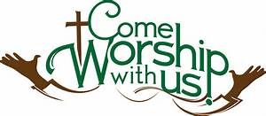

Crossroads Opens Nominations for Peacemaker Award
From UCC Coconut Wireless
Church of the Crossroads is now accepting nominations for the 2022 Hawai'i Martin Luther King, Jr., Peacemaker Award. If you know of a deserving person or organization in the Hawai'i community whose life and work exemplify a lifelong concern and commitment to the ideals of peace and social justice, please submit your nomination, including any supporting documents. Please include a contact number or email for confirmation of receipt of the submission. Mail nominations to: Dr. Martin Luther King, Jr. Celebration Committee, Attention: Jim Howell, Church of the Crossroads, 1212 University Avenue, Honolulu, HI, 96826, or email office@churchofthecrossroadshawaii.org. The deadline to submit nominations and supporting documents is December 10.

Third Quarter Pledge Statement Pick-up
Third Quarter Pledge Statements will be ready for pick up on Sunday, November 21, 2021. We will have them ready to be picked up until Sunday, November 28, 2021, and then they will be mailed to you!

November 19, 2021
Moderator’s Desk
The NCC Council, Boards and Committees are “full steam ahead” with the holidays coming and the in-person worship services, Advent and holiday card giving! We are preparing to introduce the NCC congregation to the next steps with our organization, future partnerships and recommendations from the Council. Exciting times are definitely ahead of us!
First thing, we will be holding a Town Hall to review the recommendations the Council has for the congregation on 11/28/2021 after our in-person service. The meeting will be held in the sanctuary and for an hour to be courteous to the Samoan church’s service. For those who are unable to meet with us after services on 11/28, we will have another opportunity for you to hear what is being recommended for NCC on Zoom on 12/4/2021 Saturday at 10 a.m. More information is forthcoming.
We also invited the YMCA of Honolulu staff to provide us a short presentation on their Winter Intersession that will be held on our campus on 12/12/20-12/30. Please be here in our service to hear what their program is all about.
Don’t forget our Annual Meeting is around the corner on January 30, 2022 and God-willing we hope to have the meeting in-person. We are preparing for in-person as well as by ballot to be prepared for any changes in the mandates issued by the State and the County regarding the COVID-19.
Again, we ask for your patience and prayers to move our church forward with God’s grace and guidance.

Forever grateful,
Laurie Hamano, Moderator
Stewardship
By Mairi Manley
Please be on the look out for a mailing with a letter from Pastor Jeannie and the 2022 Pledge cards. Mail the pledge cards back to the office at 2651 Pali Highway, Honolulu, HI 96817 or drop it off when you do come to our NCC in-person worship service!

White Christmas
By Judy Keith
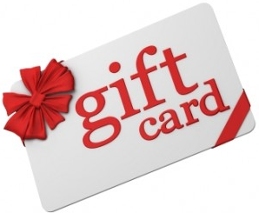
Advent is just around the corner. We will be doing our White Christmas gift card collection each Sunday during Advent. Last year we collected over $1,500.00 dollars for Family Promise, River of Life Mission, & the Transition House. It's been a rough year for everyone, Let's do what we can to brighten the holiday for others who are in need.
Please mail or drop off the cards to the NCC Office.

Advent Wreath Kits and Christmas Cards
By Becky Kanenaka
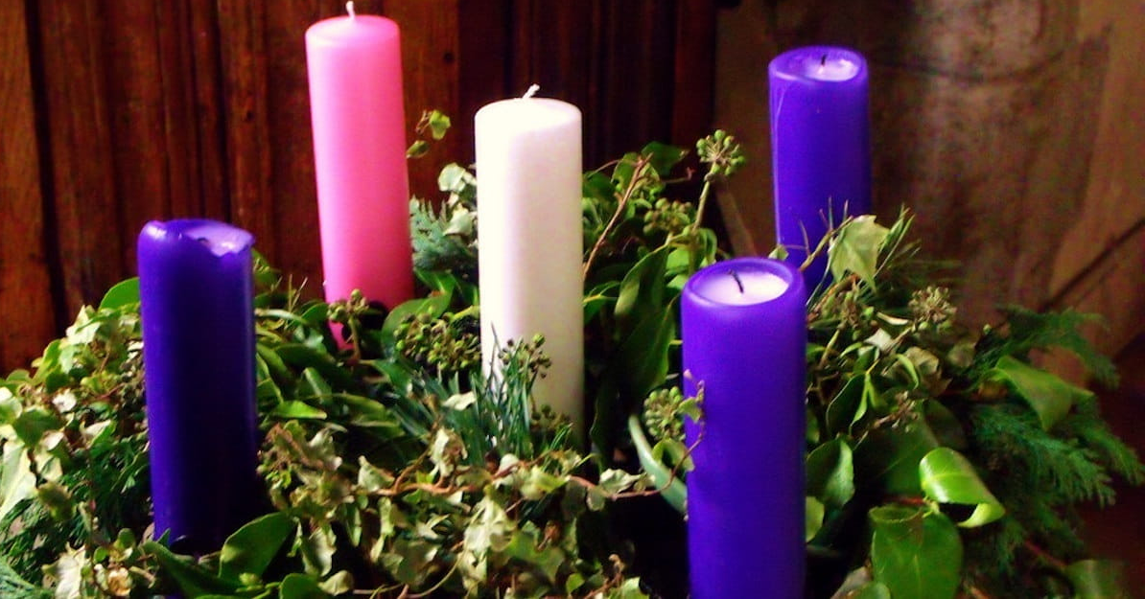
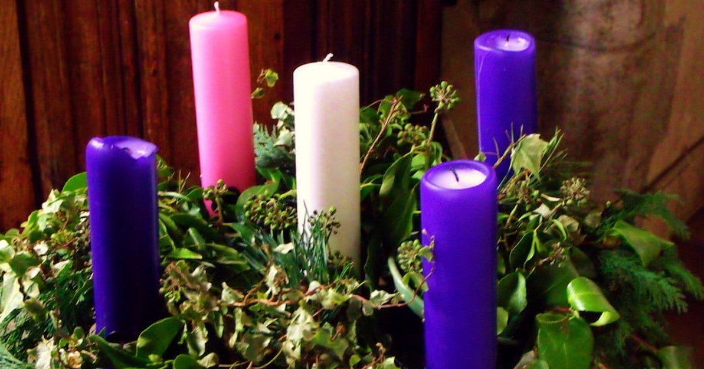
On November 28, 2021, Christmas cards along with a list of shut-ins will be passed out after worship. Please let Mairi or Becky know if you would like a packet of Christmas cards. Like last year, we are asking that you mail the Christmas cards directly to the person you are writing to.
If you have any questions, please call Mairi at (808) 595-3935 or Becky 808.282.4321

Give Aloha Reminder
Please drop off or mail your receipt, with your name at the top of the receipt, to the office as soon as you can. We would like to make sure it’s part of 2021 Donations/Pledges!

