A Weekly Newsletter of Nu‘uanu Congregational Church
NCC News
November 21, 2021

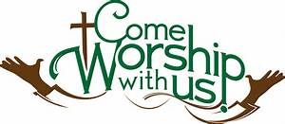

Crossroads Opens Nominations for Peacemaker Award
From UCC Coconut Wireless
Church of the Crossroads is now accepting nominations for the 2022 Hawai'i Martin Luther King, Jr., Peacemaker Award. If you know of a deserving person or organization in the Hawai'i community whose life and work exemplify a lifelong concern and commitment to the ideals of peace and social justice, please submit your nomination, including any supporting documents. Please include a contact number or email for confirmation of receipt of the submission. Mail nominations to: Dr. Martin Luther King, Jr. Celebration Committee, Attention: Jim Howell, Church of the Crossroads, 1212 University Avenue, Honolulu, HI, 96826, or email office@churchofthecrossroadshawaii.org. The deadline to submit nominations and supporting documents is December 10.

Third Quarter Pledge Statement Pick-up
Third Quarter Pledge Statements will be ready for pick up on Sunday, November 21, 2021. We will have them ready to be picked up until Sunday, November 28, 2021, and then they will be mailed to you!

Nu‘uanu Valley Interfaith Thanksgiving Service
On Tuesday, November 23, 2021, there will be the Nu‘uanu Valley Thanksgiving Interfaith Service via Zoom. The service will start at 7 p.m. and the link is https://www.facebook.com/nuuanuinterfaith/!

Food Drive
By Mairi Manley
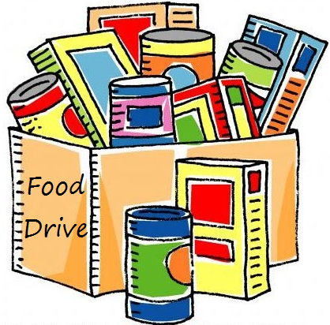
On Thanksgiving Sunday, November 28, bring non-perishable food items to place in our sukkah to donate to the Hawaii Foodbank. If you would prefer to make a monetary donation, please make your check out to the Hawaii Foodbank.

Stewardship
By Mairi Manley
Please be on the look out for a mailing with a letter from Pastor Jeannie and the 2022 Pledge cards. Mail the pledge cards back to the office at 2651 Pali Highway, Honolulu, HI 96817 or drop it off when you do come to our NCC in-person worship service!

White Christmas
By Judy Keith
Advent is just around the corner. We will be doing our White Christmas gift card collection each Sunday during Advent. Last year we collected over $1,500.00 dollars for Family Promise, River of Life Mission, & the Transition House. It's been a rough year for everyone, Let's do what we can to brighten the holiday for others who are in need.
Please mail or drop off the cards to the NCC Office.

Pies for Family Promise
By Judy Keith
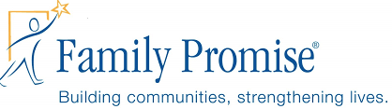
What would Thanksgiving be without pie? We are collecting monetary donations to purchase twelve pies from Costco for the guests at Family Promise at Thanksgiving. Sign up with Judy Keith if you would like to contribute.

Switching of Holidays
By Mairi Manley
This year, the NCC office is trying something new! We will be switching the Veteran's Day Holiday, November 11, 2021 for the day after Thanksgiving. If you need anything on November 11, 2021, from either myself or Pastor Jeannie, please call or email us!

Advent Wreath Kits and Christmas Cards
By Becky Kanenaka
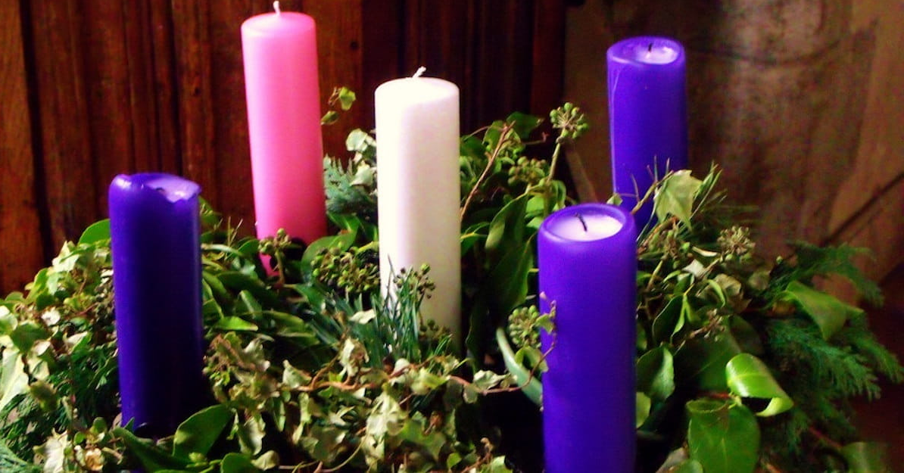
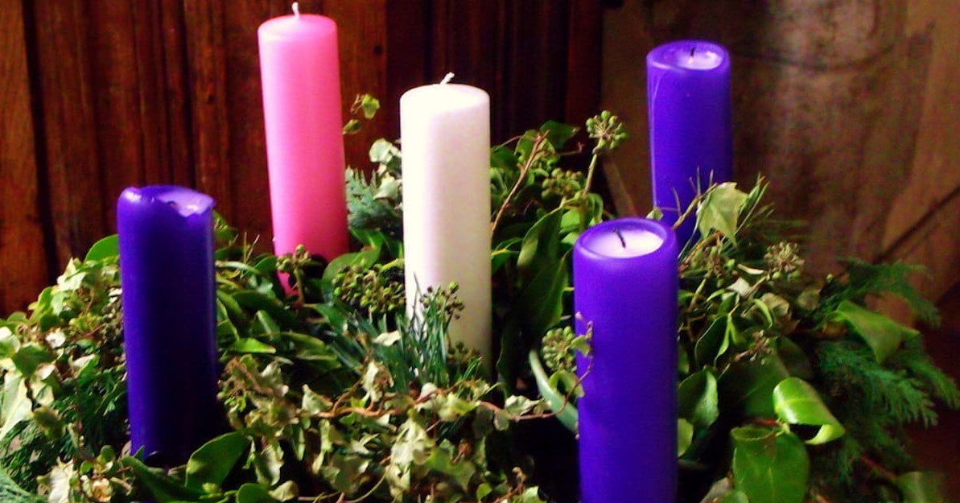
Advent wreath kits will be passed out early this year. The kits will be passed out November 21, 2021. Please let Mairi or Becky know if you would like an advent wreath kit. Email Becky at ken214@hawaii.rr.com

On November 28, 2021, Christmas cards along with a list of shut-ins will be passed out after worship. Please let Mairi or Becky know if you would like a packet of Christmas cards. Like last year, we are asking that you mail the Christmas cards directly to the person you are writing to.

If you have any questions, please call Mairi at (808) 595-3935 or Becky 808.282.4321

Town Hall Meeting
After service on November 28, 2021 we will be having a
Town hall meeting to discuss the recommendations made by
the Council! If you can’t make it on the 28th, we will be
having one via Zoom on December 4, 2021 at 9 a.m.

Give Aloha Reminder
by Mairi Manley
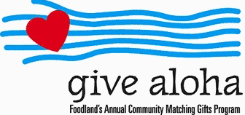
Please drop off or mail your receipt, with your name at the top of the receipt, to the office as soon as you can. We would like to make sure it’s part of 2021 Donations/Pledges!

