A Weekly Newsletter of Nu‘uanu Congregational Church
NCC News
November 14, 2021

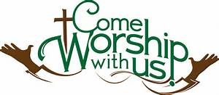

Crossroads Opens Nominations for Peacemaker Award
From UCC Coconut Wireless
Church of the Crossroads is now accepting nominations for the 2022 Hawai'i Martin Luther King, Jr., Peacemaker Award. If you know of a deserving person or organization in the Hawai'i community whose life and work exemplify a lifelong concern and commitment to the ideals of peace and social justice, please submit your nomination, including any supporting documents. Please include a contact number or email for confirmation of receipt of the submission. Mail nominations to: Dr. Martin Luther King, Jr. Celebration Committee, Attention: Jim Howell, Church of the Crossroads, 1212 University Avenue, Honolulu, HI, 96826, or email office@churchofthecrossroadshawaii.org. The deadline to submit nominations and supporting documents is December 10.

Third Quarter Pledge Statement Pick-up
Third Quarter Pledge Statements will be ready for pick up on Sunday, November 21, 2021. We will have them ready to be picked up until Sunday, November 28, 2021, and then they will be mailed to you!

Food Drive
By Mairi Manley
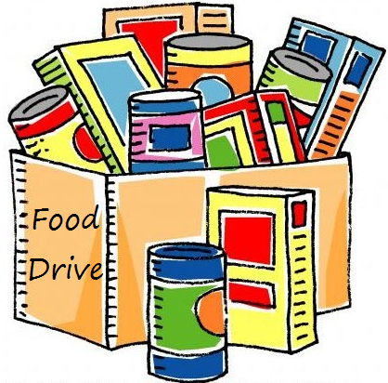
On Thanksgiving Sunday, November 28, bring non-perishable food items to place in our sukkah to donate to the Hawaii Foodbank. If you would prefer to make a monetary donation, please make your check out to the Hawaii Foodbank.

Stewardship
By Mairi Manley
Please be on the look out for a mailing with a letter from Pastor Jeannie and the 2022 Pledge cards. Mail the pledge cards back to the office at 2651 Pali Highway, Honolulu, HI 96817 or drop it off when you do come to our NCC in-person worship service!

White Christmas
By Judy Keith
Advent is just around the corner. We will be doing our White Christmas gift card collection each Sunday during Advent. Last year we collected over $1,500.00 dollars for Family Promise, River of Life Mission, & the Transition House. It's been a rough year for everyone, Let's do what we can to brighten the holiday for others who are in need.
Please mail or drop off the cards to the NCC Office.

Pies for Family Promise
By Judy Keith
What would Thanksgiving be without pie? We are collecting monetary nonations to purchase twelve pies from Costco for the guests at Family Promise at Thanksgiving. Sign up with Judy Keith if you would like to contribute.
Switching of Holidays
By Mairi Manley
This year, the NCC office is trying something new! We will be switching the Veteran's Day Holiday, November 11, 2021 for the day after Thanksgiving. If you need anything on November 11, 2021, from either myself or Pastor Jeannie, please call or email us!

Advent Wreath Kits and Christmas Cards
By Becky Kanenaka
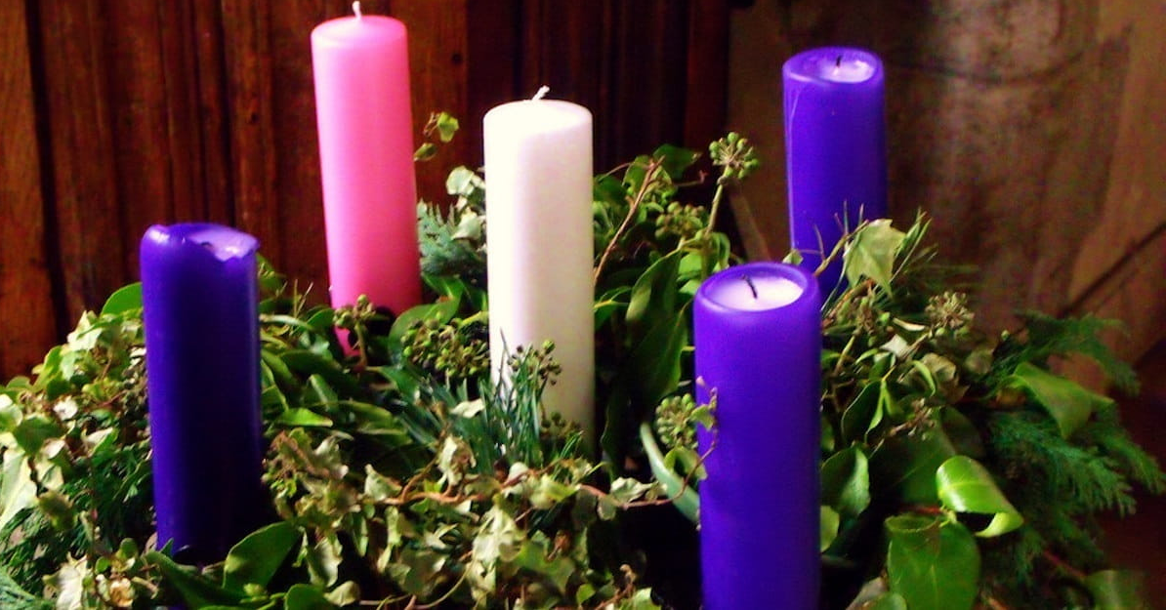
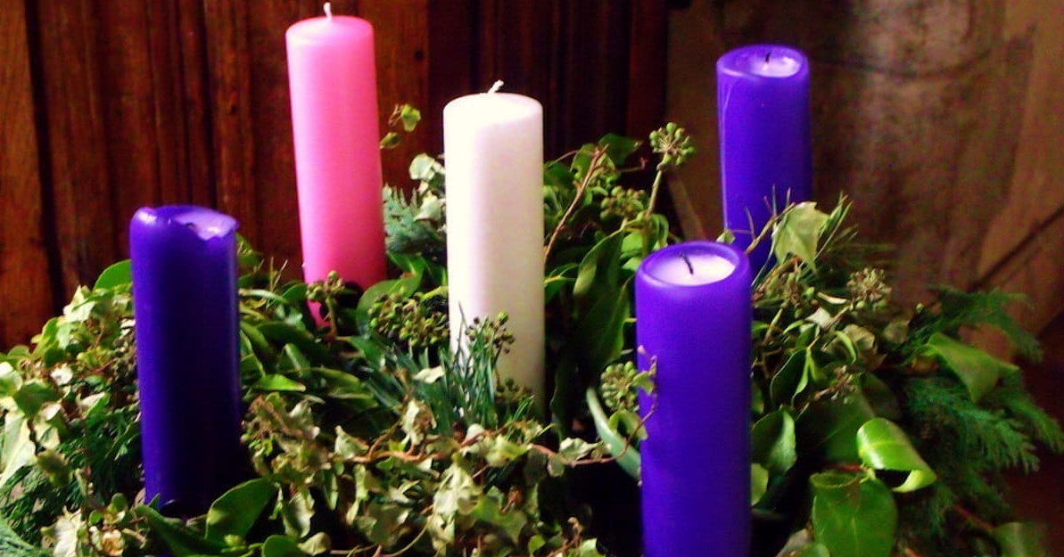
Advent wreath kits will be passed out early this year. The kits will be passed out November 21, 2021. Please let Mairi or Becky know if you would like an advent wreath kit. Email Becky at ken214@hawaii.rr.com

On November 28, 2021, Christmas cards along with a list of shut-ins will be passed out after worship. Please let Mairi or Becky know if you would like a packet of Christmas cards. Like last year, we are asking that you mail the Christmas cards directly to the person you are writing to.

If you have any questions, please call Mairi at (808) 595-3935 or Becky 808.282.4321

Give Aloha Reminder
by Mairi Manley
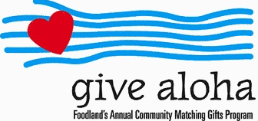
Please drop off or mail your receipt, with your name at the top of the receipt, to the office as soon as you can. We would like to make sure it’s part of 2021 Donations/Pledges!

In Search of Rev. Masaichi’s Wartime Banner
by Randy Obata
We’ve received a picture of the banner from Albert Matsumoto! If anyone else has any photos, please call Mairi in the office!
We need your help locating an old cloth banner—or any information related to the banner—which was once stored for many years, dating back to the 1970s, at Nuuanu Congregational Church but appears to be missing. The banner was created by Rev. Masaichi Goto and displayed at NCC’s men’s dormitory during World War II when the church was located at Kukui Street and Nuuanu Avenue. The banner lists the names of dormitory residents who volunteered to serve our country when the war began. Also listed are names of the young men, highlighted with a blue star, who were killed in action. One person recalls the banner having a colored border along its edges and measuring approximately 3.5 ft. wide x 5 ft. long. We are also interested in finding the names of anyone who lived in the dormitory during those wartime years.
Randy Obata, a member of the Kensaku and Tsuru Obata Endowment Committee, is seeking the banner for inclusion in the Endowment’s current video and oral history project about NCC. If you may know anything about the banner, please contact Mairi Manley, NCC’s administrative coordinator, at nccadmin@hawaiiantel.net or 595-3935. You may also contact Randy at
NCC News
November 14, 2021
randy.obata@gmail.com.

