A Weekly Newsletter of Nu‘uanu Congregational Church
NCC News
October 31, 2021

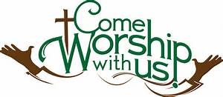
All Saints Day 2021: Remembering Our Loved Ones Lost to COVID-19
by Pastor Jeannie Thompson
On Monday, November 1st, All Saints Day, Central Union Church (CUC) will host an all-day memorial event to remember those people in our Hawaii community who have died of COVID-19.
A chair for each person will be placed on the lawn in front of CUC which is located at 1660 South Beretania Street.
Throughout the day, pastors from our UCC churches will take shifts to offer a ministry of presence. All people from every faith tradition are invited to stop and pay their respects. At noon, we will begin tolling the bell for each person who has died since the pandemic began.
Says the Rev. Brandon Duran of CUC: “we will give thanks for those who died, and hope this gesture will provide a space for loved ones to remember and grieve.”
The event will be open to the public starting at 8:00 AM until 6:00PM, November 1st.

Volunteers needed for All Saints Day at Central Union Church (11/01/21)
NCC News
September 26, 2021
By Brandon Duran (Rev. at Central Union)

Hi friends, I hope you're well. Thank you for adding your time and energy to this work of grace. I would love to hear your thoughts and suggestions to the notes below. Here's an All Saints Day update:

Proposed Schedule:
- 7:00am-8:00am Chair set up
- 12:00pm-1:00pm Program
- 6:00pm-7:00:pm Chair break down

Needs:
- We will need plenty volunteers to help set up and break down chairs. Please let me know if you are able to recruit members from your church. If each church can bring 5 people that would help a lot!
- Clergy to stand vigil as a ministry of presence throughout the day. Can you stand vigil? If so what times? Vital times are:
  - 8:00am-9:00am
  - 12:00pm-1:00pm
  - 5:00pm-6:00pm

Please let Mairi Manley know if you can help, (808) 595-3935 or nccadmin@hawaiiantel.net.

The Festival of All Saints, November 7, 2021
By Lori Yamashiro
The Festival of All Saints is the church’s memorial day, and again this year we will have a special service on Sunday, November 7 at 9 a.m. to remember the saints. We will recall those who have made contributions to our world and also members of Nu‘uanu Congregational Church whom we have named as our “Nu‘uanu Saints.” A special part of the service will recall those of our membership who have died since All Saints Sunday last year. Family members will be invited to come forward and light a candle as each name is called.
All are invited to bring photographs of those you would like to remember to this service. The photographs will be placed on tables at the front of the sanctuary. With all of these saints surrounding us, we will then celebrate communion. All of us are invited to participate in this special service.

Give Aloha Reminder
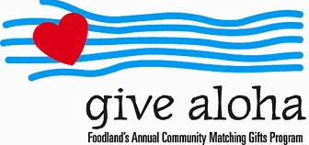
Please drop off or mail your receipt, with your name at the top of the receipt, to the office as soon as you can. We would like to make sure it’s part of 2021 Donations/Pledges!

Great News! The Mango Chutney & Jam Sale is back !!!
by Donna Chung
Don Ikeda is once again donating the “fruits” of his labor of love for Nuuanu Congregational Church. And it’s just in time for the holidays, so remember to think of your gifting needs.
It will be on the first Sunday of November at the church. Due to the pandemic, the sale will take place with pre-orders and pre-payment.
- Please fill out the “attached“ order form (or handwrite your order). The order form is also on nuuanu.org.
- Then send or bring to the church office with your payment
- We have sold out of many items. Mairi’s suggestion is to call the office with your order before mailing payment. We may not have what you are looking for by the time the order gets to the office!
If you are paying by check please make the check out to Nuuanu Congregational Church and please write “chutney sale” on the memo line of the check.
On November 7th (Sunday), your orders will be pre-packed and ready to go! There have been more than a few times when the popular mango Chutneys were sold out, so please put your orders in soon. There are 155 jars of Mango chutney available. Don will be busy preparing Lilikoi jelly, smaller amounts of Guava Jam (Sold out) and Calamondin (citrus flavor) Marmalade. His jellies and jams are almost completely sold out! The updated Order form is attached. Mairi will attach the updated order form to the Order of Worship email and updating the form on Nuuanu.org.
Don has generously added 26 more jars of the Lilikoi jam and his biscotti are completely sold out!

CALLING FOR ALL CHUTNEY AND JAM JARS!!
By Donna Chung
If you have jars from Don Ikeda’s previous chutney and jam sales, please bring them to the church office, as soon as you are able to. I will take them to Don to use for the chutneys and jams he is preparing now.

Food Drive
By Mairi Manley
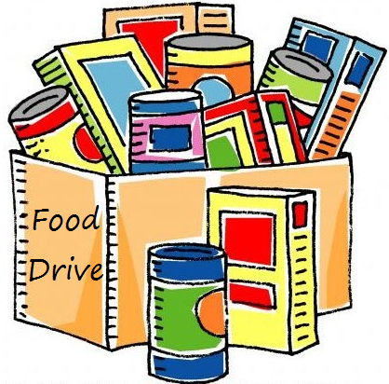
Our monthly collection for the Hawaii Foodbank will be on the first Sunday of every month. If it is not safe to have Communion Service In-Person, we will be offering drive through communion, so please bring your donations to church.
In the first year of the pandemic, the Hawaii Foodbank had to purchase more than 12.5 million dollars worth of emergency food. Their regular annual budget is $400,000. So the need is great. Last month we collected 164 pounds of food and $50.00 dollars.
Monetary donations are always welcome. We will no longer
accept checks made payable to Nu‘uanu Congregational Church for
the Hawai‘i Foodbank. Please make checks payable to: Hawaii
Foodbank.

In Search of Rev. Masaichi’s Wartime Banner
by Randy Obata
We need your help locating an old cloth banner—or any information related to the banner—which was once stored for many years, dating back to the 1970s, at Nuuanu Congregational Church but appears to be missing. The banner was created by Rev. Masaichi Goto and displayed at NCC’s men’s dormitory during World War II when the church was located at Kukui Street and Nuuanu Avenue. The banner lists the names of dormitory residents who volunteered to serve our country when the war began. Also listed are names of the young men, highlighted with a blue star, who were killed in action. One person recalls the banner having a colored border along its edges and measuring approximately 3.5 ft. wide x 5 ft. long. We are also interested in finding the names of anyone who lived in the dormitory during those wartime years.
Randy Obata, a member of the Kensaku and Tsuru Obata Endowment Committee, is seeking the banner for inclusion in the Endowment’s current video and oral history project about NCC. If you may know anything about the banner, please contact Mairi Manley, NCC’s administrative coordinator, at nccadmin@hawaiiantel.net or 595-3935. You may also contact Randy at randy.obata@gmail.com.

