A Weekly Newsletter of Nu‘uanu Congregational Church
NCC News
October 10, 2021

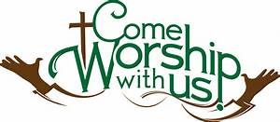
Green Day in October
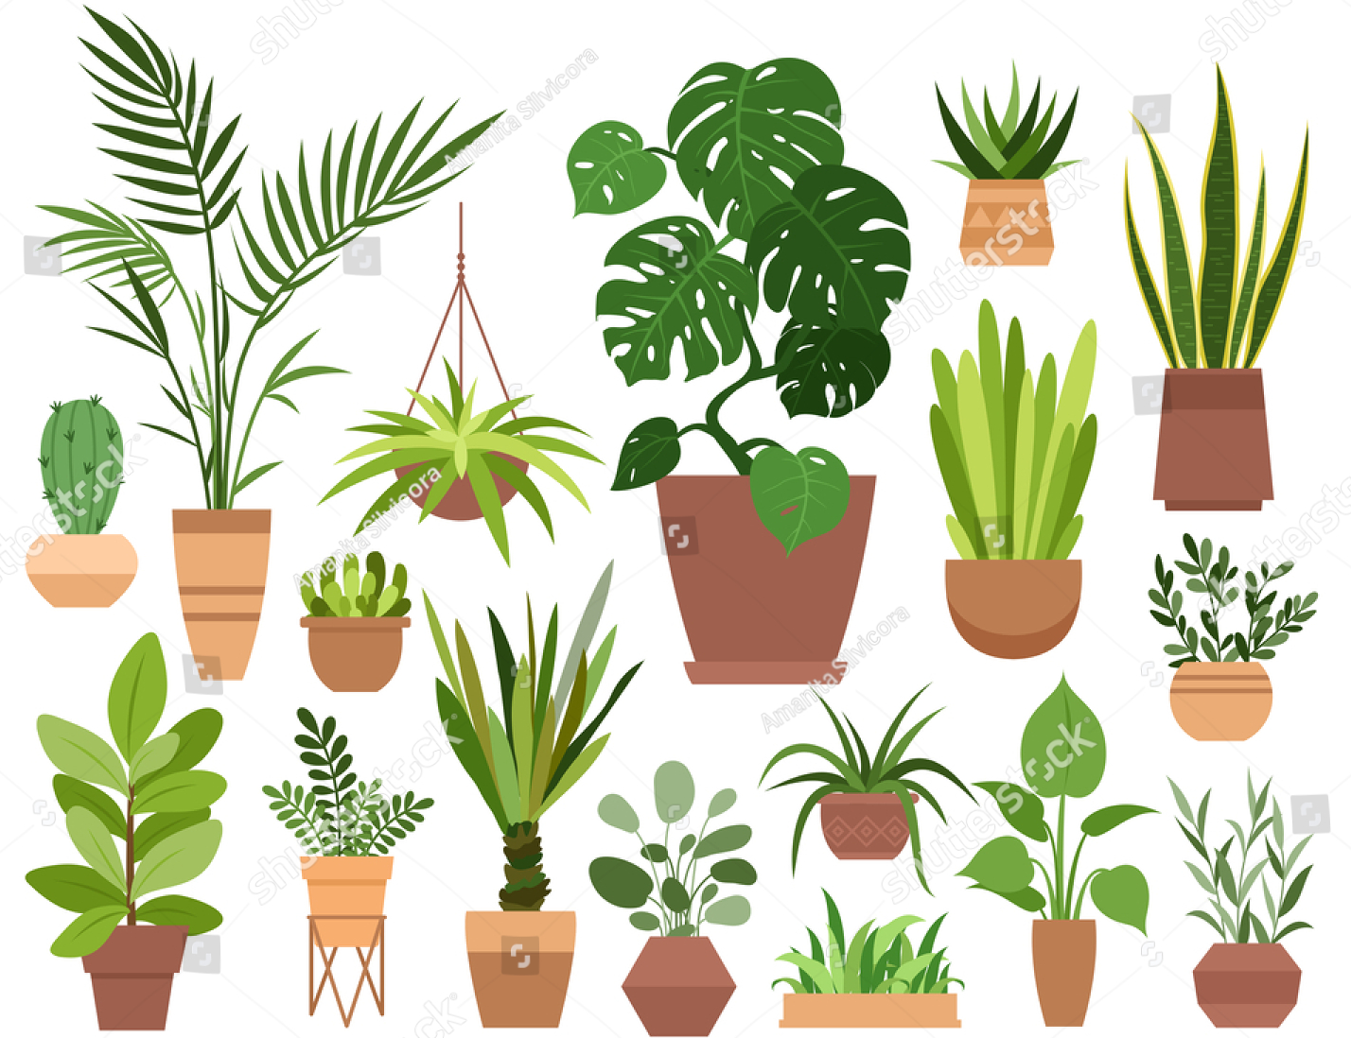
NCC Missions will have another virtual Green day this month! Pictures and prices of the plants are on nuuanu.org.
If you like anything you see, please email Becky Kanenaka at hiken214@gmail.com or Mairi Manley at nccadmin@hawaiiantel.net. We will gladly put them on the side for you.
Pick up will be on Saturday, October 23, 2021 from 9:00 am to 12:00 noon. Forms of payment accepted will be cash, check (made payable to Nuuanu Congregational Church), or venmo. Join us in supporting NCC Missions!

National Suicide and Mental Health Hotline Number
Reported by HNN News 09/29/21
Starting October 24, 2021, you will need to dial the area code 808 before the number you are trying to reach. The number may not be completed if you don’t.
The Federal Communications Commission adopted 988 as a new National Suicide Prevention and Mental Health Crisis Hotline that will take into effect on July 16, 2022. It’s like dialing 911 for the police or an ambulance but for Suicide prevention and Mental Health.
Please start to make this a habit so that you may reach whom you are calling!
CALLING FOR ALL CHUTNEY AND JAM JARS !!
By Donna Chung
If you have jars from Don Ikeda’s previous chutney and jam sales., please bring them to the church office, as soon as you are able to. I will take them to Don to use for the chutneys and jams he is preparing now.

Great News! The Mango Chutney & Jam Sale is back !!!
by Donna Chung
Don Ikeda is once again donating the “fruits” of his labor of love for Nuuanu Congregational Church. And it’s just in time for the holidays, so remember to think of your gifting needs.
It will be on the first Sunday of November at the church. Due to the pandemic, the sale will take place with pre-orders and pre-payment.
- Please fill out the “attached“ order form (or handwrite your order). The order form is also on nuuanu.org.
- Then send or bring to the church office with your payment
If you are paying by check please make the check out to Nuuanu Congregational Church and please write “ chutney sale” on the memo line of the check.
On November 7th (Sunday), your orders will be pre-packed and ready to go! This time, there is a generous offering of mango chutney, 259 jars to be exact. In addition, Don will be busy preparing Lilikoi jelly, smaller amounts of Guava Jam and Calamondin (citrus flavor) Marmalade.
If you are wondering whether there will be biscotti, there will be 50 sacks of Cranberry Biscotti and a smaller amount of Chocolate Biscotti.
For items that are offered in smaller amounts, please order early.

September 27, 2021
Moderator’s Desk
September marks our 18th month through this COVID-19 pandemic. We are incredibly thankful for the NCC teams working on determining the movement toward in-person services, the movement of the Strategic Plan for our future, worship services online and events that continue to allow us to remain connected.
The NCC Council remains strong and hard at work. The Transition Team is working toward partnerships and asking where God is calling us to be. It is with the assistance of technology that all of this has been able to keep us working in an organized fashion moving forward without missing a beat. To all of the committees, chairs and staff, thank you for your faithful service!
The application was made to CPB for the second PPP loan through the Small Business Association and NCC was approved once again for the “forgiveness” of $32,757; this totals to $85,147 in funds to NCC through the SBA and the County grant of $10,000 from last year to present. These funds allow us to pay our staff and assists us in funding our missional work.

To this, we all need to holler a resounding, “Thank You God!”

Forever thankful,
Laurie Hamano, Moderator

Give Aloha Reminder
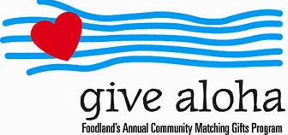
Please drop off or mail your receipt, with your name at the top of the receipt, to the office as soon as you can. We would like to make sure it’s part of 2021 Donations/Pledges!
Volunteers needed for All Saints Day at Central Union Church (11/01/21)
NCC News
September 26, 2021
By Brandon Duran (Rev. at Central Union)

Hi friends, I hope you're well. Thank you for adding your time and energy to this work of grace. I would love to hear your thoughts and suggestions to the notes below. Here's an All Saints Day update:

Proposed Schedule:
- 7:00am-8:00am Chair set up
- 12:00pm-1:00pm Program
- 6:00pm-7:00:pm Chair break down

Needs:
- We will need plenty volunteers to help set up and break down chairs. Please let me know if you are able to recruit members from your church. If each church can bring 5 people that would help a lot!
- Clergy to stand vigil as a ministry of presence throughout the day. Can you stand vigil? If so what times? Vital times are:
  - 8:00am-9:00am
  - 12:00pm-1:00pm
  - 5:00pm-6:00pm

Please let Mairi Manley know if you can help, (808) 595-3935 or nccadmin@hawaiiantel.net.

