A Weekly Newsletter of Nu‘uanu Congregational Church
NCC News
January 10, 2021

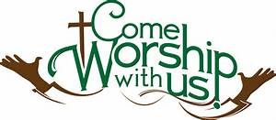
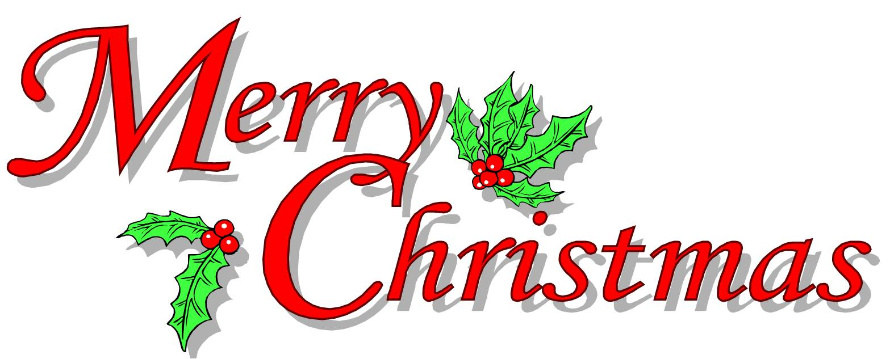
by Lori Yamashiro

NCC held it’s first ever Christmas Eve Drive-in Service this past Christmas. The service was pre-recorded and projected on a 20’ x 12’ screen that was set up against Kibo Kan and attendees could listen to the service on their car radio. It was the usual wonderful NCC Christmas Eve service: a Christmas pageant, singing Christmas carols (in our cars) and there were even (battery operated) candles to light when we sang Silent Night!
We were happy to see 24 cars and 61 people in attendance and hope they found it to be a wonderful worship experience, even though it wasn’t quite our usual service. On behalf of the Diaconate, thanks to all the scripture readers, advent candle lighters, musicians, cast and crew of the video pageant (thanks to Darwin Ing for editing the pageant video) and to Russell Ishida for editing the entire video. Special thanks to Paul & Paula Yamamoto and Lance Goya for making the big screen idea a reality.

White Christmas
Over $1,500 worth of gift cards were given, and given what a crazy year this has been, that is quite an achievement! There were gift cards for Target, Foodland, Longs, & Walmart, plus a few other places as well. Even when we are unable to come together to worship in person, we still are church & we are still being church. Well done!

2021 Offering Envelopes

In these difficult times, the church appreciates those who have continued to submit their offerings. Many have mailed their offerings while others have dropped off theirs at the church office.
We have the 2021 offering envelopes ready for pick up in the church office, for those who have pledged or who have continued to give to the church. Any envelopes that have not been picked up by February 7, 2021 (Communion Sunday) will be mailed to you.
Another option is: We are now able to accept pledges and other donations on our website! Look for the "donate" button on the homepage of our nuuanu.org website. More details about the online giving option will be included in the February Caller.

Again, thank you for supporting Nu’uanu Congregational Church.

Howard Mau
Financial Secretary

Prayer Vigil
On Wednesday, January 6, 2021, our nation’s capital was overrun by a mob bent on disrupting the certification of the presidential election. In the wake of the shocking display of vandalism and violence, the pastors in the national office of our denomination quickly put together a prayer vigil. If you would like to see it, it’s on YouTube at this link:
https://www.youtube.com/watch?v=uxmSPkuWu9o

Correction from January Caller
In Jeannie’s article, 5th paragraph, the line should read: “The first is from Jane Uyechi, who shared a devotional from the Guideposts.”

