A Weekly Newsletter of Nu‘uanu Congregational Church
NCC News
September 5, 2021

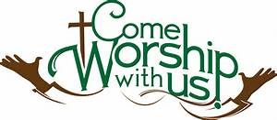
In-Person Services
The medical team met on Sunday, August 29, 2021 and decided to suspend In-Person Service through the month of September. They will meet again towards the end of September to assess the situation.
Please call me in the office if you have any questions. If I don’t have an answer, I will get one for you. Thank you for your understanding on this situation.

The Hawai‘i Foodbank Collection
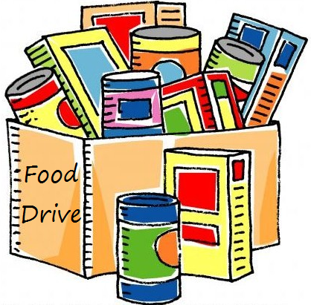
On September 5, we will have our monthly collection for the Hawaii Foodbank, as well as Drive Through Communion. Please bring your donations to church.
In the first year of the pandemic, the Hawaii Foodbank had to purchase more than 12.5 million dollars worth of emergency food. Their regular annual budget is $400,000. So the need is great. Last month we collected 209 pounds of food and 1,525 dollars.
Monetary donations are always welcome. We will no longer accept checks made payable to Nu‘uanu Congregational Church for the Hawai‘i Foodbank. Please make checks payable to: Hawaii Foodbank.
Reminder
The office will be closed on Monday, September 6, 2021 for Labor Day!

Flu Shots
By Lori Yamashiro
Dear Friends,
Save the date! The Hawai'i Conference, in coordination with Times Pharmacy, is hosting a drive-through Flu Shot Clinic at the Conference Office (1848 Nu'uanu Avenue, Honolulu) on Tuesday, September 7, from 10:30 a.m. to 11:30 a.m. Plan to stop by and get your flu shot by Times Pharmacy staff. During COVID-19 times, it is still critical to get a flu shot. Most insurance plans will cover the cost of the shot with $0 copay. Times Pharmacy is contracted with all major insurances including HMSA, Kaiser, UHA, HMA, HMAA, Tricare, and Medicare Part B. No appointment is necessary, but please email coconutwireless@hcucc.org if you plan to come by so we can ensure that we have enough of the vaccines. You must be 18 years of age or older. Peak flu season begins in early October, so get your shot early!
Thanks and stay safe!

Give Aloha is Back
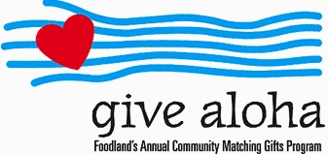
It’s that time of year! During the month of September 2021, you may make donations through Give Aloha at Foodland, Sac N Save, or Foodland Farms. The organization code for Nu‘uanu Congregational Church is 78424. The cumulative total of up to $249.00 per person/per organization is allowed.
Please drop off or mail your receipt, with your name at the top of the receipt, to the office as soon as you can. The absolute deadline to turn in your receipt is by December 31, 2021 so that we may add it to your donation total for the year.

Church World Service and the earthquake in Haiti
CWS is conducting damage assessments with partners. This process will likely take several days, given communications limitations and the magnitude of the quake. Our team will also conduct an assessment of the houses and schools that have been constructed through CWS programs in recent years to determine whether there are new needs among those program participants. We anticipate that our response will focus on recovery and rehabilitation. We know that will include housing reconstruction, trauma recovery support and water infrastructure repairs in the municipality of Pestel, a community that our team worked with to recover following Hurricane Matthew.
Please consider helping with the recovery by making a donation right now in support of CWS's response.

Church World Service assisting Afghan refugees
Church World Service have been assisting individuals who served alongside the U.S. mission in Afghanistan and urges the Biden administration and Congress to prioritize the evacuation of all of the more than 18,000. The organization, along with other U.S. partner agencies, will provide services for arrivals through case management and resettlement services.
“These men and women put themselves at risk to support the U.S. mission in Afghanistan. They were interpreters, they were cooks, they were office workers. They took on a great number of roles to keep Americans safe and defend their nation. With the withdrawal of U.S. forces, however, they are increasingly vulnerable for that service,” said Erol Kekic, Senior Vice President for the Immigration and Refugee Program at Church World Service. “That’s why we are involved from the moment they set foot on American soil, so they can focus on family and the future, not the fear they’ve been living in for far too long.”
Church World Service welcomes refugees across 17 states through 23 offices. They provide services to newly arrived refugees and immigrants, helping them to integrate into local communities, find jobs and learn the necessary skills to support their new lives in the United States.
Please mail your check, payable to:
Church World Service
P.O. Box 968
Elkhart, IN 46515
Church World Service, Inc., is tax-exempt under section 501(c)(3) of the U.S. Internal Revenue Code.

Severe Storms 2021
From UCC Coconut Wireless
More than 20 U.S. states from the South to the Northeast are reeling from the impact of Hurricane Ida and its sizeable remnants with catastrophic water and wind damage, including significant power outages.
To stay on top of the unfolding situation, United Church of Christ Disaster Ministries is listening in to coordination calls and reaching out to UCC Conference Ministers and Back Bay Mission as they begin their damage assessments.
Recovery needs, both short- and long-term, will be massive, with damage estimates in the billions of dollars.
In addition to monitoring the big picture, UCC Disaster Ministries is collecting news of damage to UCC churches.
The wind ripped off the roof of Little Farms UCC in Metairie, La., and damaged St. Paul’s UCC in New Orleans. Back Bay Mission, a UCC community ministry in Biloxi, Miss., reported light damage: missing screens, and lots of debris and downed tree limbs.
This isn’t the first severe storm this year and we can be reasonably sure it won’t be the last.
What’s the best way to help now? Send money. UCC Disaster Response and Recovery Minister Lesli Remaly said of Hurricane Ida, “For a storm this size, money makes good sense as we know long-term recovery and rebuilding will be necessary.”
One can also mail a check made payable to the United Church of Christ PO BOX 71957 Cleveland, OH 44194. Please be sure to note “2021 Severe Storms” on your check in the memo section, or in an attached letter.
Top of Form
Bottom of Form

