**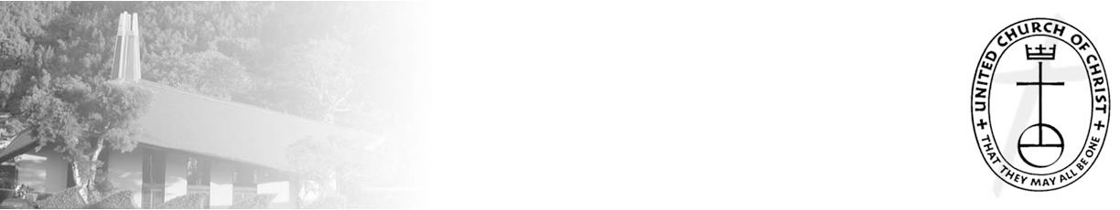***A Weekly Newsletter of Nu‘uanu Congregational Church*

***NCC News***

**September 26, 2021**

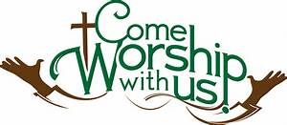

**The Hawai‘i Foodbank Collection**

*By Mairi Manley*

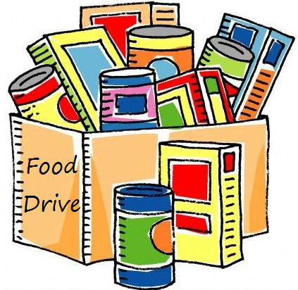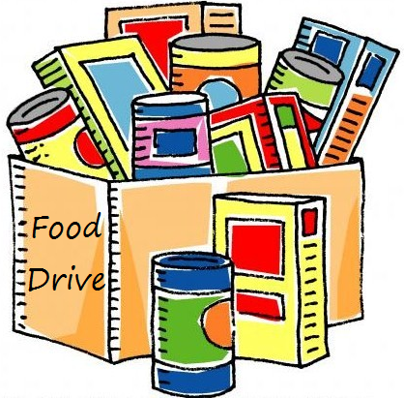 Our monthly collection for the Hawaii Foodbank will be on the first Sunday of every month. If it is not safe to have Communion Service In-Person, we will be offering drive through communion, so please bring your donations to church.

In the first year of the pandemic, the Hawaii Foodbank had to purchase more than 12.5 million dollars worth of emergency food. Their regular annual budget is $400,000. So the need is great. Last month we collected 191 pounds of food and $210.00 dollars.

Monetary donations are always welcome. **Please make checks payable to: Hawaii Foodbank.**

**Hawai'i Unveils SMART Health Card**

*From UCC Coconut Wireless*

Individuals who are fully vaccinated and have received vaccination in Hawai'i can obtain a SMART Health Card to show establishments, such as restaurants, businesses and other venues, proof of their vaccination on their digital device without carrying a physical vaccine document.  
     A Hawai'i SMART Health Card is a feature found in the Hawai'i Safe Travels Digital Platform and follows the format recommended by the Vaccine Credential Initiative. This format is also used by some other states such as California and some vaccination providers such as CVS.

Read more about the SMART health card at <https://hawaiicovid19.com> and [upload](https://hcucc.us1.list-manage.com/track/click?u=d09d80abc8cc6a2ef04d9acf4&id=16e810840d&e=893b6006d9" \t "_blank) your vaccination information to receive a QR code.

**O'ahu Association Churches Gather for Fall Mokupuni**

*From UCC Coconut Wireless*

The pandemic has been hard on all of our churches and on all in our community, including the homeless, the most vulnerable among us. With stimulus payments as well as eviction moratoriums ending, what can churches do? It is a good time for us to hear from those who work among the homeless, who can help us gain wisdom and work together as the Body of Christ—whether as individual churches or together.  
     The O'ahu Association invites its churches to join us **virtually** at our Fall Mokupuni on Saturday, October 9, for a time of learning, discerning, and celebrating. Presenting our program on homelessness and faith communities will be MacArthur Flournoy, chaplain at The Institute for Human Services (IHS), along with Connie Mitchell, IHS executive director; Jerry Coffee, IHS staff; Ellen Carson, retired attorney and IHS board member; Irene Hassan, United Church of Christ Minister for Refugee and Migration Services; and Pastor

Brandon Duran, Central Union Church.

**Neighbors in Need (NIN)**

*By Wayne Koboyashi*

NIN is a mission offering of the UCC that supports ministries of justice and compassion throughout the United States. One-third of the funds is used by The Council for American Indian Ministry and its witness among indigenous churches and people. Two-thirds of this offering is used by the UCC’s Justice and Witness Ministries.

Grants are also awarded to churches and organizations for projects that address the rights and freedoms of all persons, environmental justice, or economic justice. During this year, special consideration will be given to projects focusing on serving our immigrant neighbors and communities.

We will be receiving the offering on World Communion Sunday, Oct. 3, 2021. Envelopes will be included with the October Caller.

# State to distribute 1 million free at-home COVID tests on Oahu

# *From HNN News 9/20/21*

With the help of a Federal pilot program, the state health department will be distributing 1 million free, at home COVID Test to eligible zip codes. To order a test kit, go to [COVIDTestHonolulu.org](http://covidtesthonolulu.org/" \t "_blank). They’re available through Oct. 18 while supplies last.

Residents in the following zip codes are available to get the tests:

96701, 96706, 96707, 96712, 96717, 96730, 96731, 96734, 96744, 96762, 96782, 96786, 96789, 96791, 96792, 96795, 96797, 96813, 96814, 96815, 96816, 96817, 96818, 96819, 96821, 96822, 96825, 96826, 96844, 96850, 96853, 96854, 96857, 96858, 96859, 96860, 96861, 96863.

Officials said 125,000 Oahu residents in eligible zip codes will get eight rapid antigen tests in order to test twice a week for four weeks.

Ideal candidates include those who are unvaccinated or have a high risk of COVID exposure.

Participants in the program will get rapid antigen tests that require a quick swab inside each nostril. Results are ready in about 10 minutes.

Those who test positive on self-administered tests should follow [home isolation guidelines](https://linkprotect.cudasvc.com/url?a=https%3a%2f%2fcovidtesthonolulu.org%2fwp-content%2fuploads%2f2021%2f09%2fHome-Isolation-and-Quarantine-Guidance-1.pdf&c=E,1,MpdAAgpC_wyPIrEY_xxZaceeoZHuOciyk2ksEeUTld0iIJMd3sg7Mn6hhb7Kh_wf3eKSXue35CxLLqn5ySrwxXYXSyEfbF-_ueqU8zGc5vP5&typo=1) and contact their healthcare provider to seek follow-up testing.

**Give Aloha is Back**

*by Mairi Manley*

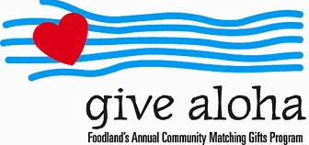 During the month of September 2021, you may make donations through Give Aloha at Foodland, Sac N Save, or Foodland Farms. The organization code for Nu‘uanu Congregational Church is 78424. The cumulative total of up to $249.00 per person/per organization is allowed.

Please drop off or mail your receipt, with your name at the top of the receipt, to the office as soon as you can. The deadline to turn in your receipt is by December 31, 2021 so it can be included in your donation total for the year.

**Green Day in October**

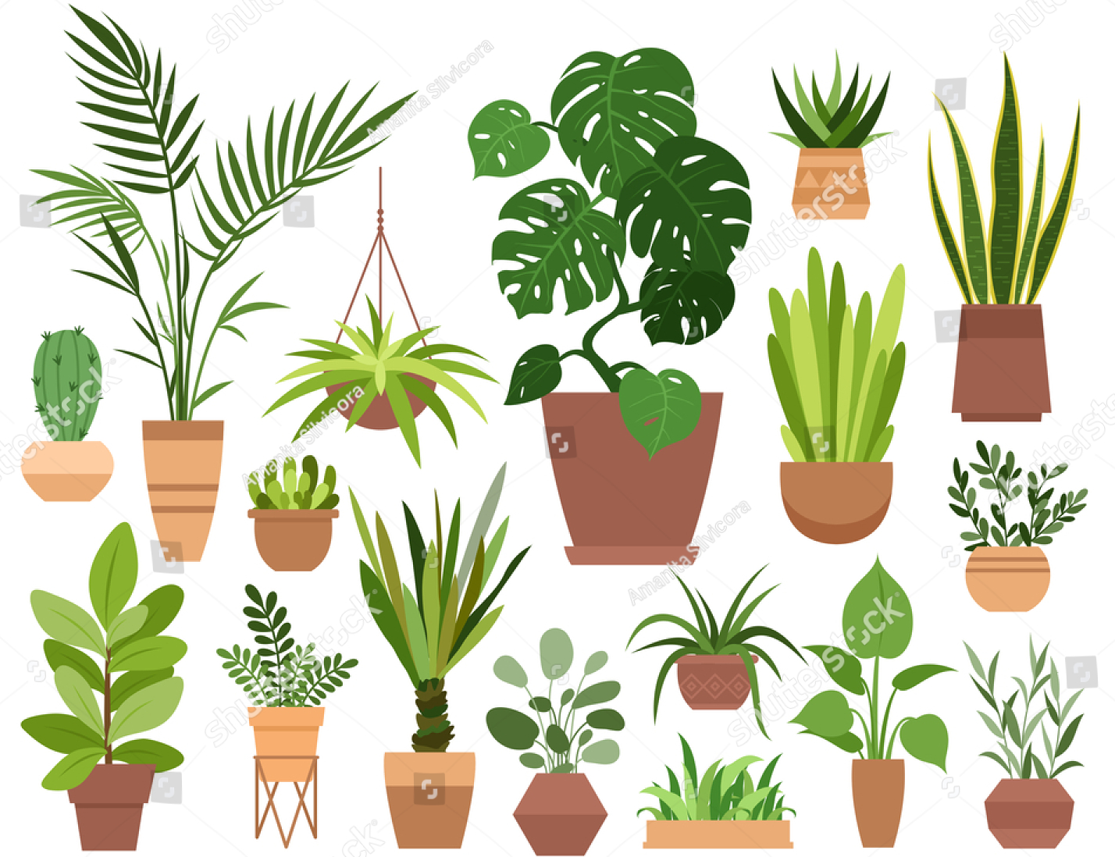 NCC Missions will have another virtual Green day this month! Pictures and prices of the plants will be loaded onto [nuuanu.org](http://nuuanu.org) by October 8, 2021.

If you like anything you see, please email Becky Kanenaka at [hiken214@gmail.com](mailto:hiken214@gmail.com) or Mairi Manley at [nccadmin@hawaiiantel.net](mailto:nccadmin@hawaiiantel.net). We will gladly put them on the side for you.

Pick up will be on Saturday, October 23, 2021 from 9:00 am to 12:00 noon. Forms of payment accepted will be cash, check (made payable to Nuuanu Congregational Church), or venmo. Please join us in supporting NCC Missions!

****

***NCC News***

**September 26, 2021**

**Scouts Troop 201**

Many thanks to the Scouts Troop for repainting the stall lines, handicap stall, speed bumps, and curb walls in the upper parking lot on Saturday September 11, 2021. What a good deed on the 20th anniversary of September 11, 2001 attacks!