**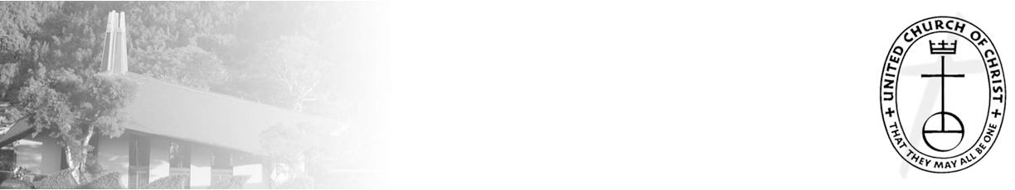**

***NCC News***

**September 19, 2021**

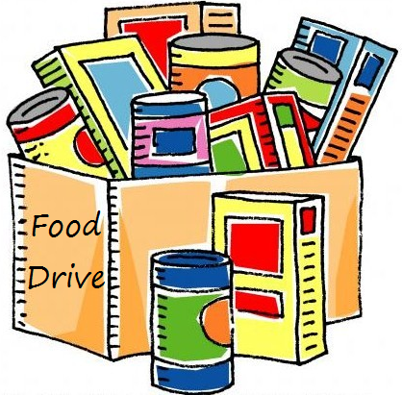



*A Weekly Newsletter of Nu‘uanu*

*Congregational Church*

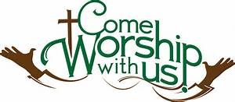

**The Hawai‘i Foodbank Collection**

*By Mairi Manley*

Our monthly collection for the Hawaii Foodbank will be on the first Sunday of every month. If it is not safe to have Communion Service In-Person, we will be offering drive through communion, so please bring your donations to church.

In the first year of the pandemic, the Hawaii Foodbank had to purchase more than 12.5 million dollars worth of emergency food. Their regular annual budget is $400,000. So the need is great. Last month we collected 191 pounds of food and $210.00 dollars.

Monetary donations are always welcome. **Please make checks payable to: Hawaii Foodbank.**

**Give Aloha is Back**

*by Mairi Manley*

During the month of September 2021, you may make donations through Give Aloha at Foodland, Sac N Save, or Foodland Farms. The organization code for Nu‘uanu Congregational Church is 78424. The cumulative total of up to $249.00 per person/per organization is allowed.

Please drop off or mail your receipt, with your name at the top of the receipt, to the office as soon as you can. The deadline to turn in your receipt is by December 31, 2021 so it can be included in your donation total for the year.

**Scouts Troop 201**

Many thanks to the Scouts Troop for repainting the stall lines, handicap stall, speed bumps, and curb walls in the upper parking lot on Saturday September 11, 2021. What a good deed on the 20th anniversary of September 11, 2001 attacks!

**Hawai'i Unveils SMART Health Card**

*From UCC Coconut Wireless*

Individuals who are fully vaccinated and have received vaccination in Hawai'i can obtain a SMART Health Card to show establishments, such as restaurants, businesses and other venues, proof of their vaccination on their digital device without carrying a physical vaccine document.  
     A Hawai'i SMART Health Card is a feature found in the Hawai'i Safe Travels Digital Platform and follows the format recommended by the Vaccine Credential Initiative. This format is also used by some other states such as California and some vaccination providers such as CVS.

Read more about the SMART health card at <https://hawaiicovid19.com> and [upload](https://hcucc.us1.list-manage.com/track/click?u=d09d80abc8cc6a2ef04d9acf4&id=16e810840d&e=893b6006d9" \t "_blank) your vaccination information to receive a QR code.

**O'ahu Association Churches Gather for Fall Mokupuni**

*From UCC Coconut Wireless*

The pandemic has been hard on all of our churches and on all in our community, including the homeless, the most vulnerable among us. With stimulus payments as well as eviction moratoriums ending, what can churches do? It is a good time for us to hear from those who work among the homeless, who can help us gain wisdom and work together as the Body of Christ—whether as individual churches or together.  
     The O'ahu Association invites its churches to join us **virtually** at our Fall Mokupuni on Saturday, October 9, for a time of learning, discerning, and celebrating. Presenting our program on homelessness and faith communities will be MacArthur Flournoy, chaplain at The Institute for Human Services (IHS), along with Connie Mitchell, IHS executive director; Jerry Coffee, IHS staff; Ellen Carson, retired attorney and IHS board member; Irene Hassan, United Church of Christ Minister for Refugee and Migration Services; and Pastor

Brandon Duran, Central Union Church.