A Weekly Newsletter of Nu‘uanu Congregational Church
NCC News
September 12, 2021

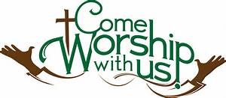

In-Person Services
The medical team met on Sunday, August 29, 2021 and decided to suspend In-Person Service through the month of September. They will meet again towards the end of September to assess the situation.
Please call me in the office if you have any questions. If I don’t have an answer, I will get one for you. Thank you for your understanding on this situation.

The Hawai‘i Foodbank Collection
By Mairi Manley
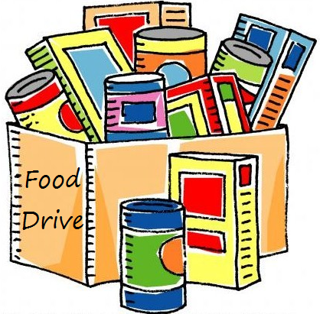
Our monthly collection for the Hawaii Foodbank will be on the first Sunday of every month. If it is not safe to have Communion Service In-Person, we will be offering drive through communion, so please bring your donations to church.
In the first year of the pandemic, the Hawaii Foodbank had to purchase more than 12.5 million dollars worth of emergency food. Their regular annual budget is $400,000. So the need is great. Last month we collected 191 pounds of food and $210.00 dollars.
Monetary donations are always welcome. We will no longer accept checks made payable to Nu‘uanu Congregational Church for the Hawai‘i Foodbank. Please make checks payable to: Hawaii Foodbank.

Give Aloha is Back
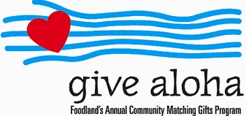
It’s that time of year! During the month of September 2021, you may make donations through Give Aloha at Foodland, Sac N Save, or Foodland Farms. The organization code for Nu‘uanu Congregational Church is 78424. The cumulative total of up to $249.00 per person/per organization is allowed.
Please drop off or mail your receipt, with your name at the top of the receipt, to the office as soon as you can. The absolute deadline to turn in your receipt is by December 31, 2021 so that we may add it to your donation total for the year.

Severe Storms 2021
From UCC Coconut Wireless
More than 20 U.S. states from the South to the Northeast are reeling from the impact of Hurricane Ida and its sizeable remnants with catastrophic water and wind damage, including significant power outages.
To stay on top of the unfolding situation, United Church of Christ Disaster Ministries is listening in to coordination calls and reaching out to UCC Conference Ministers and Back Bay Mission as they begin their damage assessments.
Recovery needs, both short- and long-term, will be massive, with damage estimates in the billions of dollars.
In addition to monitoring the big picture, UCC Disaster Ministries is collecting news of damage to UCC churches.
The wind ripped off the roof of Little Farms UCC in Metairie, La., and damaged St. Paul’s UCC in New Orleans. Back Bay Mission, a UCC community ministry in Biloxi, Miss., reported light damage: missing screens, and lots of debris and downed tree limbs.
This isn’t the first severe storm this year and we can be reasonably sure it won’t be the last.
What’s the best way to help now? Send money. UCC Disaster Response and Recovery Minister Lesli Remaly said of Hurricane Ida, “For a storm this size, money makes good sense as we know long-term recovery and rebuilding will be necessary.”
One can also mail a check made payable to the United Church of Christ PO BOX 71957 Cleveland, OH 44194. Please be sure to note “2021 Severe Storms” on your check in the memo section, or in an attached letter.

