**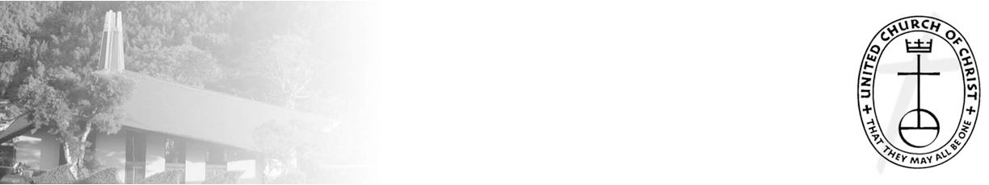**

***NCC News***

**August 1, 2021**

*A Weekly Newsletter of Nu‘uanu Congregational Church*

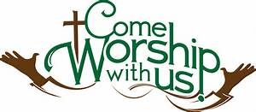

**Learn to Play the Organ!**

*By Katherine Crosier*

 The American Guild of Organists-Hawaii Chapter is accepting scholarship applications from August 1 to August 31, 2021 for the scholarship period October 2021 through September 2022.  Auditions will be held in September 2021. Visit [agohawaii.org](http://agohawaii.org/" \t "_blank) to download an application.  For details, e-mail Elizabeth Wong at [ew\_ago\_hawaiichapter@yahoo.com](mailto:ew_ago_hawaiichapter@yahoo.com" \t "_blank)

**Give Aloha will be Back**

*by Mairi Manley*

 During the month of September 2021, you may

make donations through Give Aloha at Foodland,

Sac N Save, or Foodland Farms. The cumulative total

of up to $249.00 per person/ per transaction is allowed.

Please drop off or mail your receipt to the office

by December 31, 2021 so that we may add it to your donation total for the year.

**Second Quarter Donation Statements**

The 2nd Quarter statements are printed and will be ready for pickup at worship service on August 1, 2021. Included in the packet is a letter from

Lori Yamashiro and Income Expenses up until June of 2021. Please ask for them either before or after service.

The statement will be mailed to you if it is not picked up by the end of worship service on August 8, 2021. Mahalo!

**Hawai‘i Foodbank & Family Promise School Supply Drive**

*By Judy Keith*

Thanks to all who supported the Foodbank and School supplies collections last week. Your generosity was overwhelming. We collected 209 pounds of food and checks totaling $1,525.00 for the Foodbank and so many school supplies that we were able to donate to both Family Promise and Puuhale Elementary School. The needs in our community are even greater than usual this year and it was wonderful to see the outpouring of donations to the two drives.

**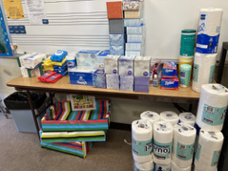 **

**Altar Flower Arrangements**

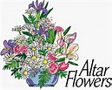 In preparation for In-Person Worship Services, we have the Altar Flowers List up in the NCC Office. The chart will be out during worship service on Sundays. If you don’t get a chance on Sunday, it will be in the office.

If you would like to sign up for Altar Flower Arrangements, please call or email me at (808) 595-3935 or nccadmin@hawaiiantel.net. The following dates are still open:

* September 5, 2021
* October 24, 2021
* November 7, 2021
* November 21, 2021
* December 12, 2021
* December 19, 2021

**Community Garden**

**This has been moved to Aug. 14.** On July 31, 2021, in the morning,Nate Cantrill from the Scouts Troop 201 will be constructing the community garden here at church. The garden will be where Hale Ohana was in the concrete area.