A Weekly Newsletter of Nu‘uanu Congregational Church
NCC News
August 29, 2021

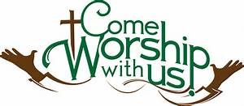

In-Person Services
The medical team and Diaconate met Thursday night. Due to the concern of the active Covid cases, hospitalizations, hospitals at or near maximum capacity, they have decided to cancel In-Person Services for the remainder of August. We definitely would like to see Pastor Jeannie get her surgery! They will meet again on September 1 to decide what to do in September.
Please call me in the office if you have any questions. If I don’t have an answer, I will get one for you. Thank you for your understanding on this situation.

Learn to Play the Organ!
By Katherine Crosier
The American Guild of Organists-Hawaii Chapter is accepting scholarship applications from August 1 to August 31, 2021 for the scholarship period October 2021 through September 2022. Auditions will be held in September 2021. Visit agohawaii.org to download an application. For details, e-mail Elizabeth Wong at ew_ago_hawaiichapter@yahoo.com.

Give Aloha will be Back
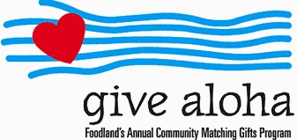
Correction: The cumulative total of up to $249.00 per person/per organization is allowed. During the month of September 2021, you may make donations through Give Aloha at Foodland, Sac N Save, or Foodland Farms. The organization code for Nu‘uanu Congregational Church is 78424.
Please drop off or mail your receipt, with your name at the top of the receipt, to the office as soon as you can. The absolute deadline to turn in your receipt is by December 31, 2021 so that we may add it to your donation total for the year.

The Hawai‘i Foodbank Collection
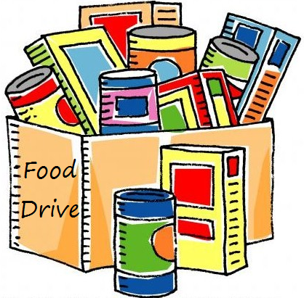
On September 5 we will do our monthly collection for the Hawaii Foodbank, whether our worship is in person or virtual. If things are not safe enough for us to worship in person, we will be offering drive through communion, so please bring your donations to church. In the first year of the pandemic, the Hawaii Foodbank had to purchase more than 12.5 million dollars worth of emergency food. Their regular annual budget is $400,000. So the need is great. Last month we collected 209 pounds of food and 1,525 dollars.
Monetary donations are always welcome. We will no longer accept checks made payable to Nu‘uanu Congregational Church for the Hawai‘i Foodbank. Please make checks payable to: Hawaii Foodbank.

Church World Service and the earthquake in Hatti
CWS is conducting damage assessments with partners. This process will likely take several days, given communications limitations and the magnitude of the quake. Our team will also conduct an assessment of the houses and schools that have been constructed through CWS programs in recent years to determine whether there are new needs among those program participants.
We anticipate that our response will focus on recovery and rehabilitation. We know that will include housing reconstruction, trauma recovery support and water infrastructure repairs in the municipality of Pestel, a community that our team worked with to recover following Hurricane Matthew.
Please consider helping with the recovery by making a donation right now in support of CWS's response.
Church World Service assisting Afghan refugees
Church World Service have been assisting individuals who served alongside the U.S. mission in Afghanistan and urges the Biden administration and Congress to prioritize the evacuation of all of the more than 18,000. The organization, along with other U.S. partner agencies, will provide services for arrivals through case management and resettlement services.
“These men and women put themselves at risk to support the U.S. mission in Afghanistan. They were interpreters, they were cooks, they were office workers. They took on a great number of roles to keep Americans safe and defend their nation. With the withdrawal of U.S. forces, however, they are increasingly vulnerable for that service,” said Erol Kekic, Senior Vice President for the Immigration and Refugee Program at Church World Service. “That’s why we are involved from the moment they set foot on American soil, so they can focus on family and the future, not the fear they’ve been living in for far too long.”
Church World Service welcomes refugees across 17 states through 23 offices. They provide services to newly arrived refugees and immigrants, helping them to integrate into local communities, find jobs and learn the necessary skills to support their new lives in the United States.
Please mail your check, payable to:
Church World Service
P.O. Box 968
Elkhart, IN 46515
Church World Service, Inc., is tax-exempt under section 501(c)(3) of the U.S. Internal Revenue Code.

