A Weekly Newsletter of Nu‘uanu Congregational Church
NCC News
August 22, 2021

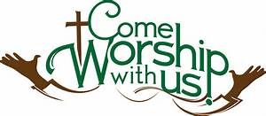

In-Person Services
The medical team and Diaconate met Thursday night. Due to the concern of the active Covid cases, hospitalizations, hospitals at or near maximum capacity, they have decided to cancel In-Person Services for the remainder of August. We definitely would like to see Pastor Jeannie get her surgery! They will meet again on September 1 to decide what to do in September.
I will be calling people who signed up for Altar Flower donations to cancel their orders for at least August.
Please call me in the office if you have any questions. If I don’t have an answer, I will get one for you. Thank you for your understanding on this situation.

Learn to Play the Organ!
By Katherine Crosier
The American Guild of Organists-Hawaii Chapter is accepting scholarship applications from August 1 to August 31, 2021 for the scholarship period October 2021 through September 2022. Auditions will be held in September 2021. Visit agohawaii.org to download an application. For details, e-mail Elizabeth Wong at ew_ago_hawaiichapter@yahoo.com
Give Aloha will be Back
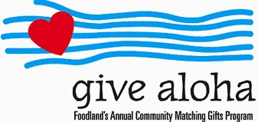
Correction: The cumulative total of up to $249.00 per person/per organization is allowed. During the month of September 2021, you may make donations through Give Aloha at Foodland, Sac N Save, or Foodland Farms. The organization code for Nu‘uanu Congregational Church is 78424.
Please drop off or mail your receipt, with your name at the top of the receipt, to the office as soon as you can. The absolute deadline to turn in your receipt is by December 31, 2021 so that we may add it to your donation total for the year.

The Hawai‘i Foodbank Collection
On September 5 we will do our monthly collection for the Hawaii Foodbank, whether our worship is in person or virtual. If things are not safe enough for us to worship in person, we will be offering drive through communion, so please bring your donations to church. In the first year of the pandemic, the Hawaii Foodbank had to purchase more than 12.5 million dollars worth of emergency food. Their regular annual budget is $400,000. So the need is great. Last month we collected 209 pounds of food and 1,525 dollars.
Monetary donations are always welcome. We will no longer accept checks made payable to Nu‘uanu Congregational Church for the Hawai‘i Foodbank. Please make checks payable to: Hawaii Foodbank.

Altar Flower Arrangements
by Mairi Manley
I would like to thank whom I called for the month of August and being able to be flexible with canceling their Altar Flower donations at the drop of a dime! I will be letting you know what dates we still need Altar Flower donations for when we start In-Person Services again.

Caller Articles
By Mairi Manley
It would be greatly appreciated to have September Caller articles emailed to me by Monday, August 23, 2021. nccadmin@hawaiiantel.net

