A Weekly Newsletter of Nu‘uanu Congregational Church
NCC News
August 15, 2021

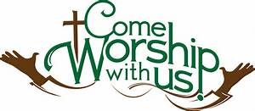

In-Person Services
The medical team and Diaconate met Thursday night. Due to the concern of the active Covid cases, hospitalizations, hospitals at or near maximum capacity, they have decided to cancel In-Person Services for the remainder of August. We definitely would like to see Pastor Jeannie get her surgery! They will meet again on September 1 to decide what to do in September.
I will be calling people who signed up for Altar Flower donations to cancel their orders for at least August.
Please call me in the office if you have any questions. If I don’t have an answer, I will get one for you. Thank you for your understanding on this situation.

Learn to Play the Organ!
By Katherine Crosier
The American Guild of Organists-Hawaii Chapter is accepting scholarship applications from August 1 to August 31, 2021 for the scholarship period October 2021 through September 2022. Auditions will be held in September 2021. Visit agohawaii.org to download an application. For details, e-mail Elizabeth Wong at ew_ago_hawaiichapter@yahoo.com
Give Aloha will be Back
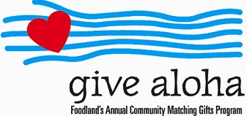
Correction: The cumulative total of up to $249.00 per person/per organization is allowed. During the month of September 2021, you may make donations through Give Aloha at Foodland, Sac N Save, or Foodland Farms. The organization code for Nu‘uanu Congregational Church is 78424.
Please drop off or mail your receipt, with your name at the top of the receipt, to the office as soon as you can. The absolute deadline to turn in your receipt is by December 31, 2021 so that we may add it to your donation total for the year.

Hawai‘i Foodbank & Family Promise School Supply Drive
By Judy Keith
Thanks to all who supported the Foodbank and School supplies collections last week. Your generosity was overwhelming. We collected 209 pounds of food and checks totaling $1,525.00 for the Foodbank and so many school supplies that we were able to donate to both Family Promise and Puuhale Elementary School. The needs in our community are even greater than usual this year and it was wonderful to see the outpouring of donations to the two drives.
