A Weekly Newsletter of Nu‘uanu Congregational Church
NCC News
December 6, 2020

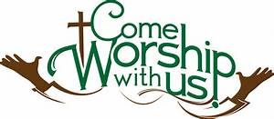

Annual Reports Due
To all board and committee chairs, Moderator, and Pastor, please submit your annual reports to Mairi Manley by December 18 via email. Adhering to this deadline will be most appreciated. Reports should be in Word or Pages format, Century Schoolbook font, size 12. Any photos should be sent separately (not within the report). Mahalo.

2020 Contributions
Just a reminder....in order for contributions to be credited for the 2020 tax year, they must be either mailed to the church with a USPS postmark not later than December 31, 2020 or received by the church office before 12:00 p.m. Thursday, December 31, 2019. Contributions received after that will be credited to 2021.

Give Aloha – Mahalo!
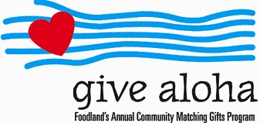
Your Foodland receipt with your name on it must be received by the church office by December 31, 2020, so we may properly credit your giving account for the 2020 tax year. Receipts received after December 31 will be credited to 2021. Foodland does not provide us with any names. Also, please make sure that the date, time, and store is on the receipt. That is the only way we are able to verify your giving with the printout provided by Foodland. There are approximately 5 outstanding receipts remaining. Mahalo.

Paula's Retirement
Please join us on December 6th, during Communion Element pick up, to thank Paula for 14 years of service as Administrative Coordinator for the church. She may be retiring but she'll still be around when we have in-person church services.

Correction in Day!
Advent Organ Chorales
A Virtual Organ Recital
by Katherine Crosier, organist
Monday, December 7, 2020 • 7:00 pm

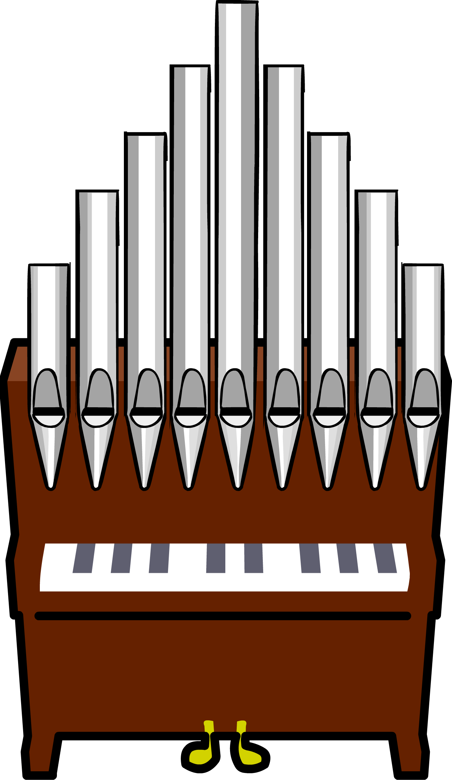
The art of hymn introductions was perfected in Germany, where the "chorale prelude" was developed by Johann Sebastian Bach and other north German composers. The chorale prelude is a relatively short setting for organ which is intended to introduce the hymn tune to the congregation. This concert will feature a wide variety of chorale preludes by international composers from Germany, France, Norway, and the United States: Bach, Johann Pachelbel, Hugo Distler, Marcel Dupré, Egil Hovland, Gerald Near and Paul Manz. Four singers will sing the hymns immediately following each chorale prelude.

The concert will be livestreamed and then archived on the Lutheran Church of Honolulu Facebook page on Dec. 7 at 7:00 pm: https://www.facebook.com/LCHwelcome/

Save the Date!
NCC Second Sunday Forum
Dec 13, 2020 10:30 AM Hawaii

Join Zoom Meeting
https://us02web.zoom.us/j/5263446259
Meeting ID: 526 344 6259

We will have a guest speaker from the Samaritan Counseling Center, Rev. Dr. Gary Augustin. He is eager to present and facilitate a discussion group about coping and isolation during the pandemic with the holidays.

If anyone would like to listen (without video), please call Mairi or Jeannie and we’ll have that number for you.

White Christmas
Covid-19 will not diminish the spirit of Christmas sharing. More than ever, we need t lift up our homeless families. As we did last year, we ask that you donate gift cards (i.e: Target, Walmart, Longs Drugs, etc.) that we can distribute to the UCC Transition house, River of Life Mission, and Family Promise. Please indicate the amount on the card, so we can distribute them equally. Mail or deliver them to the church office. Donations will be accepted December 1-19. Mahalo and Mele Kalikimaka.

