A Weekly Newsletter of Nu‘uanu Congregational Church
NCC News
December 27, 2020

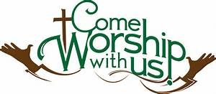

2020 Contributions
Just a reminder....in order for contributions to be credited for the 2020 tax year, they must be either mailed to the church with a USPS postmark not later than December 31, 2020 or received by the church office before 12:00 p.m. Thursday, December 31, 2019. Contributions received after that will be credited to 2021.

Give Aloha – Mahalo!
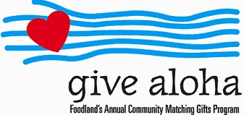
Your Foodland receipt with your name on it must be received by the church office by December 31, 2020, so we may properly credit your giving account for the 2020 tax year. Receipts received after December 31 will be credited to 2021. Foodland does not provide us with any names. Also, please make sure that the date, time, and store is on the receipt. That is the only way we are able to verify your giving with the printout provided by Foodland. There are approximately 5 outstanding receipts remaining. Mahalo.
White Christmas
Over $1,500 worth of gift cards were given, and given what a crazy year this has been, that is quite an achievement! There were gift cards for Target, Foodland, Longs, & Walmart, plus a few other places as well. Even when we are unable to come together to worship in person, we still are church & we are still being church. Well done!

